XLEAP Undulator Fiducial Report May 12, 2017
H. Imfeld, F. Gaudreault

Upstream End DownStream End
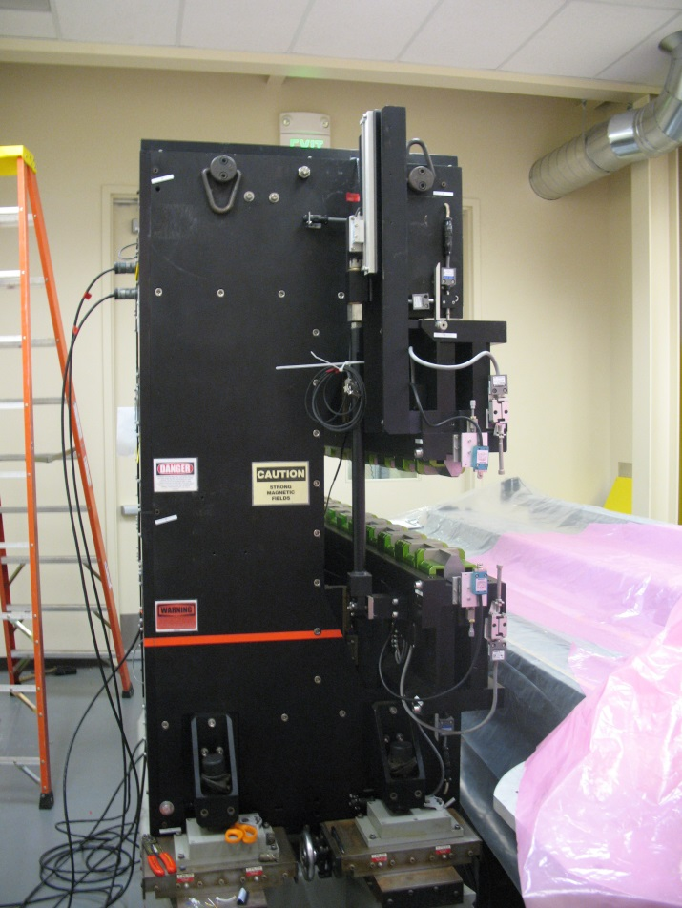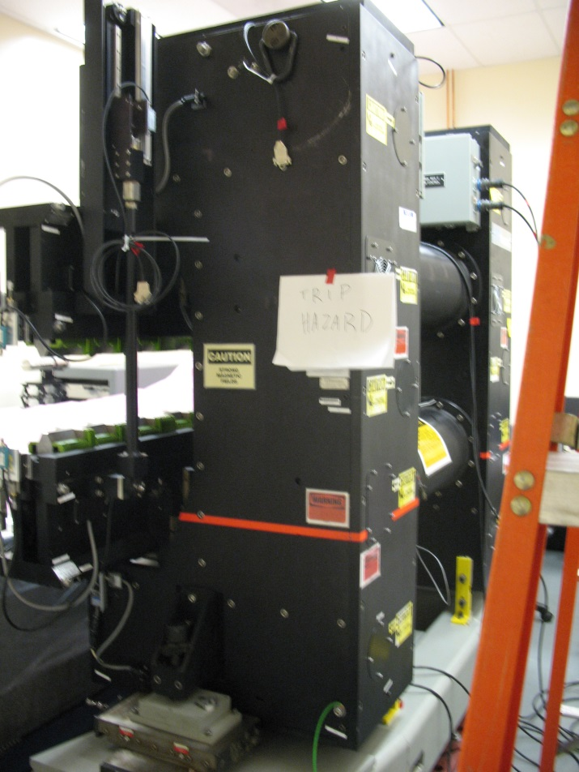
TB8
TB7
TB6
TB5
TBN
TBP
TBI
BL
TBL
TBF
TBH
TBK
TBJ
TBD
TBE
TBG
TB4
TBC
TB3
BL
TB2
TB1
TBA
TBB
TBF

Coordinate System:
Primary axis: top of the granite table; elevation, pitch and roll, where the probe travelled.
Secondary axis: edge of granite table where probe travelled, defines yaw.
Transformed System: PMY = 95.127 mm
PMX = 97.753 mm
Fit a point to end tooling balls A,B,C,D,E, J,K,L,N and P to get average Z of the magnet.

Magnet
1” Tooling Balls
TBA | -35.2346 | -2.7809 | 32.9500
TBB | -35.2444 | 26.3435 | 33.0785
TBC | -35.2311 | 26.4786 | 0.0759
TBD | -35.2243 | 26.6147 | -31.5506
TBE | -35.2083 | -2.5116 | -31.6739
TBF | -25.5174 | 29.0761 | 33.0876
TBG | -25.5338 | 29.2983 | -31.5349
TBH | 25.5188 | 29.0731 | 33.0816
TBI | 25.5058 | 29.3406 | -31.5276
TBJ | 35.2419 | -2.7271 | 32.9553
TBK | 35.2299 | 26.3984 | 33.0752
TBL | 35.2142 | 26.5363 | 0.0744
TBN | 35.2140 | 26.6722 | -31.5470
TBP | 35.2425 | -2.4549 | -31.6695

Glued Temporary points on jaws
Jaws 10mm Gap
1” Tooling Balls
TB1 | -48.8189 | 2.1467 | 13.6376
TB2 | -46.6717 | 5.4451 | 2.5253
TB3 | -46.6099 | 5.4507 | -2.5372
TB4 | -46.6263 | 5.5765 | -13.8297
TB5 | 46.5519 | 5.5942 | 13.8360
TB6 | 46.4476 | 5.4791 | 3.1292
TB7 | 46.6060 | 5.5989 | -4.9289
TB8 | 46.5482 | 5.6117 | -13.7328

