LCLS2 SXR Undulator

Alignment Engineering Group
L2?????
SN 29A804-022
March 27, 2019

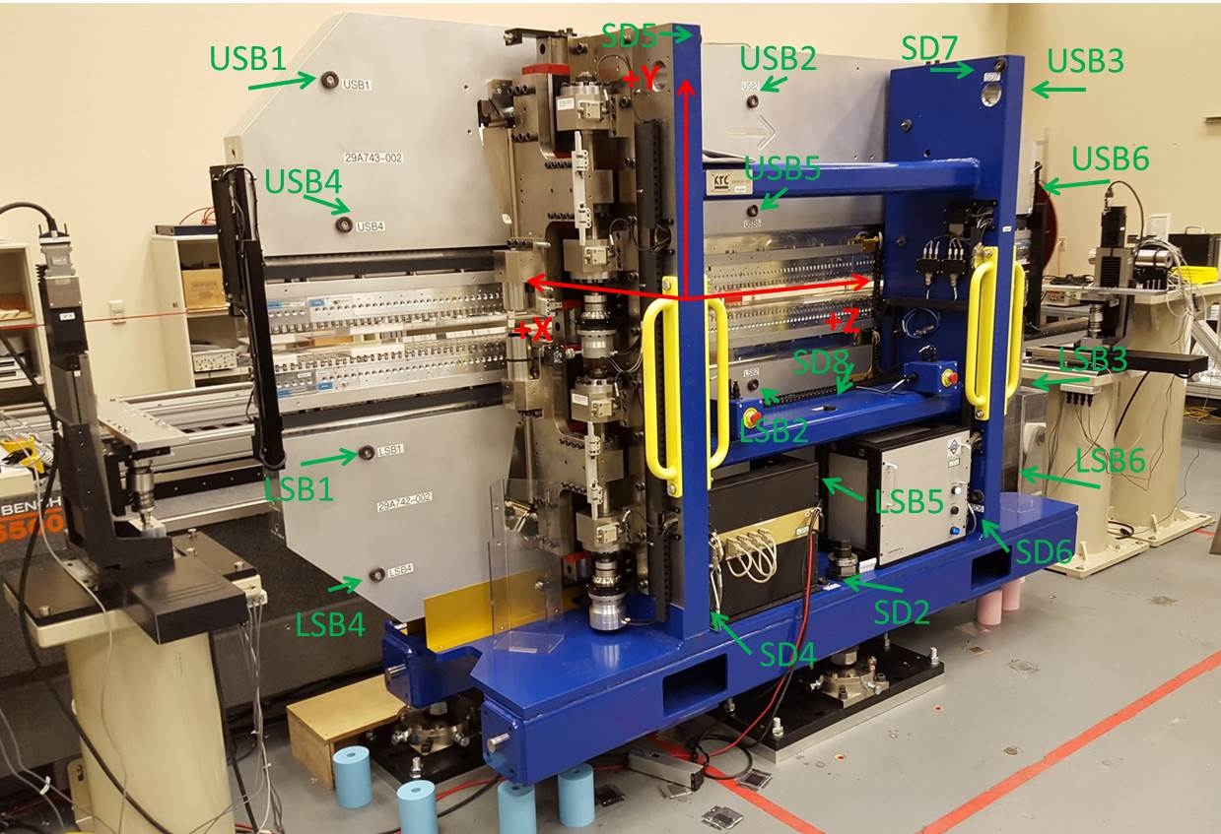

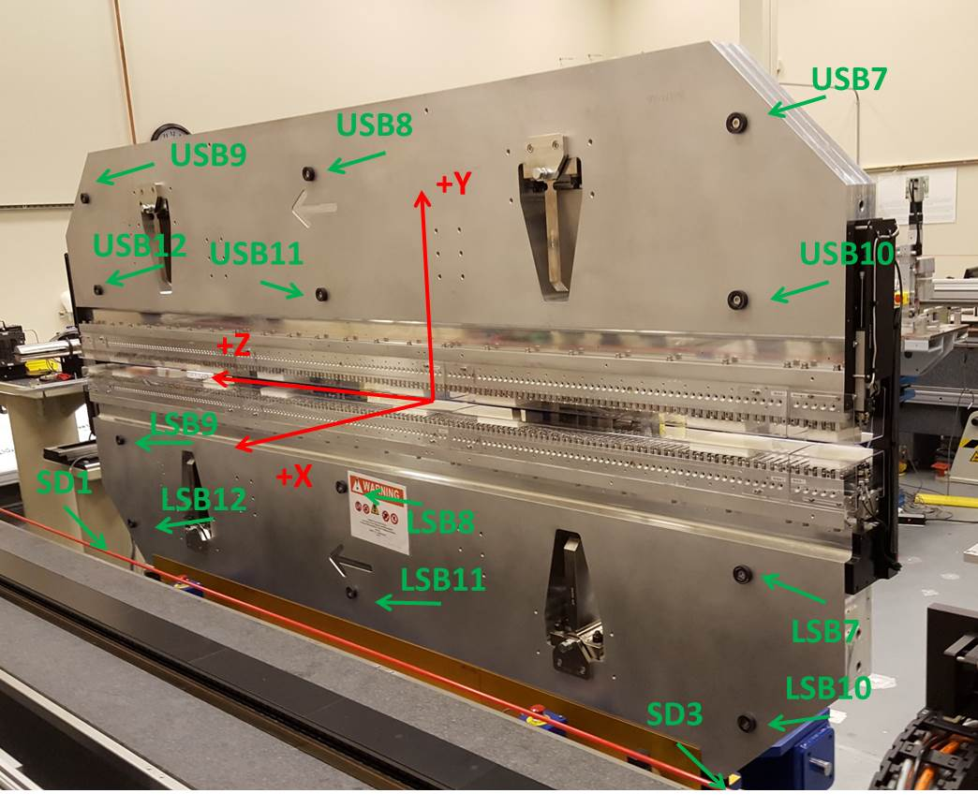

Tooling ball values to center of 1.5 inch sphere, all units are inches. Coordinates are to the SXR Undulator Magnetic Axis.
Tooling Ball | Z (in) | X (in) | Y (in)
LSB1 | -57.4733 | -3.4828 | -10.4698
LSB2 | 0.0014 | -3.4786 | -10.4801
LSB3 | 57.4820 | -3.4839 | -10.4759
LSB4 | -57.4725 | -3.4816 | -24.2631
LSB5 | 0.0007 | -3.4776 | -24.2554
LSB6 | 57.4860 | -3.4832 | -24.2398
LSB7 | -57.4752 | 3.4948 | -10.4780
LSB8 | 0.0043 | 3.5000 | -10.4704
LSB9 | 57.4702 | 3.4921 | -10.4772
LSB10 | -57.4695 | 3.4953 | -24.2581
LSB11 | 0.0086 | 3.5002 | -24.2594
LSB12 | 57.4762 | 3.4915 | -24.2543
SD1 | 50.9853 | 7.2456 | -34.7089
SD2 | -3.9176 | -19.5751 | -34.7483
SD3 | -50.9807 | 7.1639 | -34.6919
SD4 | -25.5894 | -21.7569 | -29.5985
SD5 | -25.5908 | -21.7382 | 29.4580
SD6 | 25.6803 | -21.6997 | -29.6080
SD7 | 25.6606 | -21.7112 | 29.4455
SD8 | 0.0433 | -17.1451 | -12.3525
USB1 | -57.4785 | -3.4836 | 24.2625
USB2 | 0.0046 | -3.4865 | 24.2634
USB3 | 57.4783 | -3.4828 | 24.2659
USB4 | -57.4801 | -3.4869 | 10.4778
USB5 | -0.0045 | -3.4904 | 10.4821
USB6 | 57.4831 | -3.4878 | 10.4731
USB7 | -57.4710 | 3.4928 | 24.2534
USB8 | 0.0022 | 3.4896 | 24.2551
USB9 | 57.4860 | 3.4929 | 24.2526
USB10 | -57.4775 | 3.4896 | 10.4746
USB11 | 0.0016 | 3.4860 | 10.4679
USB12 | 57.4755 | 3.4885 | 10.4672

Center | Z (m) | X (m) | Y (m) | Z (in) | X (in) | Y (in)
PM10M | -2.815986 | -0.026259 | 0.000656 | -110.8656 | -1.0338 | 0.0258
PM11M | 2.726138 | -0.026474 | 0.000401 | 107.3283 | -1.0423 | 0.0158
RFM | -2.671228 | 0.048720 | -0.000007 | -105.1665 | 1.9181 | -0.0003

PM10 and Granite coordinate system with Yurii shifts.
 |  | From Yurii |  |  | Measured
Device | Z (m) | X (m) | Y (m) | Z (m) | X (m) | Y (m) | dX (mm) | dY (mm)
PM10 | -0.368866 | -0.102492 | 0.000790 | -2.815986 | -0.102489 | 0.000806 | 0.003 | 0.016
PM11 | 5.173390 | -0.102700 | 0.000568 | 2.726138 | -0.102704 | 0.000551 | -0.004 | -0.017
RefBlock |  |  |  | -2.683678 | -0.047931 | 0.083283

