LCLS2 SXR Undulator

Alignment Engineering Group
L2?????
SN 29A804-018
January 17, 2019

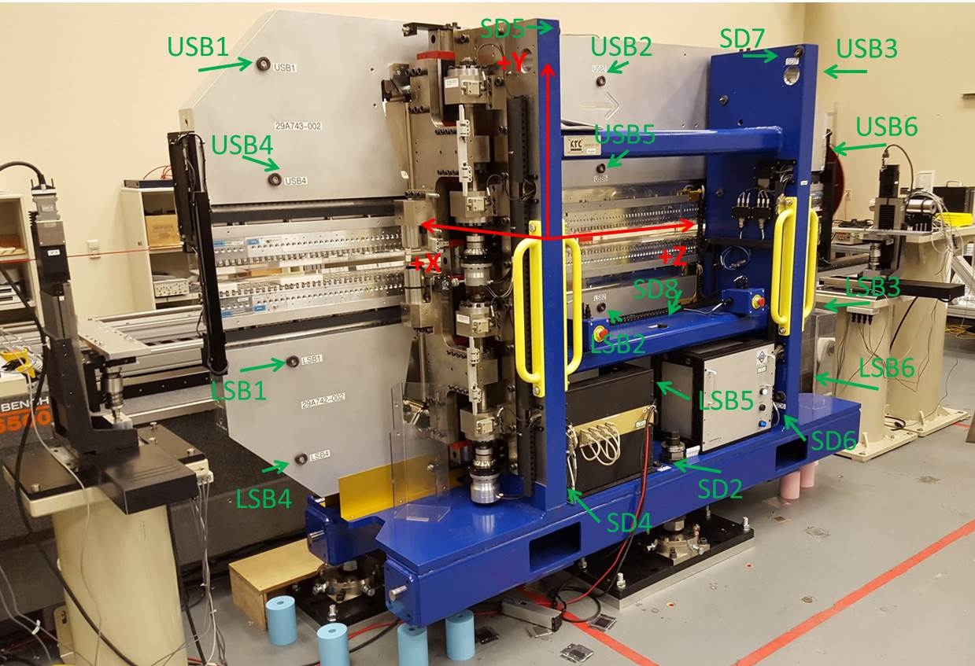

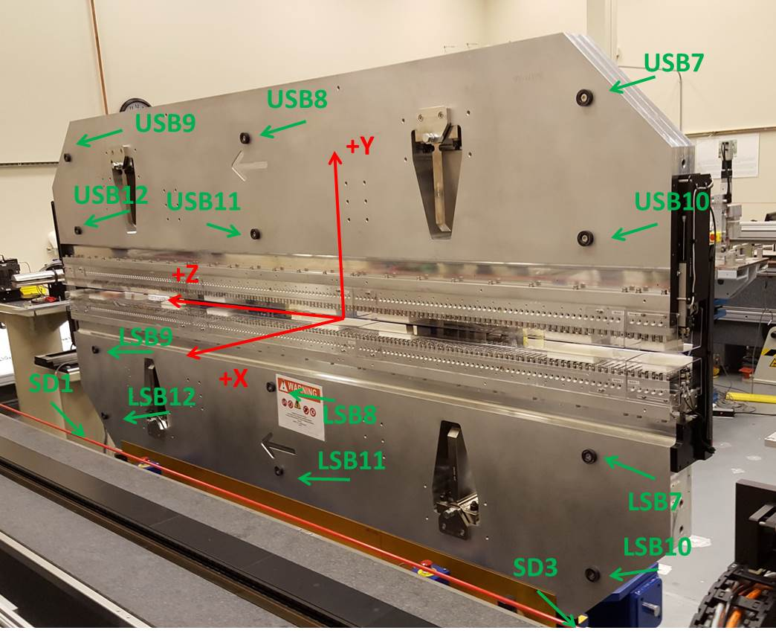

Tooling ball values to center of 1.5 inch sphere, all units are inches. Coordinates are to the SXR Undulator Magnetic Axis.
Tooling Ball | Z (in) | X (in) | Y (in)
LSB1 | -57.4745 | -3.4948 | -10.4804
LSB2 | -0.0108 | -3.4878 | -10.4732
LSB3 | 57.4705 | -3.4841 | -10.4802
LSB4 | -57.4797 | -3.4941 | -24.2611
LSB5 | 0.0080 | -3.4870 | -24.2472
LSB6 | 57.4677 | -3.4836 | -24.2557
LSB7 | -57.4717 | 3.4803 | -10.4790
LSB8 | -0.0035 | 3.4877 | -10.4775
LSB9 | 57.4718 | 3.4912 | -10.4848
LSB10 | -57.4792 | 3.4801 | -24.2697
LSB11 | 0.0006 | 3.4896 | -24.2626
LSB12 | 57.4660 | 3.4919 | -24.2633
SD1 | 50.9781 | 7.2446 | -34.6526
SD2 | -3.9296 | -19.5304 | -34.7260
SD3 | -50.9761 | 7.2445 | -34.6793
SD4 | -25.4945 | -21.7009 | -29.5740
SD5 | -25.5719 | -21.7979 | 29.4767
SD6 | 25.7672 | -21.7947 | -29.5673
SD7 | 25.7230 | -21.7023 | 29.4861
SD8 | 0.1187 | -17.0072 | -12.2903
USB1 | -57.4709 | -3.4880 | 24.2551
USB2 | -0.0023 | -3.4938 | 24.2596
USB3 | 57.4746 | -3.4994 | 24.2543
USB4 | -57.4781 | -3.4864 | 10.4708
USB5 | -0.0062 | -3.4933 | 10.4628
USB6 | 57.4670 | -3.4986 | 10.4739
USB7 | -57.4615 | 3.4881 | 24.2537
USB8 | 0.0028 | 3.4819 | 24.2535
USB9 | 57.4720 | 3.4800 | 24.2462
USB10 | -57.4769 | 3.4918 | 10.4687
USB11 | 0.0042 | 3.4844 | 10.4670
USB12 | 57.4807 | 3.4807 | 10.4814

Center | Z (m) | X (m) | Y (m) | Z (in) | X (in) | Y (in)
PM10M | -2.816012 | -0.026368 | 0.000609 | -110.8666 | -1.0381 | 0.0240
PM11M | 2.726175 | -0.026578 | 0.000384 | 107.3297 | -1.0464 | 0.0151
RFM | -2.671247 | 0.048607 | -0.000055 | -105.1672 | 1.9137 | -0.0022

PM10 and Granite coordinate system with Yurii shifts.
 |  | From Yurii |  |  | Measured
Device | Z (m) | X (m) | Y (m) | Z (m) | X (m) | Y (m) | dX (mm) | dY (mm)
PM10 | -0.368899 | -0.102496 | 0.000746 | -2.816012 | -0.102510 | 0.000747 | -0.014 | 0.001
PM11 | 5.173378 | -0.102734 | 0.000524 | 2.726175 | -0.102720 | 0.000522 | 0.014 | -0.002
RefBlock |  |  |  | -2.671247 | -0.027535 | 0.000083

