LCLS2 SXR Undulator

Alignment Engineering Group
L2?????
SN 29A804-017
December 06, 2018

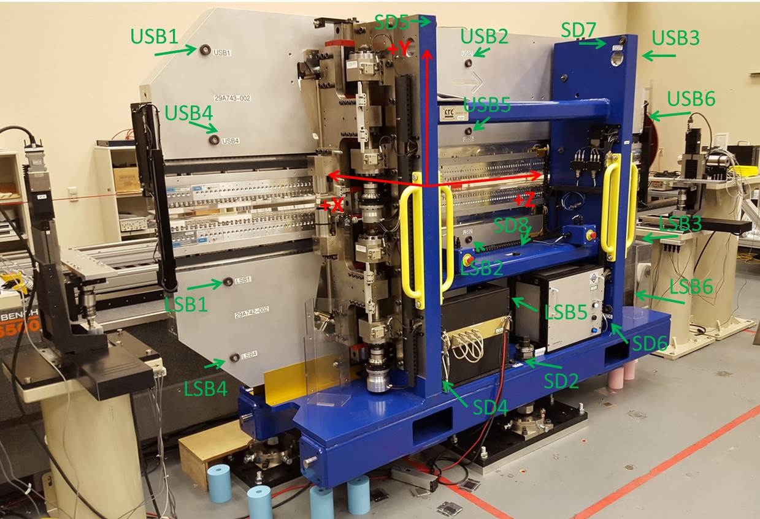

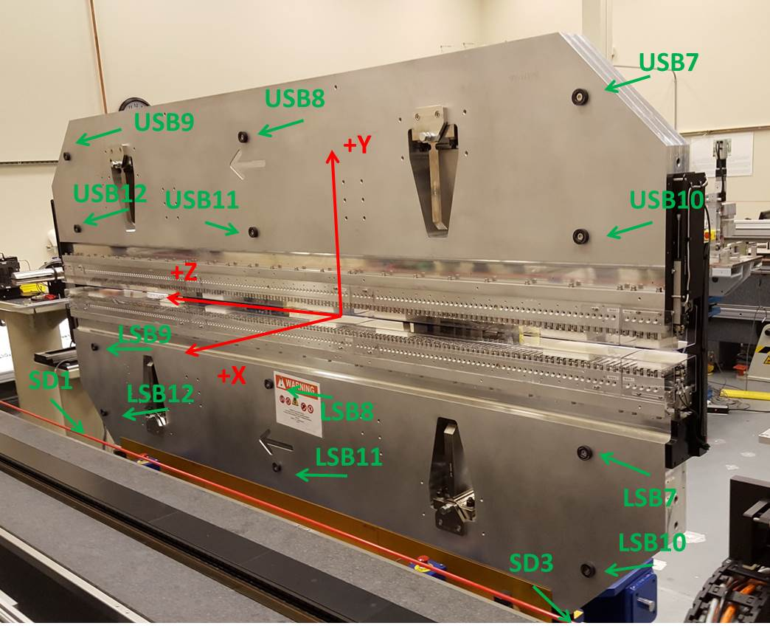

Tooling ball values to center of 1.5 inch sphere, all units are inches. Coordinates are to the SXR Undulator Magnetic Axis.
Tooling Ball | Z (in) | X (in) | Y (in)
LSB1 | -57.4848 | -3.4913 | -10.4711
LSB2 | 0.0007 | -3.4808 | -10.4818
LSB3 | 57.4783 | -3.4805 | -10.4787
LSB4 | -57.4772 | -3.4864 | -24.2463
LSB5 | -0.0029 | -3.4778 | -24.2635
LSB6 | 57.4696 | -3.4767 | -24.2490
LSB7 | -57.4946 | 3.4879 | -10.4767
LSB8 | -0.0189 | 3.4998 | -10.4779
LSB9 | 57.4607 | 3.5000 | -10.4787
LSB10 | -57.4990 | 3.4924 | -24.2571
LSB11 | -0.0181 | 3.5046 | -24.2435
LSB12 | 57.4535 | 3.5021 | -24.2487
SD1 | -50.9904 | 7.2422 | -34.6835
SD2 | -3.9305 | -19.5189 | -34.7487
SD3 | 50.9738 | 7.2729 | -34.6790
SD4 | -25.5876 | -21.6609 | -29.7733
SD5 | -25.6353 | -21.6644 | 29.4524
SD6 | 25.6380 | -21.7149 | -29.5780
SD7 | 25.6516 | -21.6828 | 29.4702
SD8 | 0.0091 | -17.0126 | -12.3711
USB1 | -57.4758 | -3.4883 | 24.2598
USB2 | -0.0028 | -3.4941 | 24.2490
USB3 | 57.4748 | -3.4928 | 24.2574
USB4 | -57.4812 | -3.4888 | 10.4753
USB5 | 0.0021 | -3.4941 | 10.4815
USB6 | 57.4754 | -3.4931 | 10.4754
USB7 | -57.4675 | 3.4914 | 24.2554
USB8 | 0.0113 | 3.4864 | 24.2565
USB9 | 57.4900 | 3.4858 | 24.2538
USB10 | -57.4552 | 3.4920 | 10.4815
USB11 | 0.0158 | 3.4864 | 10.4772
USB12 | 57.4999 | 3.4856 | 10.4735

Center | Z (m) | X (m) | Y (m) | Z (in) | X (in) | Y (in)
PM10M | -2.815775 | -0.026299 | 0.000657 | -110.8573 | -1.0354 | 0.0259
PM11M | 2.726431 | -0.026521 | 0.000408 | 107.3398 | -1.0441 | 0.0161
RFM | -2.671010 | 0.048678 | -0.000004 | -105.1579 | 1.9165 | -0.0002

PM10 and Granite coordinate system with Yurii shifts.
 |  | From Yurii |  |  | Measured
Device | Z (m) | X (m) | Y (m) | Z (m) | X (m) | Y (m) | dX (mm) | dY (mm)
PM10 | -0.368924 | -0.102500 | 0.000714 | -2.815775 | -0.102495 | 0.000727 | 0.005 | 0.013
PM11 | 5.173378 | -0.102711 | 0.000491 | 2.726431 | -0.102717 | 0.000478 | -0.006 | -0.013
RefBlock |  |  |  | -2.671010 | -0.027518 | 0.000066

