LCLS2 SXR Undulator

Alignment Engineering Group
L2?????
SN 29A804-013
August 2, 2018

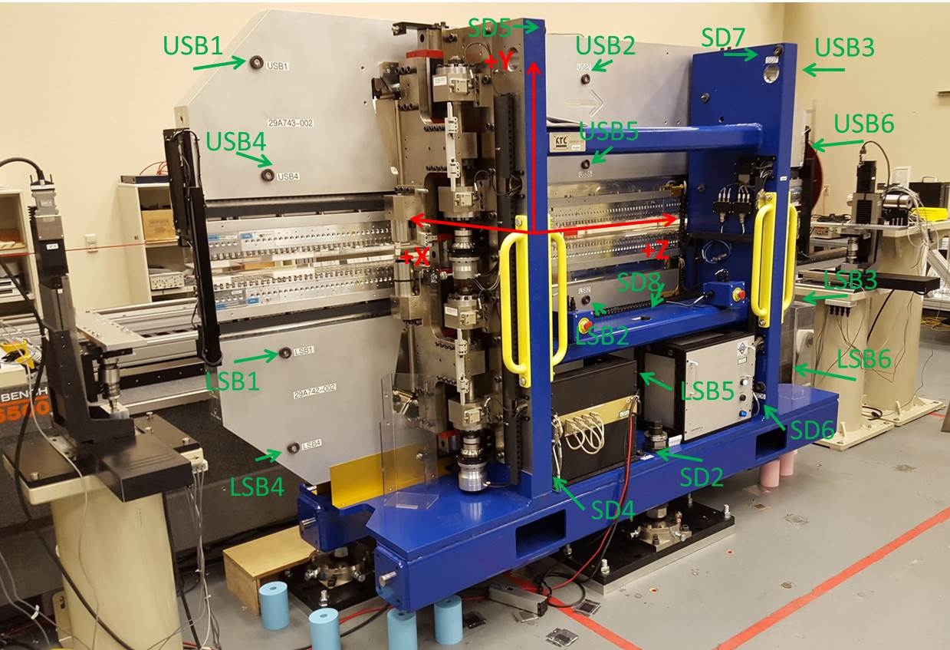

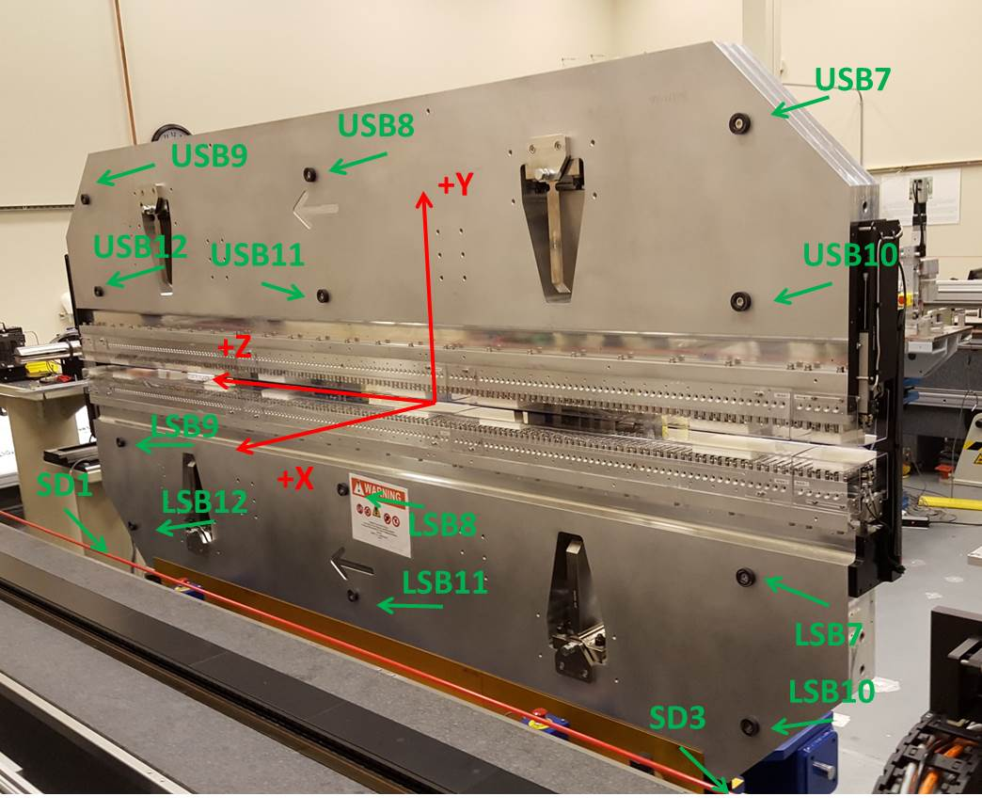

Tooling ball values to center of 1.5 inch sphere, all units are inches. Coordinates are to the SXR Undulator Magnetic Axis.
Tooling Ball | Z (in) | X (in) | Y (in)
LSB1 | -57.4818 | -3.4971 | -10.4737
LSB2 | 0.0037 | -3.4944 | -10.4709
LSB3 | 57.4798 | -3.4879 | -10.4738
LSB4 | -57.4777 | -3.4956 | -24.2526
LSB5 | -0.0011 | -3.4930 | -24.2503
LSB6 | 57.4833 | -3.4884 | -24.2545
LSB7 | -57.4848 | 3.4792 | -10.4753
LSB8 | -0.0049 | 3.4818 | -10.4744
LSB9 | 57.4667 | 3.4876 | -10.4756
LSB10 | -57.4921 | 3.4814 | -24.2509
LSB11 | -0.0057 | 3.4824 | -24.2541
LSB12 | 57.4713 | 3.4876 | -24.2506
SD1 | 50.9865 | 7.2413 | -34.6697
SD2 | -3.9368 | -19.5363 | -34.7348
SD3 | -50.9723 | 7.2275 | -34.6611
SD4 | -25.6761 | -21.7114 | -29.5774
SD5 | -25.6846 | -21.7256 | 29.4657
SD6 | 25.6658 | -21.6906 | -29.5770
SD7 | 25.6706 | -21.6989 | 29.4390
SD8 | 0.0072 | -17.0356 | -12.3360
USB1 | -57.4781 | -3.4759 | 24.2520
USB2 | 0.0005 | -3.4830 | 24.2532
USB3 | 57.4807 | -3.4883 | 24.2525
USB4 | -57.4755 | -3.4802 | 10.4752
USB5 | 0.0014 | -3.4864 | 10.4732
USB6 | 57.4814 | -3.4939 | 10.4717
USB7 | -57.4717 | 3.4982 | 24.2536
USB8 | 0.0070 | 3.4926 | 24.2511
USB9 | 57.4815 | 3.4867 | 24.2532
USB10 | -57.4736 | 3.4954 | 10.4759
USB11 | 0.0062 | 3.4885 | 10.4714
USB12 | 57.4831 | 3.4836 | 10.4749

Center | Z (m) | X (m) | Y (m) | Z (in) | X (in) | Y (in)
PM10M | -2.815361 | -0.026419 | 0.000681 | -110.8410 | -1.0401 | 0.0268
PM11M | 2.726872 | -0.026634 | 0.000453 | 107.3572 | -1.0486 | 0.0178
RFM | -2.670602 | 0.048559 | 0.000021 | -105.1418 | 1.9118 | 0.0008

PM10 and Granite coordinate system with Yurii shifts.
 |  | From Yurii |  |  | Measured
Device | Z (m) | X (m) | Y (m) | Z (m) | X (m) | Y (m) | dX (mm) | dY (mm)
PM10 | -0.369292 | -0.102474 | 0.000856 | -2.815361 | -0.102479 | 0.000850 | -0.005 | -0.006
PM11 | 5.173040 | -0.102698 | 0.000616 | 2.726872 | -0.102694 | 0.000622 | 0.004 | 0.006
RefBlock |  |  |  | -2.670602 | -0.027501 | 0.000190

