LCLS2 SXR Undulator

Alignment Engineering Group
L2?????
SN 29A804-012
July 5, 2018

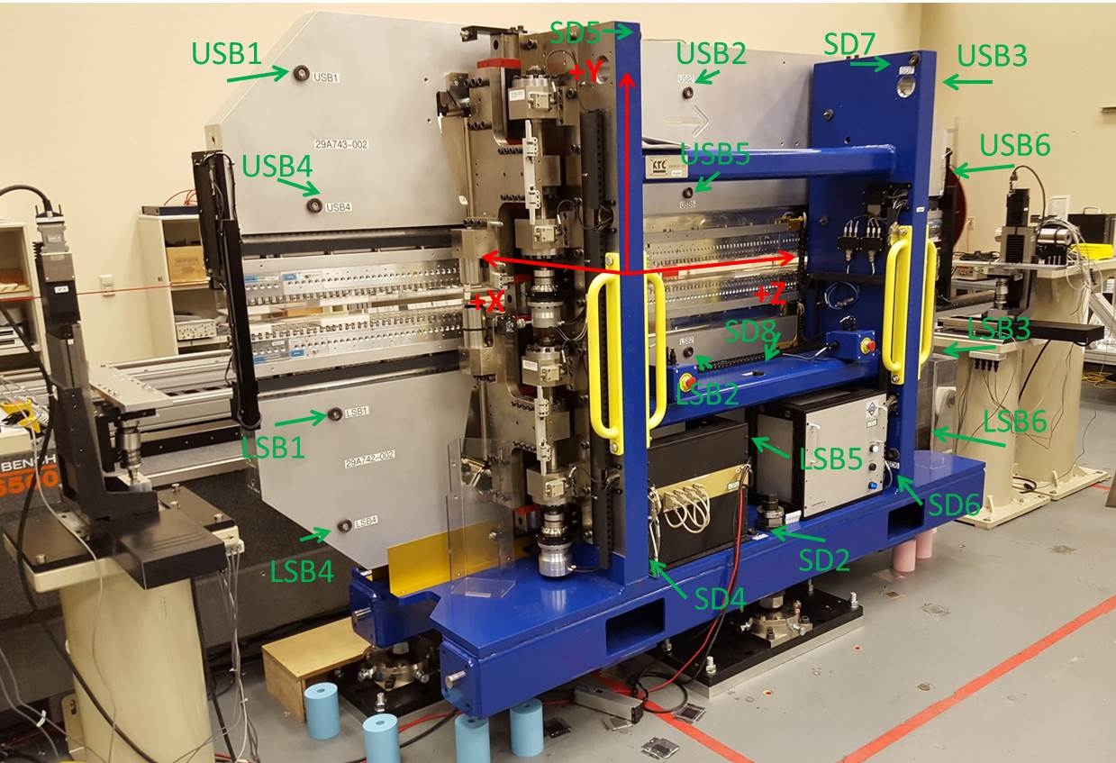

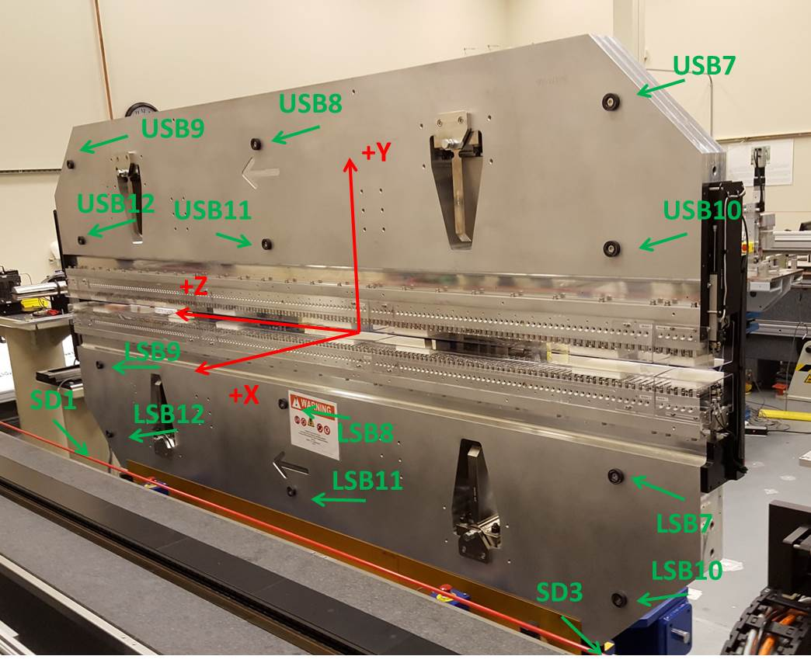

Tooling ball values to center of 1.5 inch sphere, all units are inches. Coordinates are to the SXR Undulator Magnetic Axis.
Tooling Ball | Z (in) | X (in) | Y (in)
LSB1 | -57.4837 | -3.4897 | -10.4795
LSB2 | -0.0077 | -3.4883 | -10.4759
LSB3 | 57.4752 | -3.4889 | -10.4756
LSB4 | -57.4840 | -3.4877 | -24.2580
LSB5 | -0.0043 | -3.4864 | -24.2572
LSB6 | 57.4626 | -3.4859 | -24.2570
LSB7 | -57.4776 | 3.4917 | -10.4749
LSB8 | -0.0029 | 3.4943 | -10.4765
LSB9 | 57.4755 | 3.4921 | -10.4748
LSB10 | -57.4812 | 3.4936 | -24.2543
LSB11 | -0.0017 | 3.4954 | -24.2550
LSB12 | 57.4757 | 3.4922 | -24.2562
SD1 | 50.9730 | 7.2544 | -34.6560
SD2 | -3.9345 | -19.5177 | -34.7153
SD3 | -50.9728 | 7.2400 | -34.6557
SD4 | -25.6422 | -21.6811 | -29.6071
SD5 | -25.6607 | -21.6707 | 29.4790
SD6 | 25.6412 | -21.6800 | -29.5995
SD7 | 25.6464 | -21.6754 | 29.4819
SD8 | 0.0380 | -17.0386 | -12.3041
USB1 | -57.4789 | -3.4803 | 24.2567
USB2 | 0.0026 | -3.4851 | 24.2539
USB3 | 57.4866 | -3.4890 | 24.2503
USB4 | -57.4796 | -3.4855 | 10.4763
USB5 | 0.0028 | -3.4896 | 10.4737
USB6 | 57.4843 | -3.4921 | 10.4696
USB7 | -57.4784 | 3.5013 | 24.2508
USB8 | 0.0022 | 3.4965 | 24.2503
USB9 | 57.4842 | 3.4931 | 24.2526
USB10 | -57.4778 | 3.4968 | 10.4715
USB11 | 0.0017 | 3.4927 | 10.4719
USB12 | 57.4793 | 3.4894 | 10.4732

Center | Z (m) | X (m) | Y (m) | Z (in) | X (in) | Y (in)
PM10M | -2.815442 | -0.026365 | 0.000624 | -110.8442 | -1.0380 | 0.0246
PM11M | 2.726782 | -0.026586 | 0.000385 | 107.3536 | -1.0467 | 0.0152
RFM | -2.670669 | 0.048613 | -0.000033 | -105.1444 | 1.9139 | -0.0013

PM10 and Granite coordinate system with Yurii shifts.
 |  | From Yurii |  |  | Measured
Device | Z (m) | X (m) | Y (m) | Z (m) | X (m) | Y (m) | dX (mm) | dY (mm)
PM10 | -0.369296 | -0.102480 | 0.000764 | -2.815442 | -0.102474 | 0.000764 | 0.006 | 0.000
PM11 | 5.172995 | -0.102688 | 0.000524 | 2.726782 | -0.102695 | 0.000525 | -0.007 | 0.001
RefBlock |  |  |  | -2.670669 | -0.027496 | 0.000107

