LCLS2 SXR Undulator

Alignment Engineering Group
L2?????
SN 29A804-011
June 19, 2018

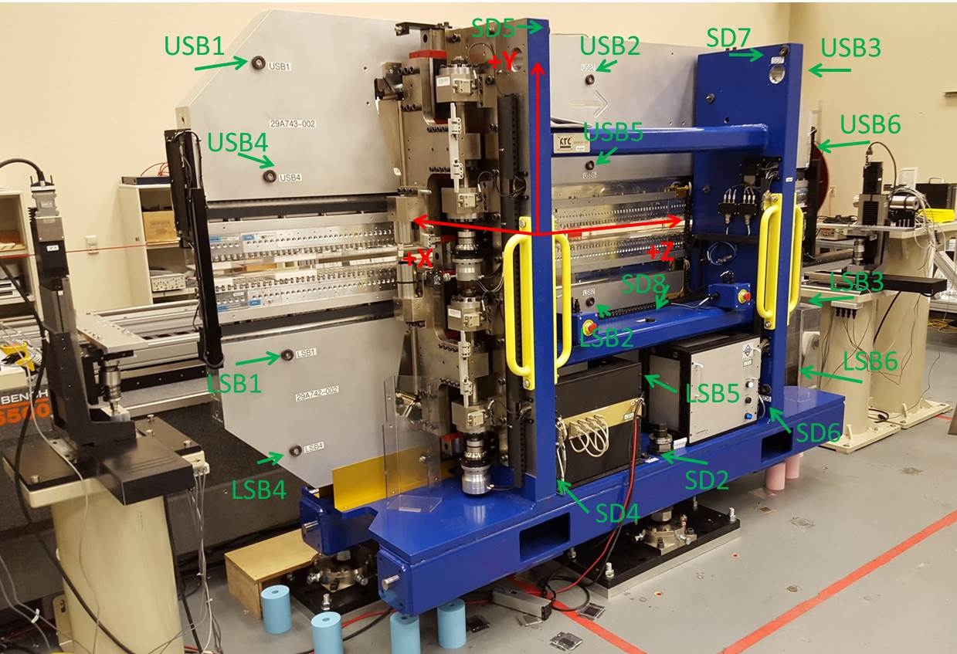

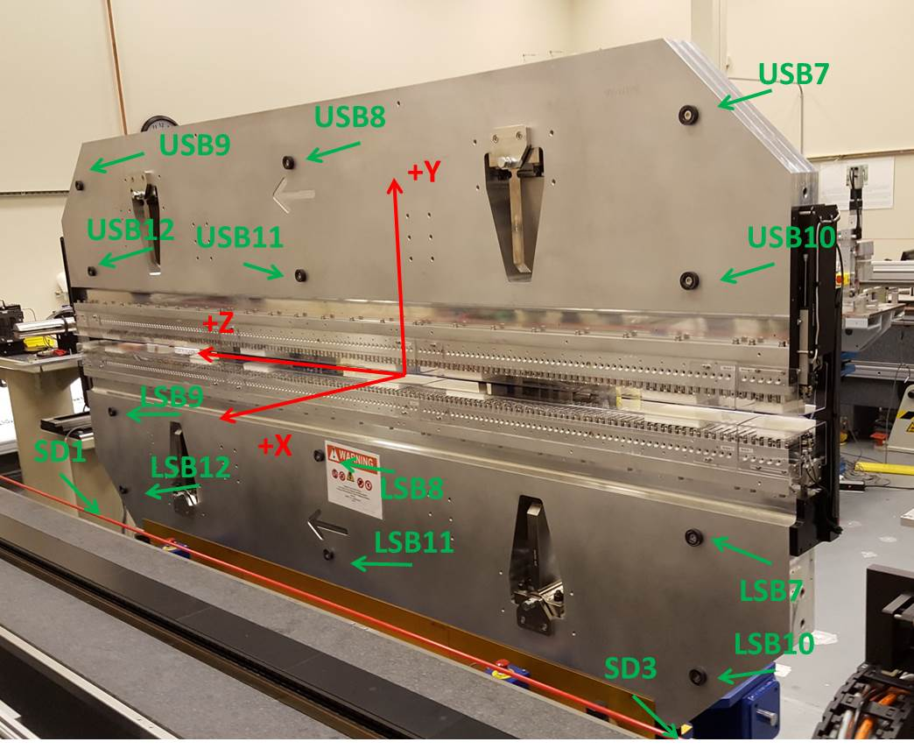

Tooling ball values to center of 1.5 inch sphere, all units are inches. Coordinates are to the SXR Undulator Magnetic Axis.
Tooling Ball | Z (in) | X (in) | Y (in)
LSB1 | -57.4846 | -3.4916 | -10.4765
LSB2 | -0.0061 | -3.4889 | -10.4768
LSB3 | 57.4739 | -3.4916 | -10.4737
LSB4 | -57.4843 | -3.4889 | -24.2554
LSB5 | -0.0054 | -3.4868 | -24.2546
LSB6 | 57.4758 | -3.4906 | -24.2550
LSB7 | -57.4847 | 3.4977 | -10.4734
LSB8 | -0.0037 | 3.5050 | -10.4739
LSB9 | 57.4772 | 3.4966 | -10.4774
LSB10 | -57.4847 | 3.5015 | -24.2510
LSB11 | -0.0027 | 3.5075 | -24.2518
LSB12 | 57.4748 | 3.4984 | -24.2555
SD1 | 50.9760 | 7.2508 | -34.7007
SD2 | -3.9224 | -19.5305 | -34.7556
SD3 | -50.9832 | 7.2230 | -34.6898
SD4 | -25.6485 | -21.6962 | -29.5923
SD5 | -25.6348 | -21.6825 | 29.4497
SD6 | 25.6196 | -21.6643 | -29.6184
SD7 | 25.6287 | -21.7041 | 29.4309
SD8 | -0.0167 | -16.9686 | -12.3650
USB1 | -57.4835 | -3.4861 | 24.2570
USB2 | -0.0015 | -3.4898 | 24.2581
USB3 | 57.4755 | -3.4834 | 24.2558
USB4 | -57.4827 | -3.4887 | 10.4762
USB5 | -0.0024 | -3.4935 | 10.4770
USB6 | 57.4748 | -3.4870 | 10.4744
USB7 | -57.4834 | 3.4911 | 24.2567
USB8 | -0.0060 | 3.4871 | 24.2563
USB9 | 57.4749 | 3.4937 | 24.2550
USB10 | -57.4841 | 3.4882 | 10.4766
USB11 | -0.0062 | 3.4839 | 10.4755
USB12 | 57.4759 | 3.4902 | 10.4778

Center | Z (m) | X (m) | Y (m) | Z (in) | X (in) | Y (in)
PM10M | -2.815211 | -0.026343 | 0.000665 | -110.8351 | -1.0371 | 0.0262
PM11M | 2.726987 | -0.026580 | 0.000411 | 107.3617 | -1.0465 | 0.0162
RFM | -2.670456 | 0.048626 | 0.000006 | -105.1361 | 1.9144 | 0.0002

PM10 and Granite coordinate system with Yurii shifts.
 |  | From Yurii |  |  | Measured
Device | Z (m) | X (m) | Y (m) | Z (m) | X (m) | Y (m) | dX (mm) | dY (mm)
PM10 | -0.369221 | -0.102476 | 0.000912 | -2.815211 | -0.102460 | 0.000918 | 0.016 | 0.006
PM11 | 5.173072 | -0.102681 | 0.000670 | 2.726987 | -0.102697 | 0.000664 | -0.016 | -0.006
RefBlock |  |  |  | -2.670456 | -0.027491 | 0.000259

