LCLS2 SXR Undulator

Alignment Engineering Group
L2?????
SN 29A804-008
April 12, 2018

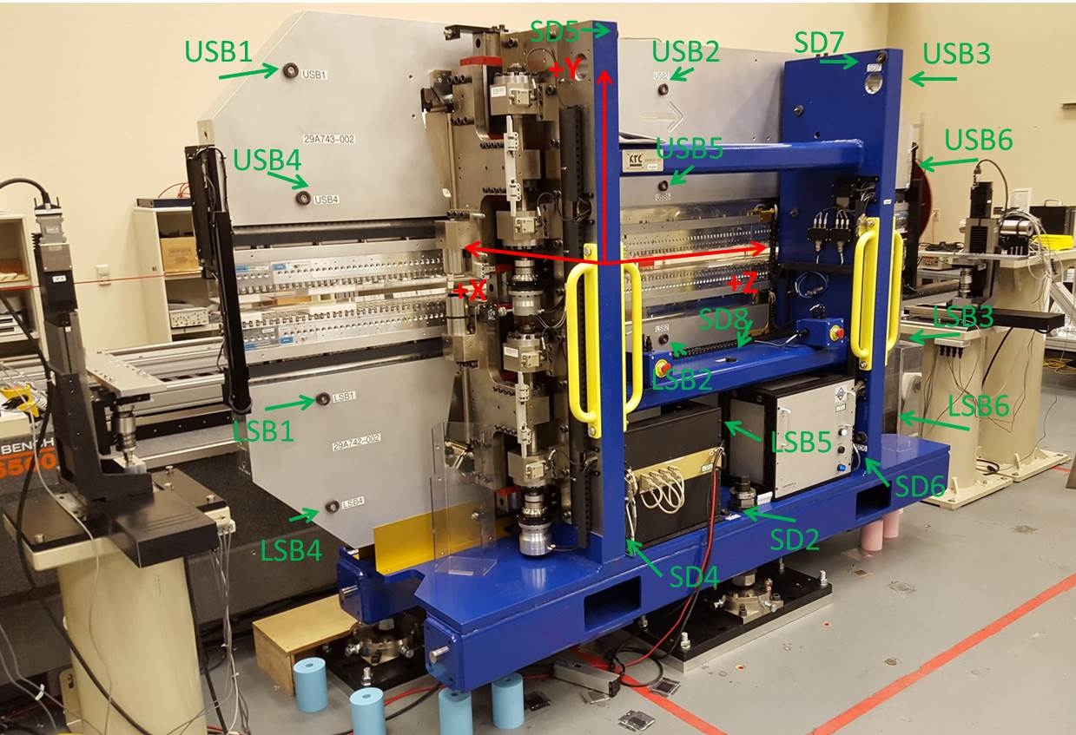

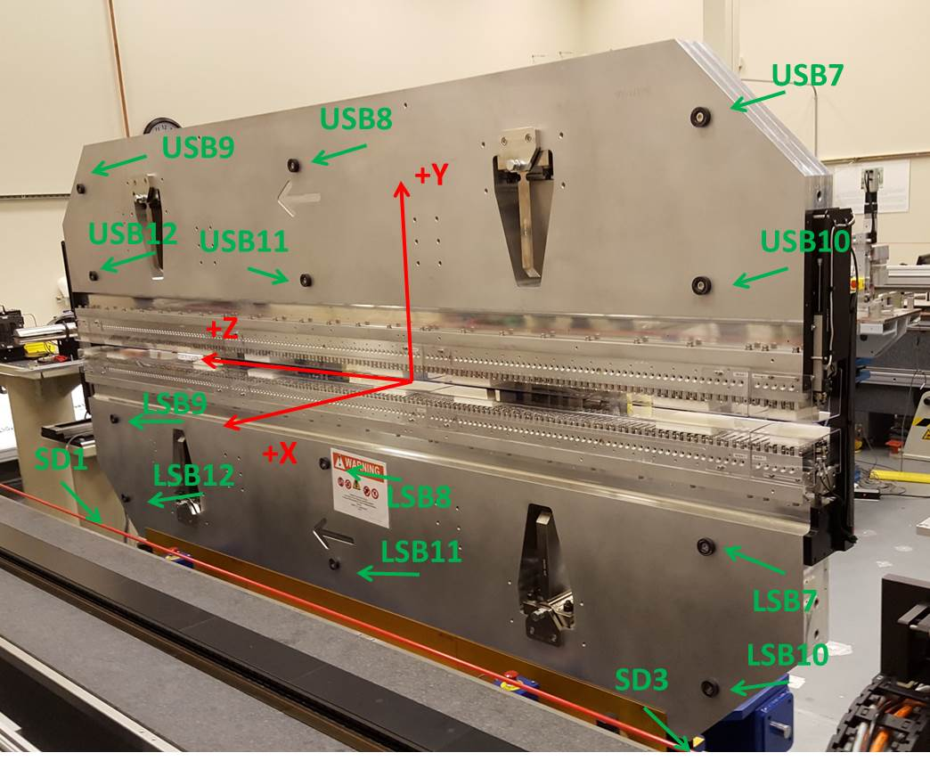

Tooling ball values to center of 1.5 inch sphere, all units are inches. Coordinates are to the SXR Undulator Magnetic Axis.
Tooling Ball | Z (in) | X (in) | Y (in)
LSB1 | -57.4860 | -3.4893 | -10.4741
LSB2 | -0.0083 | -3.4982 | -10.4705
LSB3 | 57.4743 | -3.4853 | -10.4717
LSB4 | -57.4833 | -3.4862 | -24.2541
LSB5 | -0.0073 | -3.4957 | -24.2520
LSB6 | 57.4719 | -3.4840 | -24.2508
LSB7 | -57.4857 | 3.4856 | -10.4691
LSB8 | -0.0061 | 3.4798 | -10.4702
LSB9 | 57.4699 | 3.4889 | -10.4737
LSB10 | -57.4833 | 3.4893 | -24.2498
LSB11 | -0.0054 | 3.4829 | -24.2518
LSB12 | 57.4669 | 3.4898 | -24.2538
SD1 | 50.9881 | 7.2536 | -34.6585
SD2 | -3.9465 | -19.5183 | -34.7148
SD3 | -50.9826 | 7.2424 | -34.6433
SD4 | -25.6436 | -21.7042 | -29.5635
SD5 | -25.6755 | -21.6854 | 29.4790
SD6 | 25.6304 | -21.6659 | -29.5567
SD7 | 25.5877 | -21.7081 | 29.4774
SD8 | -57.4815 | -3.4841 | 24.2532
USB1 | -0.0085 | -3.4577 | 24.2560
USB2 | 57.4665 | -3.4842 | 24.2526
USB3 | -57.4805 | -3.4868 | 10.4757
USB4 | -0.0035 | -3.4606 | 10.4748
USB5 | 57.4682 | -3.4873 | 10.4730
USB6 | -57.4895 | 3.4934 | 24.2499
USB7 | -0.0127 | 3.5102 | 24.2480
USB8 | 57.4668 | 3.4963 | 24.2566
USB9 | -57.4889 | 3.4904 | 10.4767
USB10 | -0.0089 | 3.5073 | 10.4719
USB11 | 57.4687 | 3.4926 | 10.4711
USB12 | 57.4816 | 3.4857 | 10.4730

Center | Z (m) | X (m) | Y (m) | Z (in) | X (in) | Y (in)
PM10M | -2.815025 | -0.026363 | 0.000745 | -110.8278 | -1.0379 | 0.0293
PM11M | 2.727155 | -0.026591 | 0.000505 | 107.3683 | -1.0469 | 0.0199
RFM | -2.670199 | 0.039085 | 0.000032 | -105.1259 | 1.5388 | 0.0013

PM10 and Granite coordinate system with Yurii shifts.
 |  | From Yurii |  |  | Measured
Device | Z (m) | X (m) | Y (m) | Z (m) | X (m) | Y (m) | dX (mm) | dY (mm)
PM10 | -0.368756 | -0.102452 | 0.001083 | -2.815025 | -0.102452 | 0.001083 | 0.000 | 0.000
PM11 | 5.173524 | -0.102690 | 0.000836 | 2.727155 | -0.102680 | 0.000843 | 0.010 | 0.007
RefBlock |  |  |  | -2.670199 | -0.037004 | 0.000370

