LCLS2 SXR Undulator

Alignment Engineering Group
L2?????
SN 29A804-006
January 18, 2018

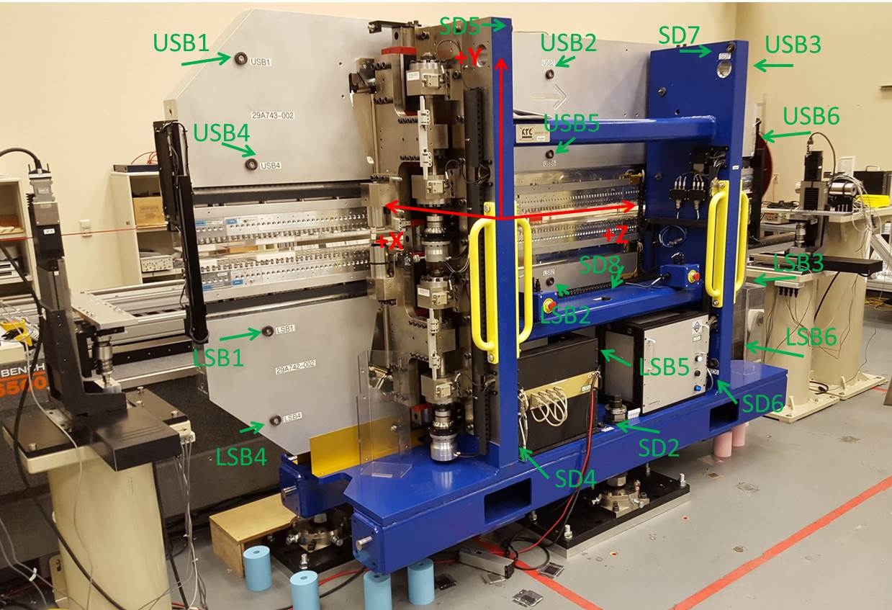

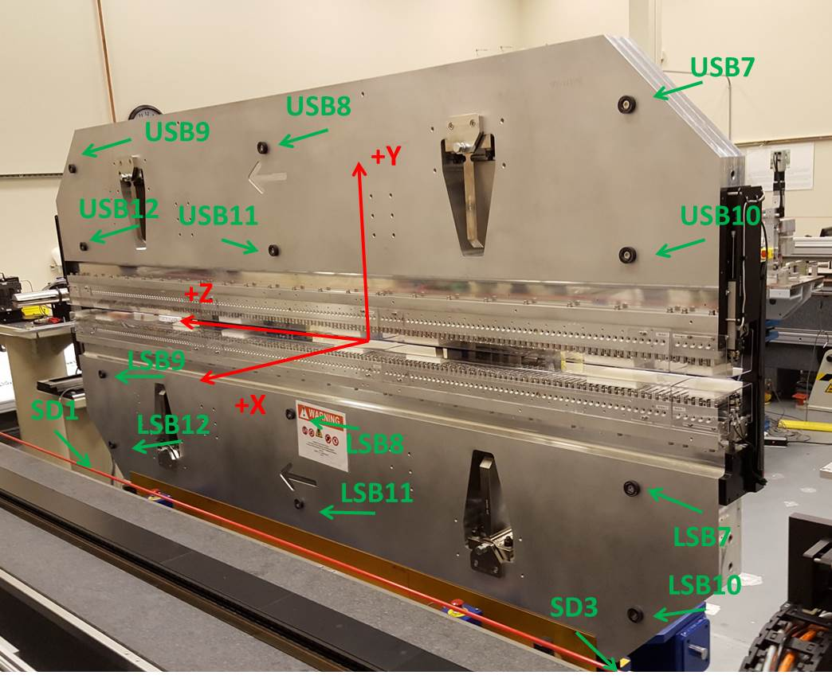

Tooling ball values to center of 1.5 inch sphere, all units are inches. Coordinates are to the SXR Undulator Magnetic Axis.
Tooling Ball | Z (in) | X (in) | Y (in)
LSB1 | -57.4811 | -3.4781 | -10.4732
LSB2 | -0.0093 | -3.4828 | -10.4741
LSB3 | 57.4771 | -3.4908 | -10.4734
LSB4 | -57.4815 | -3.4790 | -24.2535
LSB5 | -0.0042 | -3.4838 | -24.2518
LSB6 | 57.4735 | -3.4919 | -24.2527
LSB7 | -57.4820 | 3.4977 | -10.4724
LSB8 | -0.0050 | 3.4941 | -10.4740
LSB9 | 57.4779 | 3.4844 | -10.4688
LSB10 | -57.4848 | 3.4970 | -24.2527
LSB11 | -0.0148 | 3.4924 | -24.2506
LSB12 | 57.4738 | 3.4839 | -24.2525
SD1 | 50.9829 | 7.2537 | -34.6985
SD2 | -3.9289 | -19.5405 | -34.7529
SD3 | -50.9876 | 7.2269 | -34.7046
SD4 | -25.6069 | -21.7656 | -29.6550
SD5 | -25.6424 | -21.6910 | 29.4555
SD6 | 25.6283 | -21.6591 | -29.5944
SD7 | 25.6170 | -21.6845 | 29.4533
SD8 | 0.0255 | -16.9123 | -12.2998
USB1 | -57.4882 | -3.4875 | 24.2544
USB2 | -0.0080 | -3.4799 | 24.2524
USB3 | 57.4670 | -3.4800 | 24.2549
USB4 | -57.4876 | -3.4910 | 10.4767
USB5 | -0.0083 | -3.4837 | 10.4770
USB6 | 57.4685 | -3.4850 | 10.4776
USB7 | -57.4877 | 3.4874 | 24.2412
USB8 | -0.0093 | 3.4993 | 24.2528
USB9 | 57.4713 | 3.4952 | 24.2535
USB10 | -57.4818 | 3.4837 | 10.4779
USB11 | -0.0050 | 3.4951 | 10.4681
USB12 | 57.4737 | 3.4904 | 10.4775

Center | Z (m) | X (m) | Y (m) | Z (in) | X (in) | Y (in)
PM10M | -2.815242 | -0.026763 | 0.000820 | -110.8363 | -1.0537 | 0.0323
PM11M | 2.726979 | -0.026981 | 0.000992 | 107.3614 | -1.0622 | 0.0391
RFM | -2.670204 | 0.033720 | 0.000073 | -105.1261 | 1.3276 | 0.0029

PM10 and Granite coordinate system with Yurii shifts.
 |  | From Yurii |  |  | Measured
Device | Z (m) | X (m) | Y (m) | Z (m) | X (m) | Y (m) | dX (mm) | dY (mm)
PM10 | -0.366857 | -0.102380 | 0.000986 | -2.815242 | -0.102363 | 0.000970 | 0.017 | -0.016
PM11 | 5.175462 | -0.102564 | 0.001126 | 2.726979 | -0.102581 | 0.001142 | -0.017 | 0.016
RefBlock |  |  |  | -2.670204 | -0.041880 | 0.000223

