LCLS2 SXR Undulator

Alignment Engineering Group
L2?????
SN 29A804-005
February 21, 2018

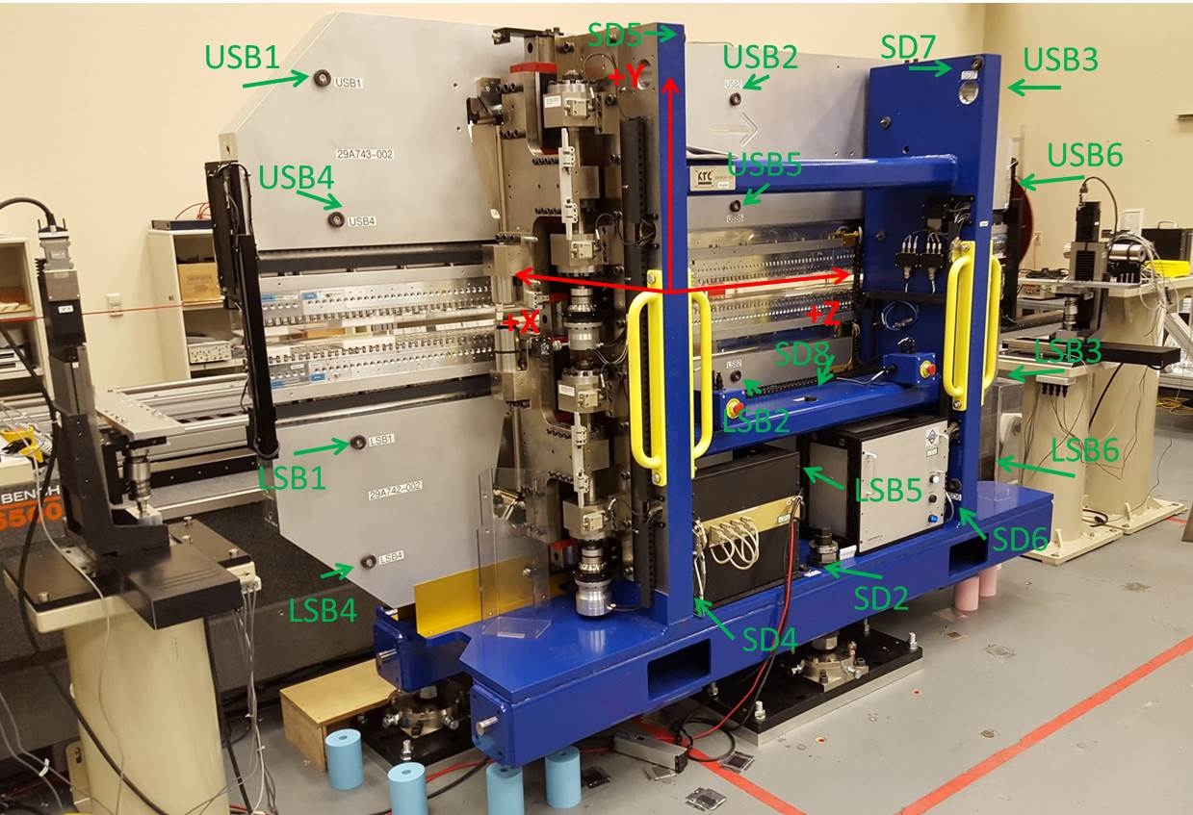

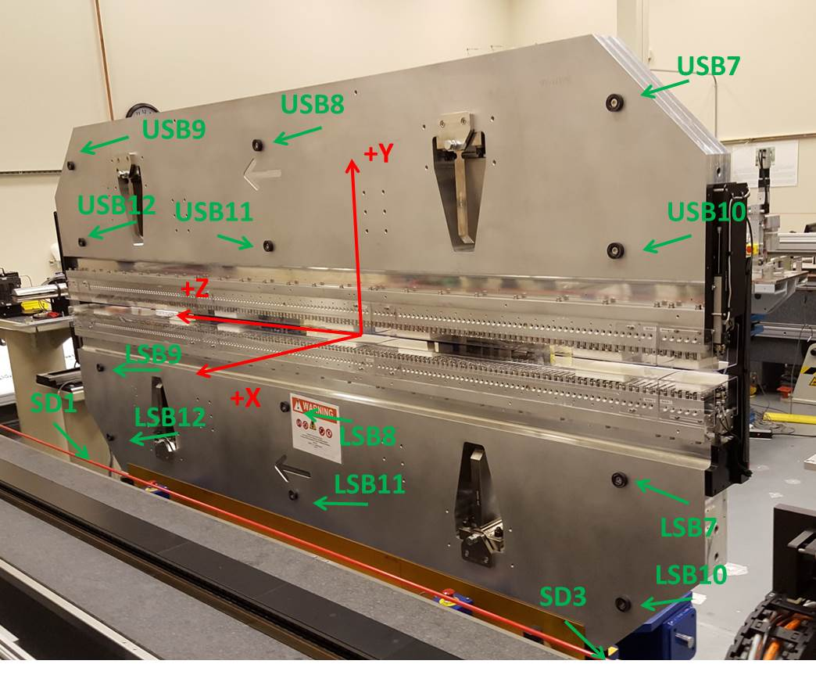

Tooling ball values to center of 1.5 inch sphere, all units are inches. Coordinates are to the SXR Undulator Magnetic Axis.
Tooling Ball | Z (in) | X (in) | Y (in)
LSB1 | -57.4774 | -3.4829 | -10.4759
LSB2 | -0.0016 | -3.4911 | -10.4721
LSB3 | 57.4668 | -3.4900 | -10.4767
LSB4 | -57.4814 | -3.4815 | -24.2589
LSB5 | -0.0087 | -3.4892 | -24.2556
LSB6 | 57.4685 | -3.4870 | -24.2545
LSB7 | -57.4784 | 3.4920 | -10.4825
LSB8 | -0.0102 | 3.4864 | -10.4742
LSB9 | 57.4692 | 3.4867 | -10.4784
LSB10 | -57.4884 | 3.4938 | -24.2503
LSB11 | -0.0069 | 3.4882 | -24.2557
LSB12 | 57.4744 | 3.4900 | -24.2511
SD1 | 50.9821 | 7.2406 | -34.7882
SD2 | -3.9531 | -19.5165 | -34.8218
SD3 | -50.9880 | 7.2539 | -34.7580
SD4 | -25.6615 | -21.6989 | -29.6775
SD5 | -25.6664 | -21.6757 | 29.3848
SD6 | 25.6261 | -21.6623 | -29.6696
SD7 | 25.6217 | -21.7020 | 29.3625
SD8 | -0.0101 | -16.9600 | -12.4759
USB1 | -57.4861 | -3.4893 | 24.2419
USB2 | -0.0058 | -3.4725 | 24.2506
USB3 | 57.4770 | -3.4897 | 24.2528
USB4 | -57.4728 | -3.4880 | 10.4665
USB5 | -0.0051 | -3.4709 | 10.4754
USB6 | 57.4763 | -3.4895 | 10.4715
USB7 | -57.4830 | 3.4880 | 24.2466
USB8 | -0.0059 | 3.5091 | 24.2460
USB9 | 57.4660 | 3.4913 | 24.2513
USB10 | -57.4884 | 3.4878 | 10.4727
USB11 | 0.0016 | 3.5072 | 10.4705
USB12 | 57.4714 | 3.4895 | 10.4633

Center | Z (m) | X (m) | Y (m) | Z (in) | X (in) | Y (in)
PM10M | -2.815041 | -0.026627 | 0.000574 | -110.8284 | -1.0483 | 0.0226
PM11M | 2.727158 | -0.026895 | 0.000358 | 107.3684 | -1.0589 | 0.0141
RFM | -2.670215 | 0.038822 | -0.000130 | -105.1266 | 1.5284 | -0.0051

PM10 and Granite coordinate system with Yurii shifts.
 |  | From Yurii |  |  | Measured
Device | Z (m) | X (m) | Y (m) | Z (m) | X (m) | Y (m) | dX (mm) | dY (mm)
PM10 | -0.368594 | -0.102446 | 0.000967 | -2.815041 | -0.102426 | 0.000952 | 0.020 | -0.015
PM11 | 5.173678 | -0.102674 | 0.000720 | 2.727158 | -0.102694 | 0.000736 | -0.020 | 0.016
RefBlock |  |  |  | -2.670215 | -0.036977 | 0.000248

