LCLS2 SXU 003

Alignment Engineering Group
L2?????
SN 29A804-003
October 20, 2017

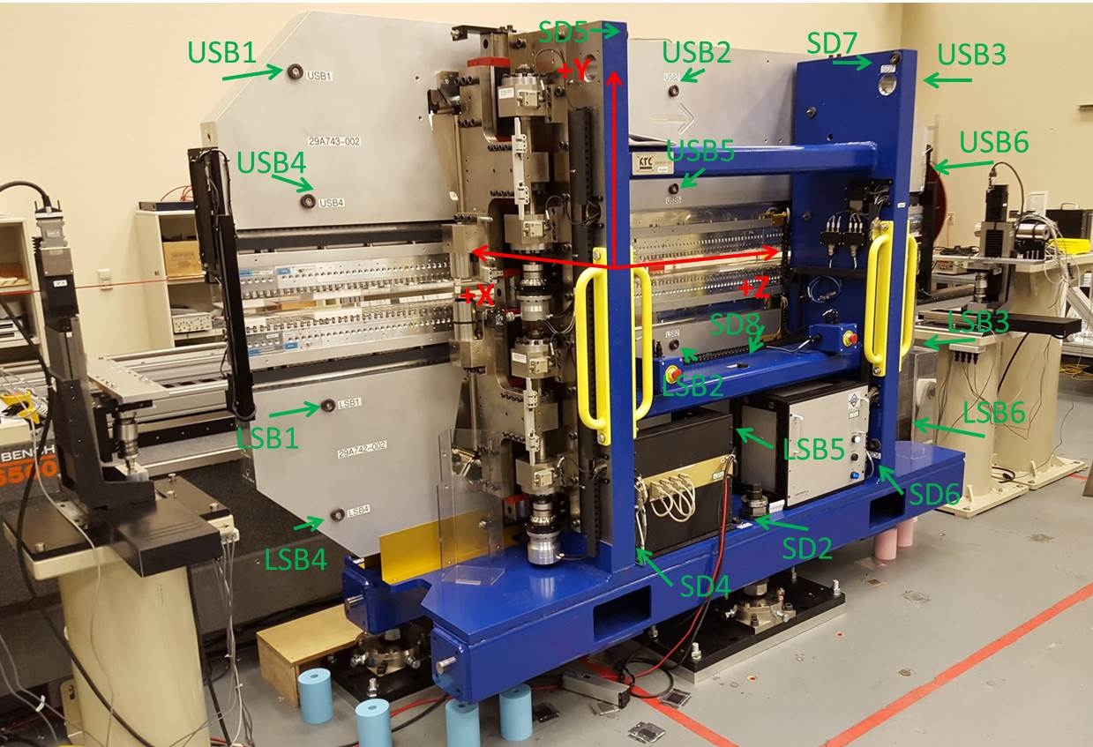

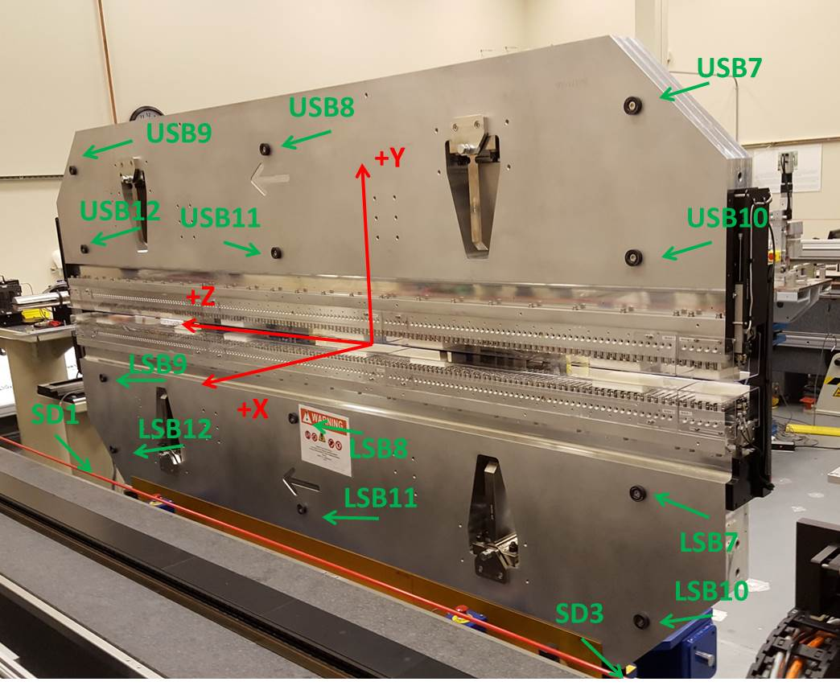

Tooling ball values to center of 1.5 inch sphere, all units are inches. Coordinates are to the SXU Magnetic Axis.
Tooling Ball | Z (in) | X (in) | Y (in)
LSB1 | -57.4509 | -3.4835 | -10.4818
LSB2 | 0.0277 | -3.4720 | -10.4853
LSB3 | 57.5177 | -3.4730 | -10.4816
LSB4 | -57.4443 | -3.4809 | -24.2596
LSB5 | 0.0242 | -3.4729 | -24.2502
LSB6 | 57.5042 | -3.4739 | -24.2456
LSB7 | -57.4442 | 3.4912 | -10.4734
LSB8 | 0.0297 | 3.5009 | -10.4666
LSB9 | 57.5137 | 3.4988 | -10.4700
LSB10 | -57.4468 | 3.4902 | -24.2500
LSB11 | 0.0315 | 3.5025 | -24.2531
LSB12 | 57.4988 | 3.4985 | -24.2546
SD1 | 51.0065 | 7.2428 | -34.6884
SD2 | -3.9209 | -19.5306 | -34.7522
SD3 | -50.9561 | 7.2428 | -34.6873
SD4 | -25.5878 | -21.6862 | -29.6016
SD5 | -25.6363 | -21.6612 | 29.4499
SD6 | 25.6708 | -21.6536 | -29.6094
SD7 | 25.6497 | -21.6955 | 29.4406
SD8 | 0.0291 | -16.9386 | -12.4062
USB1 | -57.4442 | -3.4905 | 24.2460
USB2 | 0.0261 | -3.4746 | 24.2545
USB3 | 57.4970 | -3.4929 | 24.2489
USB4 | -57.4383 | -3.4902 | 10.4792
USB5 | 0.0281 | -3.4739 | 10.4752
USB6 | 57.5000 | -3.4919 | 10.4691
USB7 | -57.4483 | 3.4883 | 24.2520
USB8 | 0.0291 | 3.5043 | 24.2418
USB9 | 57.5028 | 3.4864 | 24.2513
USB10 | -57.4410 | 3.4883 | 10.4730
USB11 | 0.0254 | 3.5061 | 10.4786
USB12 | 57.5133 | 3.4861 | 10.4673

Center | Z (m) | X (m) | Y (m) | Z (in) | X (in) | Y (in)
PM10M | -2.814854 | -0.026514 | 0.000736 | -110.8210 | -1.0439 | 0.0290
PM11M | 2.727440 | -0.026730 | 0.000889 | 107.3795 | -1.0524 | 0.0350
RFM | -2.669812 | 0.033977 | 0.000831 | -105.1107 | 1.3377 | 0.0327

 | Z (m) | X (m) | Y (m) | Z (in) | X (in) | Y (in)
Mechanical Center | 0.011531 | 0.000044 | -0.000030 | 0.4540 | 0.0017 | -0.0012

PM10 and Granite coordinate system with Yurii shifts.
 |  | From Yurii |  |  | Measured
Device | Z (m) | X (m) | Y (m) | Z (m) | X (m) | Y (m) | dX (mm) | dY (mm)
PM10 | -0.369060 | -0.102493 | 0.000994 | -2.814854 | -0.102481 | 0.000989 | 0.012 | -0.005
PM11 | 5.173317 | -0.102684 | 0.001136 | 2.727440 | -0.102697 | 0.001142 | -0.013 | 0.006
Ref Blk |  |  |  | -2.669812 | -0.041990 | 0.001084

