LCLS2 SXR Undulator

Alignment Engineering Group
L2?????
SN 29A804-002
April 18, 2019

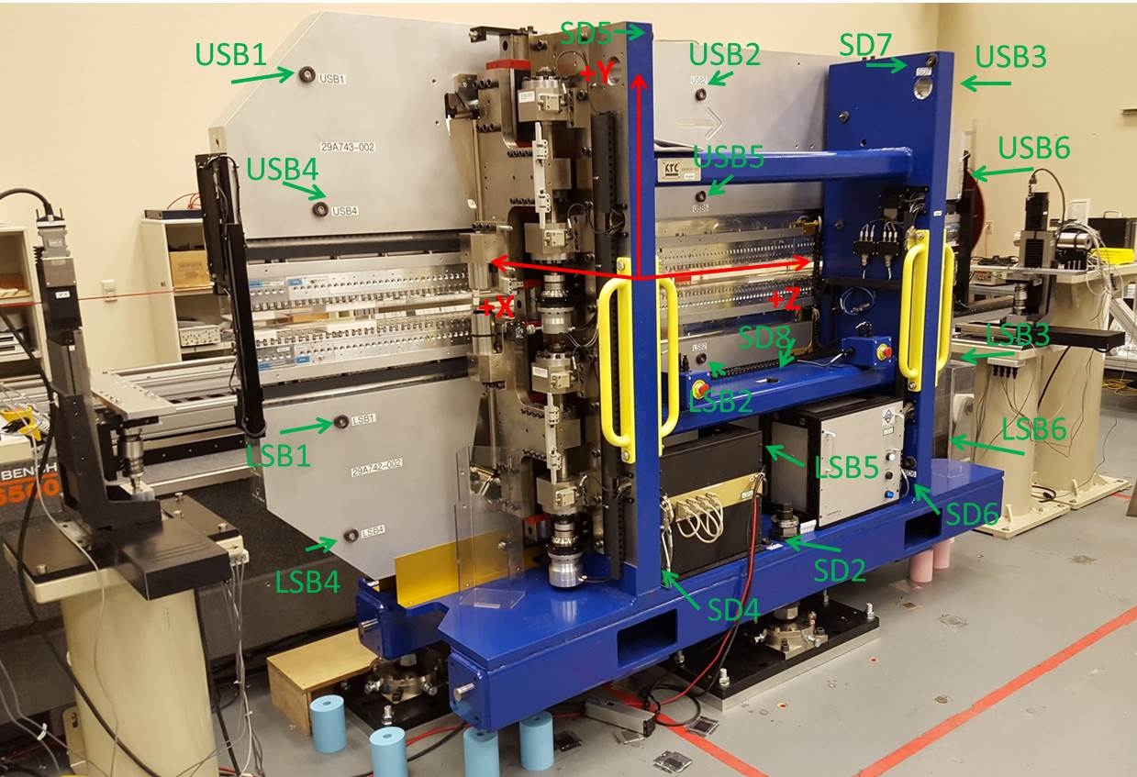

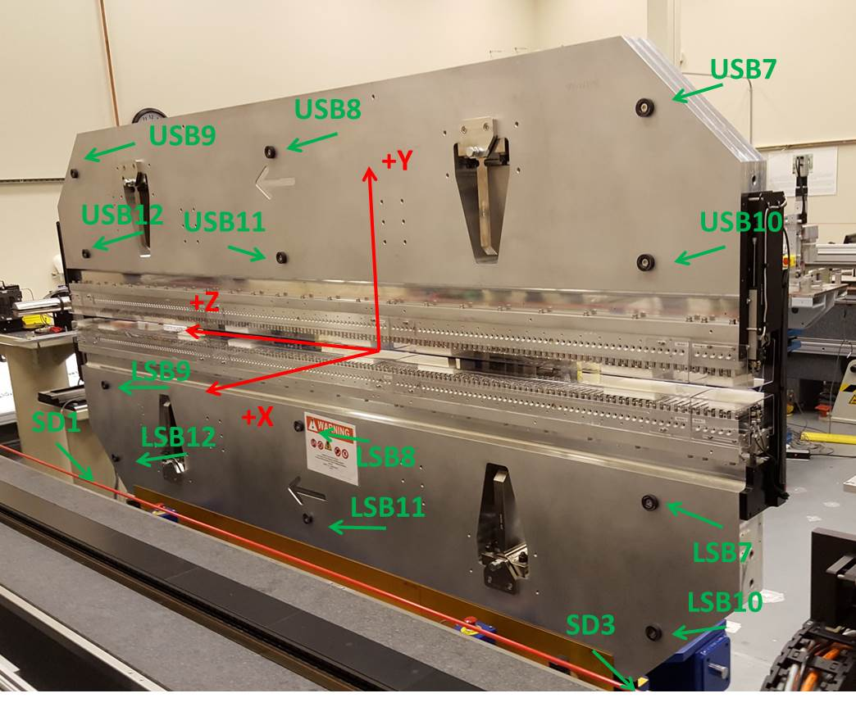

Tooling ball values to center of 1.5 inch sphere, all units are inches. Coordinates are to the SXR Undulator Magnetic Axis.
Tooling Ball | Z (in) | X (in) | Y (in)
LSB1 | -57.4625 | -3.4863 | -10.4740
LSB2 | 0.0104 | -3.4814 | -10.4738
LSB3 | 57.4912 | -3.4798 | -10.4732
LSB4 | -57.4678 | -3.4845 | -24.2550
LSB5 | 0.0067 | -3.4767 | -24.2544
LSB6 | 57.4854 | -3.4769 | -24.2468
LSB7 | -57.4685 | 3.4903 | -10.4706
LSB8 | 0.0035 | 3.4968 | -10.4752
LSB9 | 57.4773 | 3.4968 | -10.4721
LSB10 | -57.4711 | 3.4932 | -24.2478
LSB11 | -0.0007 | 3.5001 | -24.2534
LSB12 | 57.4768 | 3.5003 | -24.2507
SD1 | 50.9466 | 7.2389 | -34.5747
SD2 | -3.9730 | -19.5240 | -34.6301
SD3 | -51.0215 | 7.2444 | -34.5890
SD4 | -25.7589 | -21.7419 | -29.4865
SD5 | -25.7610 | -21.7190 | 29.5274
SD6 | 25.6017 | -21.6968 | -29.4733
SD7 | 25.5972 | -21.7178 | 29.5360
SD8 | -0.0019 | -16.9627 | -12.2143
USB1 | -57.4602 | -3.4818 | 24.2570
USB2 | 0.0102 | -3.4809 | 24.2493
USB3 | 57.4771 | -3.4894 | 24.2550
USB4 | -57.4690 | -3.4810 | 10.4803
USB5 | 0.0037 | -3.4795 | 10.4793
USB6 | 57.4823 | -3.4886 | 10.4772
USB7 | -57.4683 | 3.4992 | 24.2596
USB8 | 0.0044 | 3.5028 | 24.2515
USB9 | 57.4837 | 3.4896 | 24.2534
USB10 | -57.4696 | 3.5004 | 10.4741
USB11 | 0.0046 | 3.5037 | 10.4752
USB12 | 57.4887 | 3.4900 | 10.4774

Center | Z (m) | X (m) | Y (m) | Z (in) | X (in) | Y (in)
PM10M | -2.815811 | -0.026264 | 0.000714 | -110.8587 | -1.0340 | 0.0281
PM11M | 2.726330 | -0.026502 | 0.000462 | 107.3358 | -1.0434 | 0.0182
RFM | -2.671046 | 0.048706 | 0.000048 | -105.1593 | 1.9176 | 0.0019

PM10 and Granite coordinate system with Yurii shifts.
 |  | From Yurii |  |  | Measured
Device | Z (m) | X (m) | Y (m) | Z (m) | X (m) | Y (m) | dX (mm) | dY (mm)
PM10 | -0.368988 | -0.102530 | 0.000862 | -2.815811 | -0.102521 | 0.000856 | 0.009 | -0.006
PM11 | 5.173265 | -0.102750 | 0.000598 | 2.726330 | -0.102759 | 0.000604 | -0.009 | 0.006
RefBlock |  |  |  | -2.671046 | -0.027551 | 0.000190

