LCLS2 SXR Undulator

Alignment Engineering Group
L200112
SN 29A804-001 Repeat5
October 3, 2019

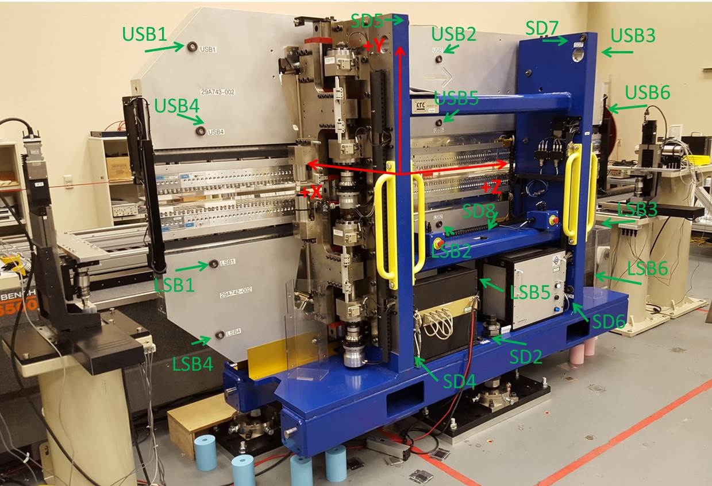

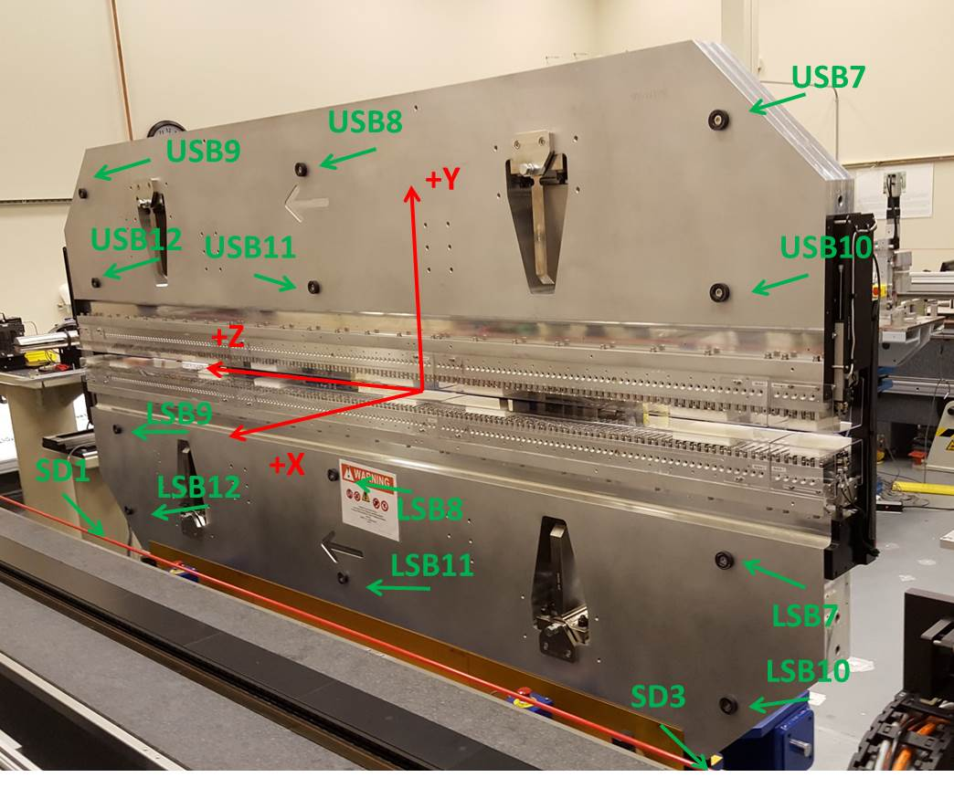

Tooling ball values to center of 1.5 inch sphere, all units are inches. Coordinates are to the SXR Undulator Magnetic Axis.
Tooling Ball | Z (in) | X (in) | Y (in)
LSB1 | -57.4778 | -3.4899 | -10.4713
LSB2 | 0.0037 | -3.5010 | -10.4746
LSB3 | 57.4871 | -3.4909 | -10.4750
LSB4 | -57.4816 | -3.4880 | -24.2576
LSB5 | -0.0022 | -3.4994 | -24.2458
LSB6 | 57.4900 | -3.4896 | -24.2503
LSB7 | -57.4677 | 3.4856 | -10.4737
LSB8 | 0.0092 | 3.4757 | -10.4755
LSB9 | 57.4858 | 3.4843 | -10.4778
LSB10 | -57.4690 | 3.4883 | -24.2536
LSB11 | 0.0048 | 3.4774 | -24.2578
LSB12 | 57.4859 | 3.4859 | -24.2561
SD1 | 50.9613 | 7.2249 | -34.7535
SD2 | -3.9652 | -19.5320 | -34.8209
SD3 | -51.0000 | 7.2353 | -34.7845
SD4 | -25.7433 | -21.7148 | -29.6749
SD5 | -25.7747 | -21.6991 | 29.3894
SD6 | 25.6088 | -21.6989 | -29.6591
SD7 | 25.6054 | -21.6970 | 29.3849
SD8 | 0.0084 | -16.9120 | -12.4397
USB1 | -57.4676 | -3.4859 | 24.2522
USB2 | 0.0076 | -3.4803 | 24.2564
USB3 | 57.4852 | -3.4916 | 24.2604
USB4 | -57.4659 | -3.4893 | 10.4750
USB5 | 0.0047 | -3.4842 | 10.4806
USB6 | 57.4851 | -3.4930 | 10.4777
USB7 | -57.4678 | 3.4896 | 24.2513
USB8 | 0.0066 | 3.4949 | 24.2470
USB9 | 57.4813 | 3.4855 | 24.2520
USB10 | -57.4672 | 3.4864 | 10.4722
USB11 | 0.0107 | 3.4919 | 10.4685
USB12 | 57.4818 | 3.4826 | 10.4745

Center | Z (m) | X (m) | Y (m) | Z (in) | X (in) | Y (in)
PM10M | -2.815699 | -0.026390 | 0.000684 | -110.8543 | -1.0390 | 0.0269
PM11M | 2.726475 | -0.026627 | 0.000474 | 107.3415 | -1.0483 | 0.0187
RFM | -2.670935 | 0.048581 | 0.000022 | -105.1549 | 1.9126 | 0.0009

PM10 and Granite coordinate system with Yurii shifts.
 |  | From Yurii |  |  | Measured
Device | Z (m) | X (m) | Y (m) | Z (m) | X (m) | Y (m) | dX (mm) | dY (mm)
PM10 | -0.369358 | -0.102530 | 0.000718 | -2.815699 | -0.102544 | 0.000710 | -0.014 | -0.008
PM11 | 5.173848 | -0.102796 | 0.000492 | 2.726475 | -0.102781 | 0.000500 | 0.015 | 0.008
RefBlock |  |  |  | -2.670935 | -0.027573 | 0.000048

