LCLS2 SXR Undulator

Alignment Engineering Group
L2?????
SN 29A804-001
September 20, 2018

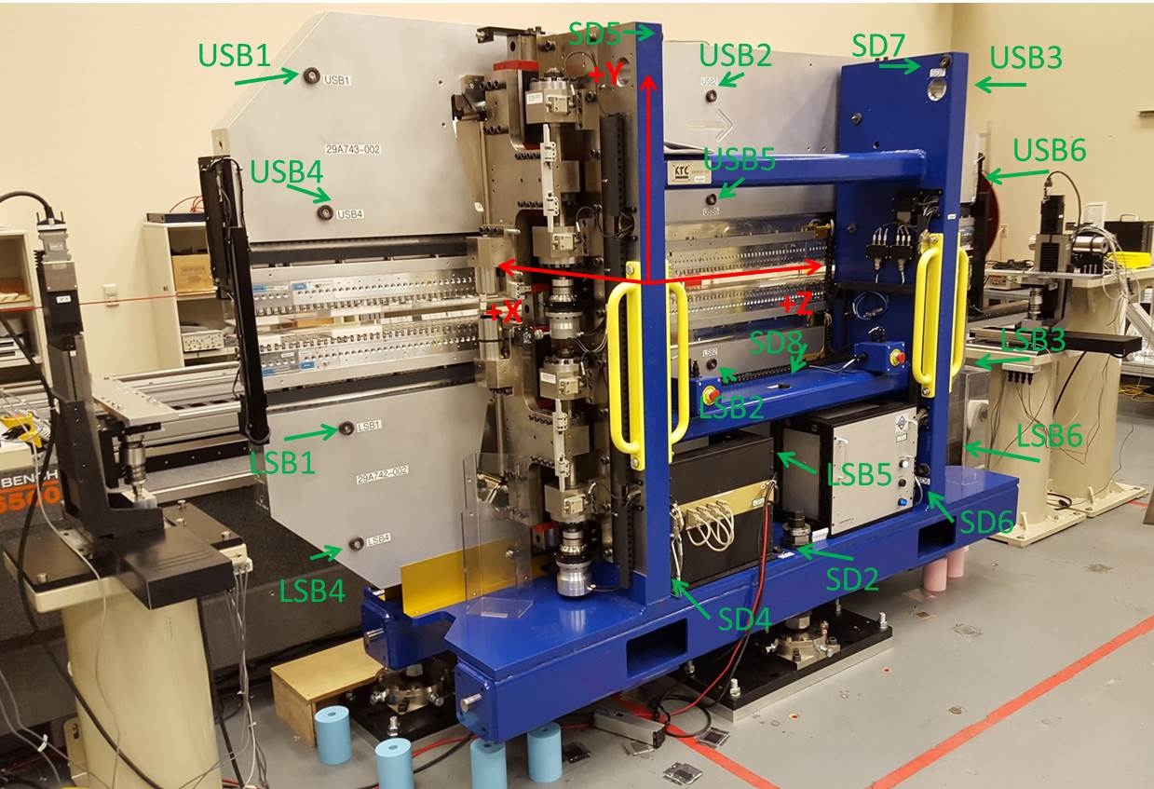

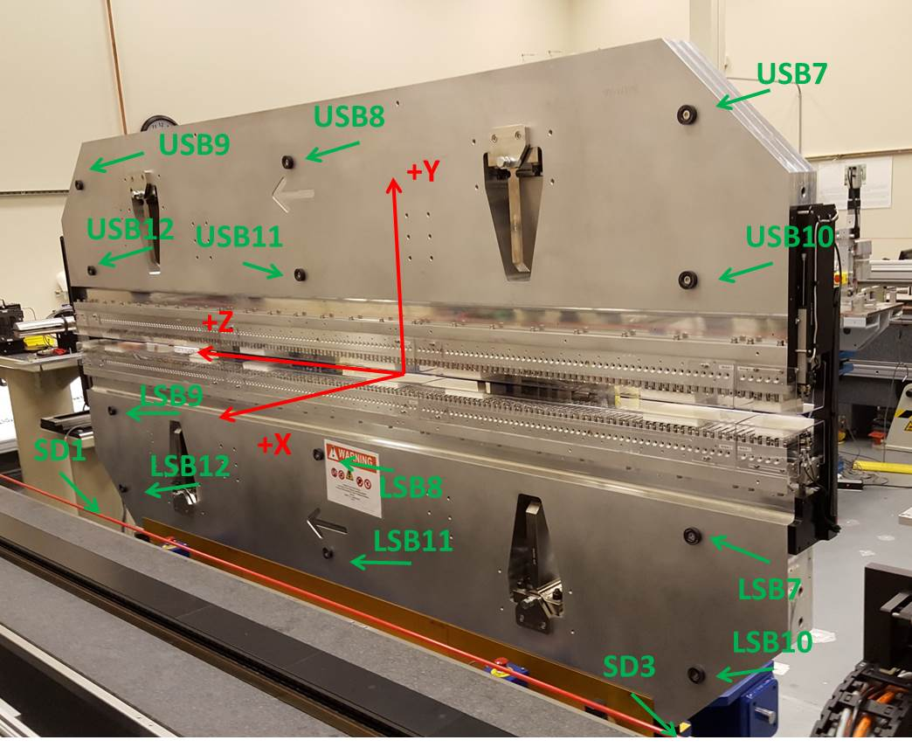

Tooling ball values to center of 1.5 inch sphere, all units are inches. Coordinates are to the SXR Undulator Magnetic Axis.
Tooling Ball | Z (in) | X (in) | Y (in)
LSB1 | -57.4823 | -3.4876 | -10.4700
LSB2 | -0.0005 | -3.5002 | -10.4736
LSB3 | 57.4830 | -3.4915 | -10.4743
LSB4 | -57.4866 | -3.4853 | -24.2561
LSB5 | -0.0069 | -3.4980 | -24.2448
LSB6 | 57.4851 | -3.4897 | -24.2504
LSB7 | -57.4722 | 3.4876 | -10.4719
LSB8 | 0.0050 | 3.4768 | -10.4741
LSB9 | 57.4818 | 3.4837 | -10.4775
LSB10 | -57.4737 | 3.4910 | -24.2523
LSB11 | 0.0006 | 3.4791 | -24.2567
LSB12 | 57.4815 | 3.4866 | -24.2554
SD1 | 50.9559 | 7.2259 | -34.7541
SD2 | -3.9708 | -19.5300 | -34.8202
SD3 | -51.0054 | 7.2381 | -34.7800
SD4 | -25.7489 | -21.7126 | -29.6728
SD5 | -25.7774 | -21.6992 | 29.3916
SD6 | 25.6035 | -21.6979 | -29.6593
SD7 | 25.6030 | -21.6981 | 29.3850
SD8 | 0.0040 | -16.9111 | -12.4386
USB1 | -57.4706 | -3.4850 | 24.2502
USB2 | 0.0048 | -3.4806 | 24.2543
USB3 | 57.4824 | -3.4931 | 24.2577
USB4 | -57.4691 | -3.4881 | 10.4729
USB5 | 0.0020 | -3.4841 | 10.4784
USB6 | 57.4822 | -3.4940 | 10.4749
USB7 | -57.4706 | 3.4905 | 24.2499
USB8 | 0.0040 | 3.4945 | 24.2457
USB9 | 57.4789 | 3.4841 | 24.2499
USB10 | -57.4703 | 3.4876 | 10.4706
USB11 | 0.0080 | 3.4920 | 10.4666
USB12 | 57.4793 | 3.4818 | 10.4721

Center | Z (m) | X (m) | Y (m) | Z (in) | X (in) | Y (in)
PM10M | -2.815597 | -0.026417 | 0.000673 | -110.8503 | -1.0400 | 0.0265
PM11M | 2.726651 | -0.026644 | 0.000438 | 107.3485 | -1.0490 | 0.0172
RFM | -2.670837 | 0.048557 | 0.000018 | -105.1511 | 1.9117 | 0.0007

PM10 and Granite coordinate system with Yurii shifts.
 |  | From Yurii |  |  | Measured
Device | Z (m) | X (m) | Y (m) | Z (m) | X (m) | Y (m) | dX (mm) | dY (mm)
PM10 | -0.368840 | -0.102506 | 0.000869 | 0.36884 | -0.102488 | 0.000878 | -0.018 | -0.009
PM11 | 5.173508 | -0.102720 | 0.000653 | 5.91111 | -0.102739 | 0.000644 | 0.019 | 0.009
RefBlock |  |  |  | 0.513599 | -0.027516 | 0.000218

