LCLS2 SXR Undulator

Alignment Engineering Group
L200112
SN 29A804-001 Repeat
March 05, 2018

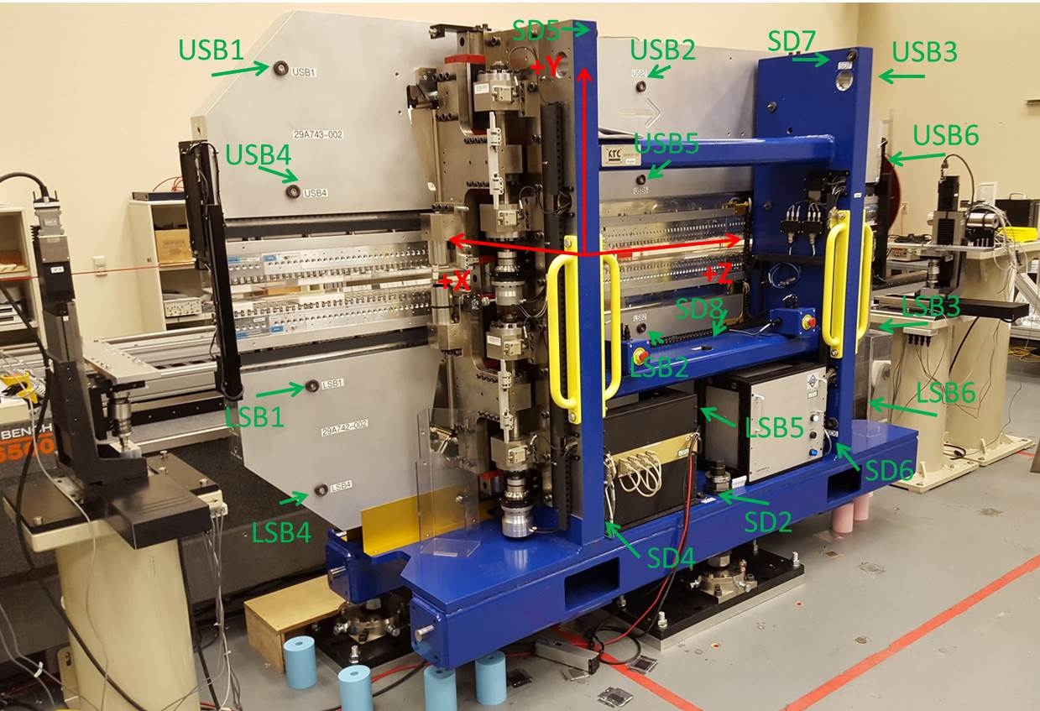

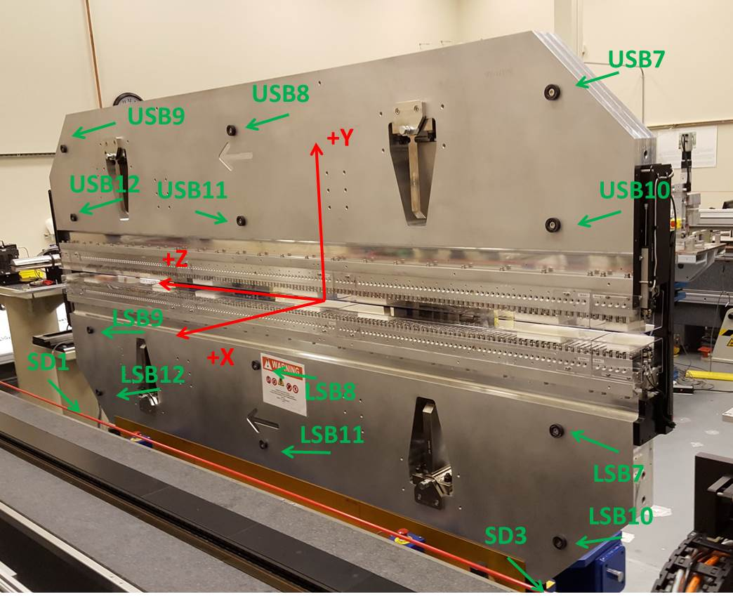

Tooling ball values to center of 1.5 inch sphere, all units are inches. Coordinates are to the SXR Undulator Magnetic Axis.
Tooling Ball | Z (in) | X (in) | Y (in)
LSB1 | -57.4772 | -3.4892 | -10.4688
LSB2 | 0.0044 | -3.5011 | -10.4730
LSB3 | 57.4880 | -3.4919 | -10.4735
LSB4 | -57.4810 | -3.4872 | -24.2550
LSB5 | -0.0017 | -3.4997 | -24.2438
LSB6 | 57.4904 | -3.4910 | -24.2493
LSB7 | -57.4668 | 3.4874 | -10.4715
LSB8 | 0.0102 | 3.4767 | -10.4735
LSB9 | 57.4867 | 3.4842 | -10.4770
LSB10 | -57.4686 | 3.4893 | -24.2515
LSB11 | 0.0058 | 3.4774 | -24.2561
LSB12 | 57.4865 | 3.4855 | -24.2551
SD1 | 50.9611 | 7.2244 | -34.7539
SD2 | -3.9660 | -19.5319 | -34.8181
SD3 | -51.0001 | 7.2355 | -34.7794
SD4 | -25.7436 | -21.7144 | -29.6707
SD5 | -25.7724 | -21.6969 | 29.3937
SD6 | 25.6085 | -21.6994 | -29.6570
SD7 | 25.6081 | -21.6956 | 29.3869
SD8 | 0.0093 | -16.9116 | -12.4363
USB1 | -57.4646 | -3.4836 | 24.2520
USB2 | 0.0102 | -3.4791 | 24.2554
USB3 | 57.4876 | -3.4915 | 24.2590
USB4 | -57.4633 | -3.4877 | 10.4743
USB5 | 0.0071 | -3.4835 | 10.4791
USB6 | 57.4877 | -3.4932 | 10.4756
USB7 | -57.4652 | 3.4922 | 24.2501
USB8 | 0.0093 | 3.4968 | 24.2468
USB9 | 57.4842 | 3.4868 | 24.2500
USB10 | -57.4649 | 3.4889 | 10.4711
USB11 | 0.0134 | 3.4933 | 10.4676
USB12 | 57.4844 | 3.4834 | 10.4727

Center | Z (m) | X (m) | Y (m) | Z (in) | X (in) | Y (in)
PM10M | -2.814896 | -0.026567 | 0.000596 | -110.8227 | -1.0459 | 0.0235
PM11M | 2.727275 | -0.026831 | 0.000359 | 107.3730 | -1.0563 | 0.0141
RFM | -2.670086 | 0.038882 | -0.000118 | -105.1215 | 1.5308 | -0.0046

PM10 and Granite coordinate system with Yurii shifts.
 |  | From Yurii |  |  | Measured
Device | Z (m) | X (m) | Y (m) | Z (m) | X (m) | Y (m) | dX (mm) | dY (mm)
PM10 | -0.368967 | -0.102466 | 0.001059 | -2.814896 | -0.102444 | 0.001053 | 0.022 | -0.006
PM11 | 5.173308 | -0.102686 | 0.000809 | 2.727275 | -0.102708 | 0.000816 | -0.022 | 0.007
RefBlock |  |  |  | -2.670086 | -0.036995 | 0.000339

