Field integrals by Hall probe
At 7.3mm gap

At 9mm gap

X-trajectory at 7.3 mm gap

X-trajectory at 9.0 mm gap

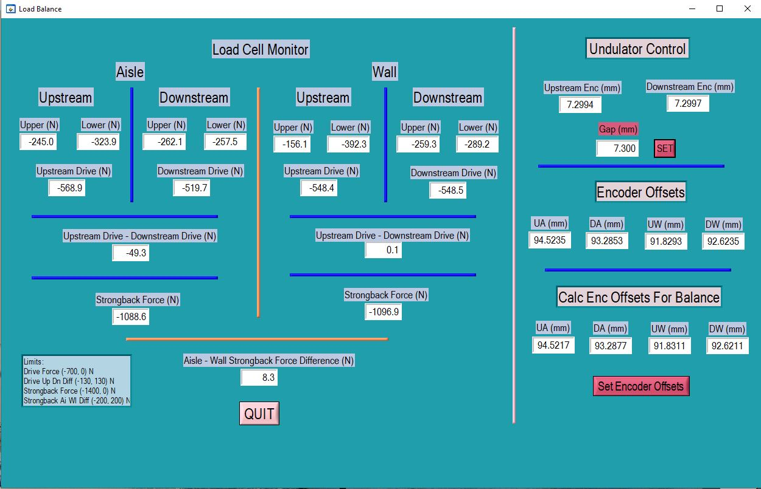
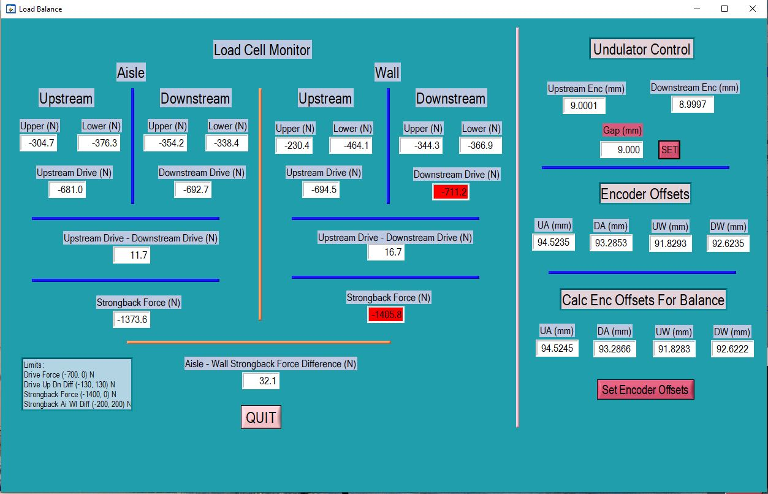
Load balancee out of tolerance at 9mm gap (see red).

