SLAC Magnetic Measurement Plan for
LCLS-II Solenoid Bucking Coil (DSG-000048059)

This traveler is intended to cover mechanical fiducialization and magnetic measurements of the LCLS-II Solenoid Bucking Coil, SOL2BKB, which will replace the LBL style bucking coil design. This will be designated 2SOLBC7.6. The magnet will be installed in the LCLS-II Spare electron gun.

Receiving:
The following information is to be noted upon receipt of the magnet by the SLAC MM group:
Received by (initials): | SDA
Date received (mm/dd/yyyy): | 9/16/2025
SLAC barcode number: | 4133
Serial number on the magnet: | N/A

Fiducialization:
Use a FARO arm and/or optical tooling to set the measurements probes for this magnet. The probe will be set to the mechanical centerline of the inner surface of the bobbin. The leads of the bucking solenoid should be set +y (12 o’clock).
Magnetic Measurements:
Enter URL of on-line magnetic measurements data (please modify or correct if necessary):
http://www-group.slac.stanford.edu/met/MagMeas/MAGDATA/LCLS-II/Solenoid/4133

- Measure the inductance and resistance of the magnet:
Inductance of coil (mH): | 0.987 mH
Resistance of coil (Ohms): | 0.2593 Ohm
Ambient temperature in degrees C | 24.7 ºC

- Determine the connection polarity (with main supply outputting positive current) which produces a “positive” field polarity for SOL2BKB as shown below:

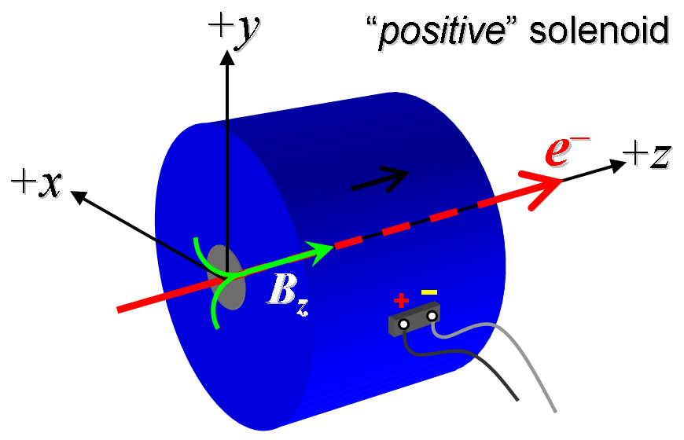
Figure 1. The magnet 2SOLBC7.6 is “positive”.

- Mark the polarity near the magnet leads with clear “+” and “−” labels as shown above.
Magnet polarity chosen from Fig. 1 is (P): | P

- Run the magnet up to 5 A for 2 hours to warm it up (magnet coil temperature). Use a linear ramp rate of 1 A/sec.
Top of Coil (°C) | 35.94 °C
Ambient temperature (°C): | 28.42 °C

- Measure the Bx, By and Bz at 5 amps from bobbin face, opposite the leads, along the center line of the solenoid in 2 mm steps for 152 mm from the bobbin face. Repeat the measurement at 0 amps. See green line below.

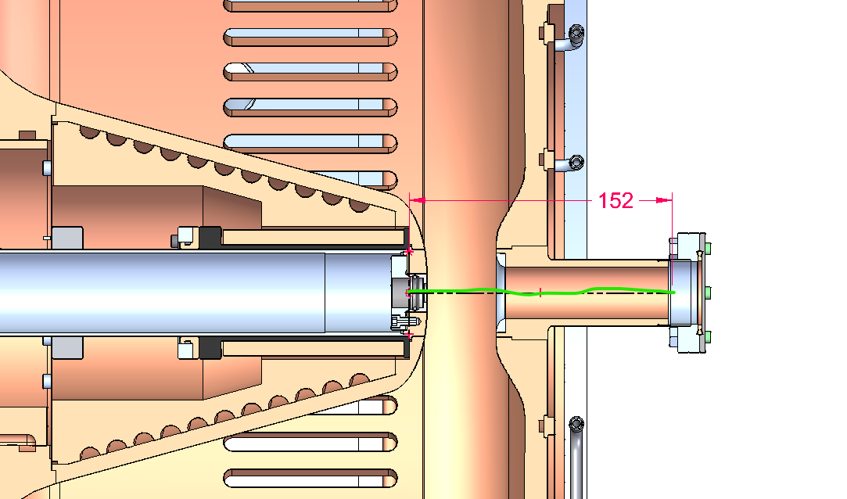
Filename of Bx,y,z vs Z data at 5 amps: | bhxyzvsxyzdat.ru2
Filename of Bx,y,z vs Z data at 0 amps: | bhxyzvsxyzdat.ru1

- Upon completion of tests, email URL of on-line data to Julian Merrick. Julian Merrick will determine if the magnet is accepted. Upon acceptance of magnet, analysis data will be placed in on-line data folder.
Magnet accepted and Analysis file(s) put into on-line data folder (initials):
Assigned beamline location (MAD-deck name): | SOL2BKB

