SLAC Traveler for LCLS-II Speader Area 0.625SD38.98, SA-375-150-75 Septum Magnets
(June 26, 2019)

This traveler is intended to cover mechanical fiducialization, and magnetic measurements of the two Spreader Area septum magnets BLXSPH & BLXSPS. These magnets are part of the Beam Spreader line and each is paired with a kicker. Both septa have a round field free channel and a rectangular channel whose field will kick the beam. The table below gives the MAD names, model drawing numbers, polarities, and installation directions of the septa.
MAD Name | Eng. Name | Drawing# | Barcode | Polarity | Terminals
BLXSPH | 0.625SD38.98 | SA-375-150-75 | 4585 | P | downstream
BLXSPS | 0.625SD38.98 | SA-375-150-75 | 4586 | N | downstream
Table 1: Spreader Area Septa Parameters.
Receiving:
The following information is to be noted upon receipt of the magnets by the SLAC MM group:
Received by (initials): | SDA
Date placed on test stand (dd-mmm-yyyy): | 7/24/2019
SLAC barcode number: | 4585
Serial number from magnet label: | 3
SLAC approved electrical safety covers? (Y or N): | N

Fiducialization:
Fiducialization will be done before magnetic measurements by the CMM or Alignment group. This will require the installation of removable tooling balls, location of the geometric axis of the poles of the magnet, and location of tooling balls with respect to the center of this geometric axis when the poles are aligned precisely horizontal. The pole gap should also be measured.

CMM technician (initials): | HI

URL of on-line CMM fiducialization data (please modify or correct if necessary):
http://www-group.slac.stanford.edu/met/MagMeas/MAGDATA/LCLS-II/Fiducial%20Reports/

Magnetic Measurements:
Enter URL of on-line magnetic measurements data (please modify or correct if necessary):
http://www-group.slac.stanford.edu/met/MagMeas/MAGDATA/LCLS-II/Septum/4585

- A beam direction arrow, with text “Beam Direction”, is to be applied to the top and/or connector side of the magnet with a sticker supplied by LCLS-II. The terminals shall be oriented down beam. The MAD name label should also be attached to the magnet. Polarity in the rectangular bending field channel should be verified, as shown below with the current polarity marked near the magnet leads with clear “+” and “-” labels.

Beam Direction and MAD name marked (initials): | SDA
Polarity marked according Table 1 parameters and to Fig. 1: | P

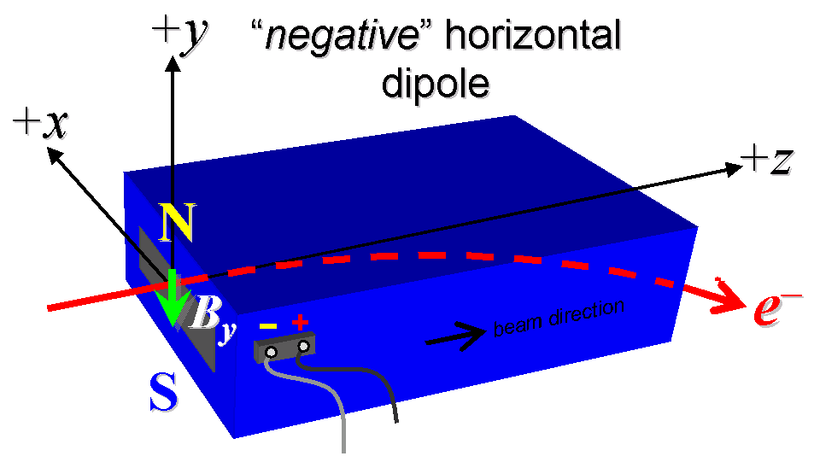

Figure 1 BLXSPH is “positive” polarity (bending electrons left or up) and BLXSPS is “negative” polarity (bending electrons right or down).

- Mark the trim leads with clear “+” and “−” labels such that, with the trim supply outputting positive current, the trim coil increases the absolute value of the magnetic field established by the main coil.
Trim coil polarity chosen from Fig. 1 is (P or N): | P

- Measure the inductance and resistance of the main and trim magnet coils:
Inductance of main coil (mH): | 1.0398 mH
Resistance of main coil (Ohms): | 0.0346 Ohm
Inductance of trim coil (mH): | 0.296 mH
Resistance of trim coil (Ohms): | 0.1100 Ohm

- Connect the magnet terminals, in the correct polarity as established above, to a unipolar (or bipolar) power supply with maximum current I ≥ 130 A.

- Connect magnet to LCW supply. Adjust supply pressure to a delta P of ~51 psi to achieve a flow rate of 0.46 gpm. Run the magnet up to 130 A for ~1 hour to warm it up (record, delta P, flow rate, and magnet coil and steel temperature).
LCW delta P (psi) | 117 psi
LCW flow rate (gpm) | 0.38 gpm
LCW delta T (°C) | 3.96 °C
Ambient temperature (°C): | 28.2 °C
Final magnet steel temperature (°C): | 27.9 °C

- Ramp the main of the magnet to 130 A and measure the pole tip field. It should be > 0.387 Tesla.
Pole Tip Field and Current | 0.45505 T @ 130.05401 Amps

- Ramp the main of the magnet to 0 A and then ramp the trim to +6 A and measure the pole tip field. After measurement turn off trim supply.
Trim Pole Tip Field and Current | 0.01181T @ 6.00380 Amps

- Standardize the magnet, starting from 0 to 130 A and back to zero, through three full cycles, finally ending at zero, with a flat-top pause time (at both 0 and 130 A) of 10 seconds. Use a three-linear ramp rate of 10 A/sec, record the ramp rate used.
Standardization complete (initials): | SDA
Ramp rate used (A/sec): | 10 A/s

- Align the stretched wire in the rectangular bending field channel. Measure the length-integrated vertical dipole field, ∫B_{y}dl, from 0 to 130 A in the rectangular bending field channel in 10-A steps, including zero (14 ‘up’ measurements). Then, still maintaining the cycle history, measure ∫B_{y}dl back down from 130 A to 0 in 10-A steps, including zero (13 ‘down’ measurements).
Filename & run number of ∫B_{y}dl up & down data: | Wiredat.ru1, wireplt.ru1

- Still maintaining the cycle history, run the main coil up to 130 A, pause at least 10 seconds, and measure ∫B_{y}dl in the rectangular bending field channel as a function of trim coil current from 0 to -6 A in 0.5-A steps, including zero (13 down measurements), and again from -6 to +6 A in 0.5-A steps (25 up measurements). Set the trim current back to 0. Use a 0.6 A/s linear ramp rate with a 10 second settle time for the trim.
Filename & run # of ∫B_{y}dl trim data at I_{main} = 130 A: | Wiredat.ru2, wireplt.ru2

- Set the main coil to 0 current after standardizing. Measure ∫B_{y}dl in the rectangular bending field channel as a function of trim coil current from 0 to −6 in 0.5-A steps, including zero (13 ‘down’ measurements), and again from −6 to +6 A in 0.5-A steps (25 ‘up’ measurements). Set the trim current to 0.
Filename & run # of ∫B_{y}dl trim data at I_{main} = 0: | Wiredat.ru3, wireplt.ru3

- With the main coil at 130 A, measure the length-integrated vertical field at multiple x positions in the rectangular bending field channel. With the wire located at the vertical mid-plane (y = 0), measure the vertical length-integrated field at each 3-mm step of horizontal wire position, from x = −21 mm to +21 mm, with x = 0 centered at the magnet’s horizontal center. Record data file name:
Filename of ∫B_{y}dl vs x data at 130 A: | Wirevsx.ru1, wirepltvsx.ru1

- Align the stretched wire into field free round channel. Standardize the magnet and measure ∫B_{y}dl in the field free channel as a function of main coil current at 0, 50, 100 and 130 A steps. Also measure the ∫B_{y}dl in the field free channel with the main power supply off.
Filename of ∫B_{y}dl vs main current in field free region: | Wiredat.ru4, wireplt.ru4

- Standardize the magnet and set the main coil to 0 A, then measure ∫B_{y}dl in the field free channel as a function of trim coil current from 0 to -6 in -2 A steps, including zero 4 ‘down’ measurements), and again from -6 to 6 A in 2 A steps (5 ‘up’ measurements). Set the trim current to 0.
Filename of ∫B_{y}dl in field free region with Main at 0 A vs trim current | Wiredat.ru5, wireplt.ru5
- Standardize the magnet and set the main coil to 130 A, then measure ∫B_{y}dl in the field free channel as a function of trim coil current from 0 to -6 in -2 A steps, including zero (4 ‘down’ measurements), and again from -6 to 6 A in 2 A steps (6 ‘up’ measurements). Set the trim current to 0.
Filename of ∫B_{y}dl in field free region with Main at 130 A vs trim current | Wiredat.ru6, wireplt.ru6

- Standardize the magnet and set the main coil to 130 A, then measure ∫B_{y}dl in the field free channel vs X from -6 to + 6 mm in 2 mm steps.
Filename of ∫B_{y}dl vs X in field free region with Main at 130 A | Wirevsx.ru7, wirepltvsx.ru7

- Standardize the magnet and measure ∫B_{X}dl in the field free channel as a function of main coil current at 0, 50, 100, and 130 A steps. Also measure the ∫B_{X}dl in the field free channel with the main power supply off.
Filename of ∫B_{x}dl vs main current in field free region: | Wiredat.ru8, wireplt.ru8

- Standardize the magnet and set the main coil to 0 A, then measure ∫B_{X}dl in the field free channel as a function of trim coil current from 0 to -6 in -2 A steps, including zero (4 ‘down’ measurements), and again from -6 to 6 A in 2 A steps (6 ‘up’ measurements). Set the trim current to 0.
Filename of ∫B_{X}dl with Main at 0 A vs trim current in field free region: | Wiredat.ru9, wireplt.ru9

- Standardize the magnet and set the main coil to 130 A, then measure ∫B_{X}dl in the field free channel as a function of trim coil current from 0 to -6 in -2 A steps, including zero (4 ‘down’ measurements), and again from -6 to 6 A in 2 A steps (6 ‘up’ measurements). Set the trim current to 0.
Filename of ∫B_{X}dl with Main at 130 A vs trim current in field free region: | Wiredat.r10, wireplt.r10

- Standardize the magnet and set the main coil to 130 A, then measure ∫B_{x}dl in the field free channel vs Y from -6 to + 6 mm in 2 mm steps.
Filename of ∫B_{y}dl vs X in field free region with Main at 130 A | Wirevsx.r11, wirepltvsx.r11

- Upon completion of tests, send data link to Mark Woodley who will produce a data analysis file. Place data analysis file in magnetic measurements data directory
Magnet data accepted and data analysis file produced | SDA

Enter URL of on-line magnetic measurements analysis data :
http://www-group.slac.stanford.edu/met/MagMeas/MAGDATA/LCLS-II/Septum/4585/BLXSPH.pptx

