LCLS2 SX Phase Shifter

Alignment Engineering Group
L200383
SN SXPS-16347
Dec 19, 2017

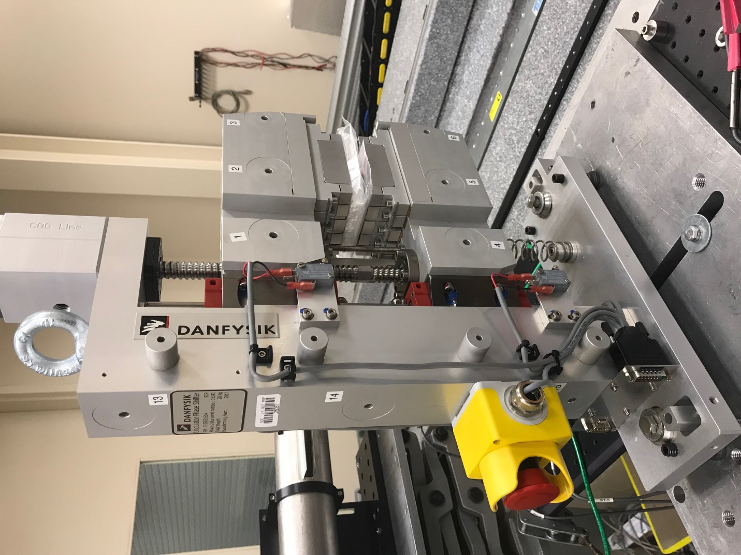
TB1
TB2
TB3
TB6
TB5
TB4
TB13
TB14
TB15
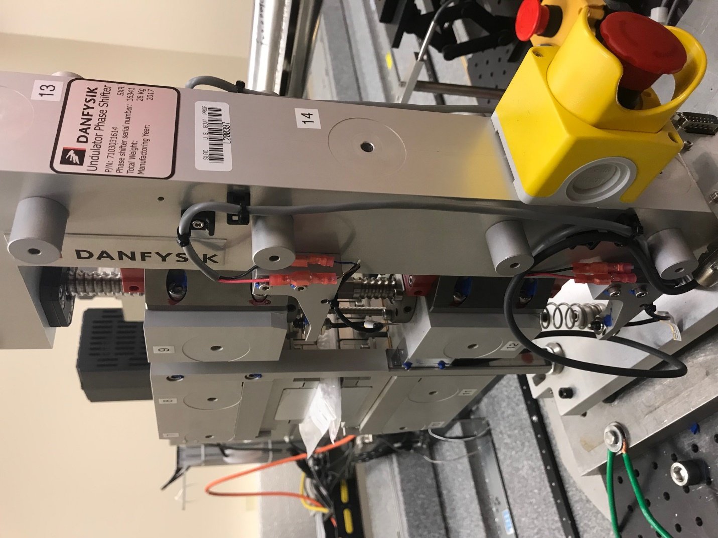
TB6
TB7
TB8
TB12

TB11
TB10
TB13
TB14
TB15

Tooling ball values to center of 1.5 inch sphere, all units are meter. Coordinates are to the HX Phase Shifter Magnetic Axis.
Tooling Ball | Z [m] | X [m] | Y [m]
TB1 | 0.070066 | -0.108458 | 0.081086
TB2 | 0.070055 | -0.025977 | 0.081036
TB3 | 0.070040 | 0.056534 | 0.080976
TB4 | 0.070192 | -0.108457 | -0.080413
TB5 | 0.070236 | -0.025908 | -0.080346
TB6 | 0.070270 | 0.056512 | -0.080244
TB7 | -0.070268 | 0.056456 | 0.080840
TB8 | -0.070276 | -0.026041 | 0.080895
TB9 | -0.070284 | -0.108535 | 0.080948
TB10 | -0.070078 | 0.056554 | -0.080476
TB11 | -0.070131 | -0.025915 | -0.080581
TB12 | -0.070184 | -0.108449 | -0.080675
TB13 | -0.000383 | -0.267658 | 0.186820
TB14 | -0.000165 | -0.267637 | 0.016795
TB15 | -0.000007 | -0.267587 | -0.153126

