LCLS2 SX Phase Shifter

Alignment Engineering Group
L200400
SN SXPS-16344
Jan 11, 2018

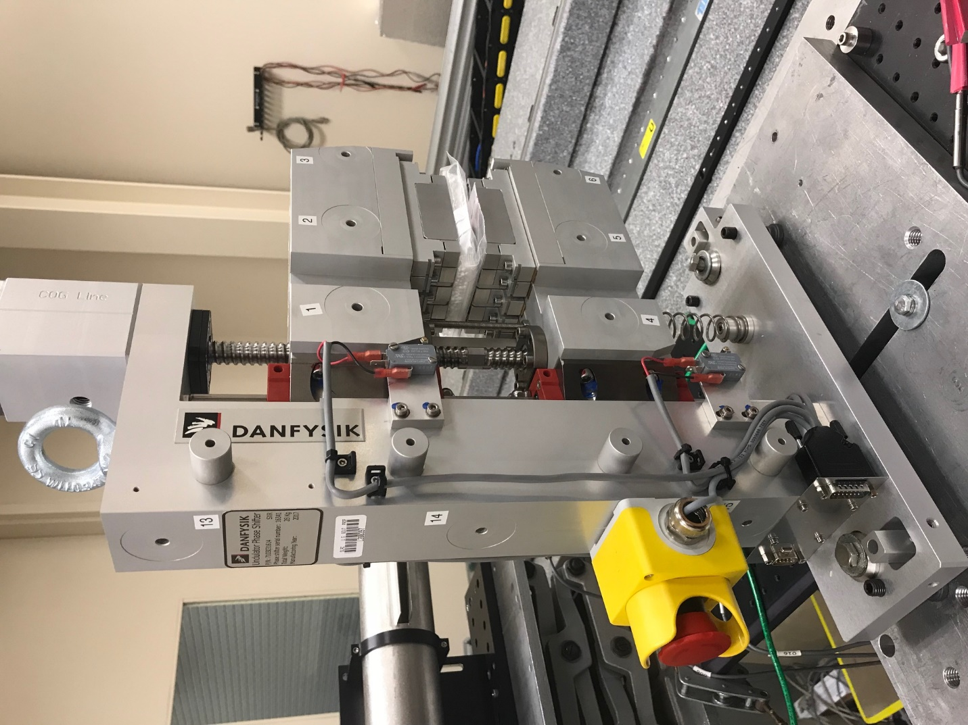
TB1
TB2
TB3
TB6
TB5
TB4
TB13
TB14
TB15
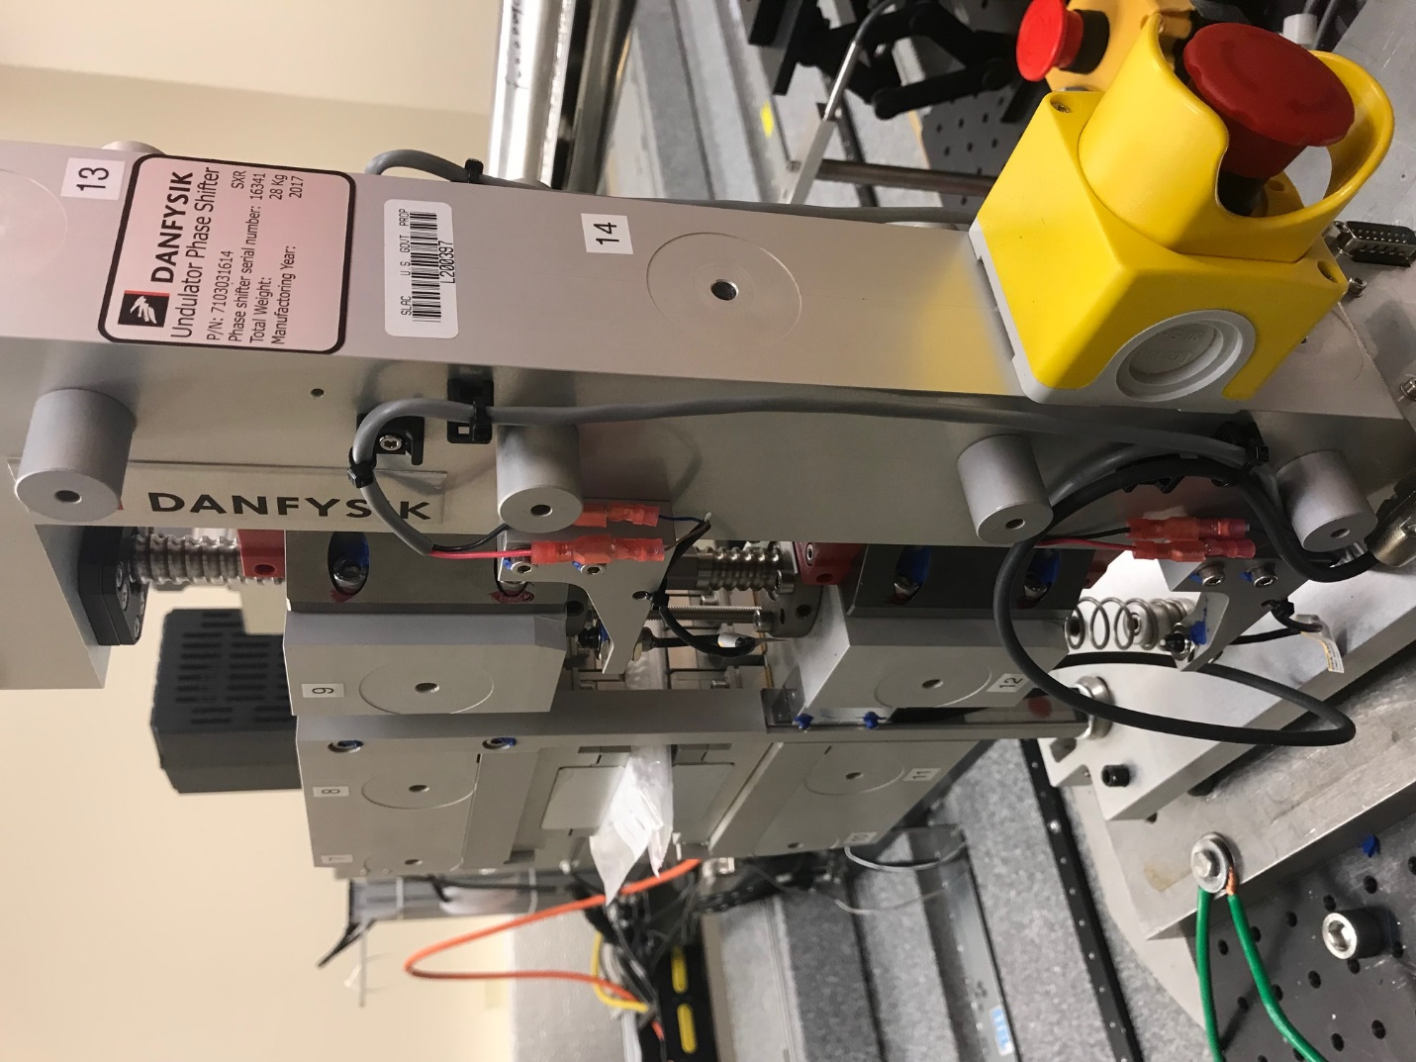
TB6
TB7
TB8
TB12

TB11
TB10
TB13
TB14
TB15

Tooling ball values to center of 1.5 inch sphere, all units are meter. Coordinates are to the HX Phase Shifter Magnetic Axis.
Tooling Ball | Z [m] | X [m] | Y [m]
TB1 | 0.070169 | -0.108838 | 0.083217
TB2 | 0.070176 | -0.026428 | 0.083310
TB3 | 0.070192 | 0.056062 | 0.083332
TB4 | 0.070128 | -0.108841 | -0.083541
TB5 | 0.070160 | -0.026326 | -0.083446
TB6 | 0.070194 | 0.056125 | -0.083317
TB7 | -0.070151 | 0.056099 | 0.083411
TB8 | -0.070180 | -0.026426 | 0.083443
TB9 | -0.070224 | -0.108905 | 0.083388
TB10 | -0.070148 | 0.056270 | -0.083428
TB11 | -0.070204 | -0.026254 | -0.083551
TB12 | -0.070254 | -0.108741 | -0.083622
TB13 | -0.000123 | -0.268164 | 0.186416
TB14 | -0.000155 | -0.268066 | 0.016370
TB15 | -0.000240 | -0.267956 | -0.153578

