LCLS2 SX Phase Shifter

Alignment Engineering Group
L200397
SN SXPS-16341
Jul 12, 2018

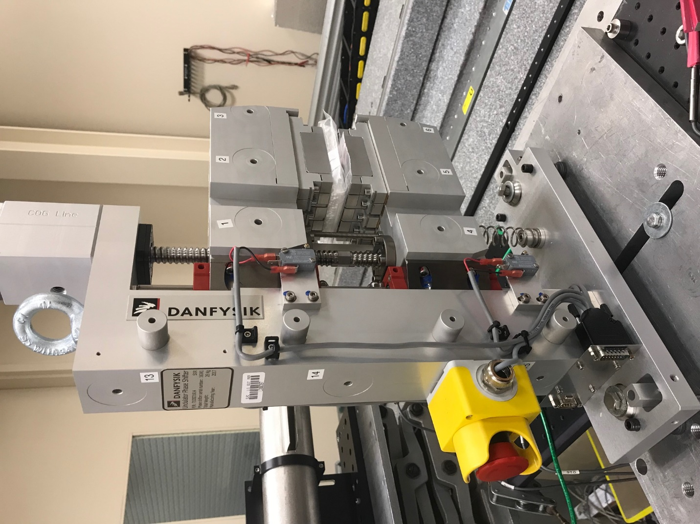
TB1
TB2
TB3
TB6
TB5
TB4
TB13
TB14
TB15
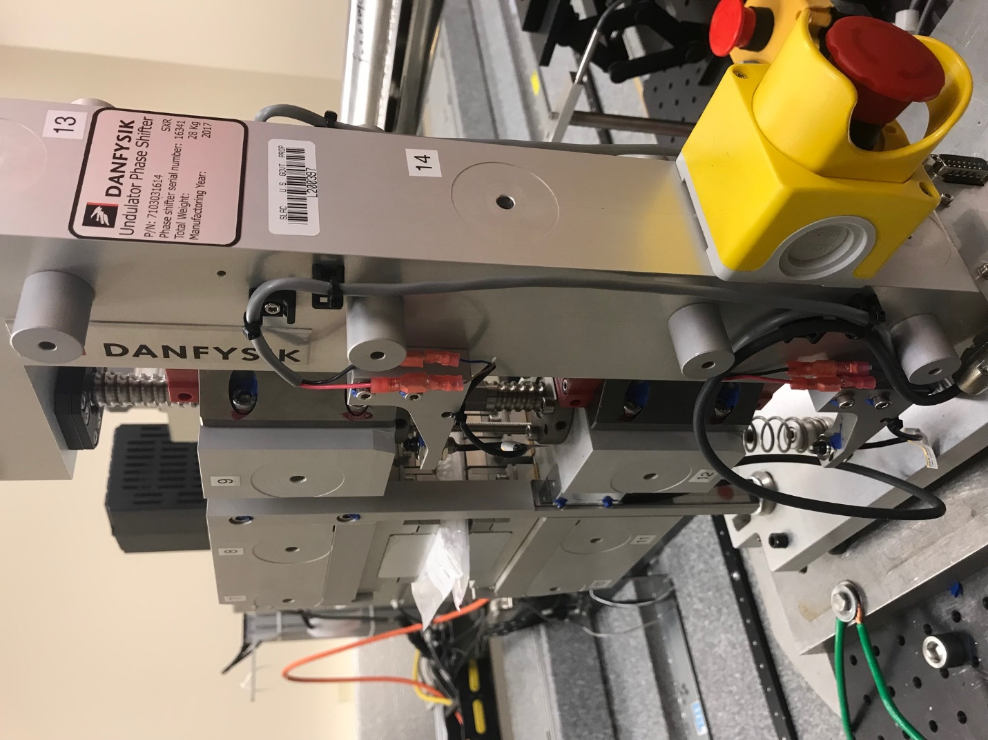
TB6
TB7
TB8
TB12

TB11
TB10
TB13
TB14
TB15

Tooling ball values to center of 1.5 inch sphere, all units are meter. Coordinates are to the HX Phase Shifter Magnetic Axis.
Tooling Ball | Z [m] | X [m] | Y [m]
TB1 | 0.070352 | -0.108863 | 0.084274
TB2 | 0.070262 | -0.026359 | 0.084245
TB3 | 0.070169 | 0.056136 | 0.084208
TB4 | 0.070154 | -0.108853 | -0.084469
TB5 | 0.070085 | -0.026338 | -0.084412
TB6 | 0.070018 | 0.056158 | -0.084332
TB7 | -0.070172 | 0.055969 | 0.084419
TB8 | -0.070094 | -0.026517 | 0.084485
TB9 | -0.070027 | -0.109024 | 0.084467
TB10 | -0.070324 | 0.056042 | -0.084315
TB11 | -0.070264 | -0.026447 | -0.084373
TB12 | -0.070211 | -0.108954 | -0.084433
TB13 | 0.000243 | -0.268176 | 0.186360
TB14 | 0.000172 | -0.268152 | 0.016363
TB15 | 0.000016 | -0.268133 | -0.153621

