LCLS2 SX Phase Shifter

Alignment Engineering Group
L200396
SN SXPS-16340
Nov 10, 2017

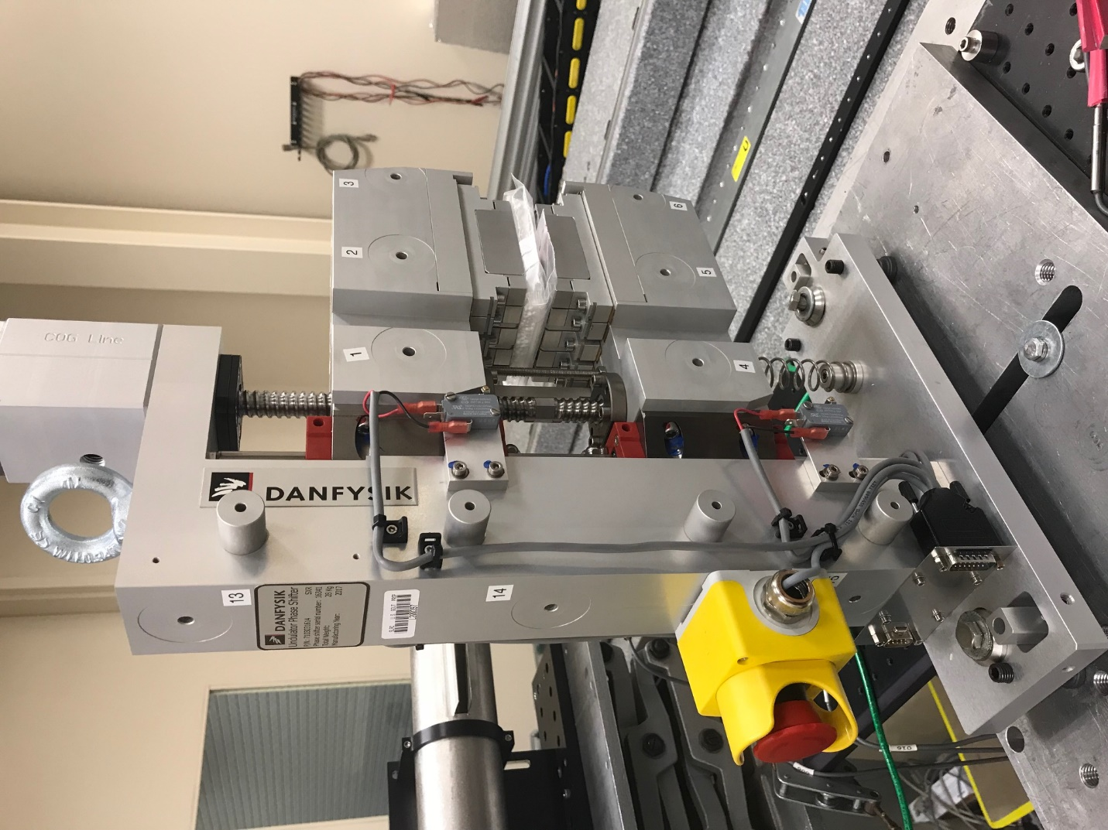
TB1
TB2
TB3
TB6
TB5
TB4
TB13
TB14
TB15
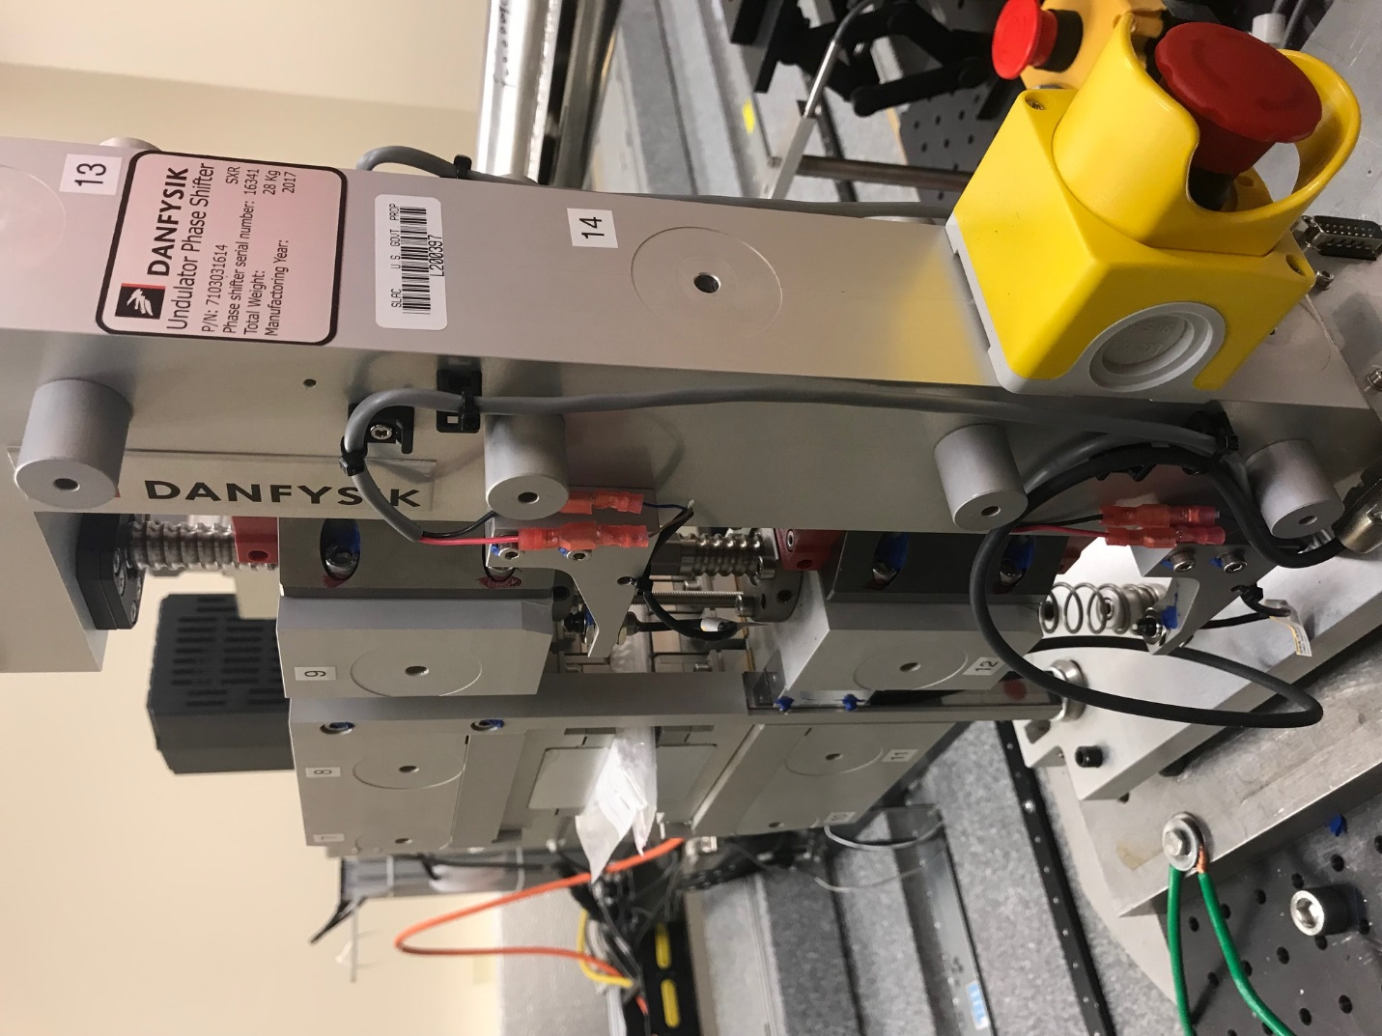
TB6
TB7
TB8
TB12

TB11
TB10
TB13
TB14
TB15

Tooling ball values to center of 1.5 inch sphere, all units are meter. Coordinates are to the HX Phase Shifter Magnetic Axis.
Tooling Ball | Z [m] | X [m] | Y [m]
TB1 | 0.070104 | -0.108996 | 0.084382
TB2 | 0.070090 | -0.026529 | 0.084471
TB3 | 0.070093 | 0.055967 | 0.084462
TB4 | 0.070124 | -0.108975 | -0.084625
TB5 | 0.070118 | -0.026485 | -0.084513
TB6 | 0.070118 | 0.056024 | -0.084385
TB7 | -0.070195 | 0.055884 | 0.084320
TB8 | -0.070203 | -0.026558 | 0.084364
TB9 | -0.070218 | -0.109079 | 0.084361
TB10 | -0.070218 | 0.055991 | -0.084363
TB11 | -0.070230 | -0.026466 | -0.084426
TB12 | -0.070240 | -0.108976 | -0.084497
TB13 | -0.000205 | -0.268292 | 0.186541
TB14 | -0.000181 | -0.268200 | 0.016582
TB15 | -0.000230 | -0.268114 | -0.153412

