LCLS2 SX Phase Shifter

Alignment Engineering Group
L200395
SN SXPS-16339
Jan 30, 2017

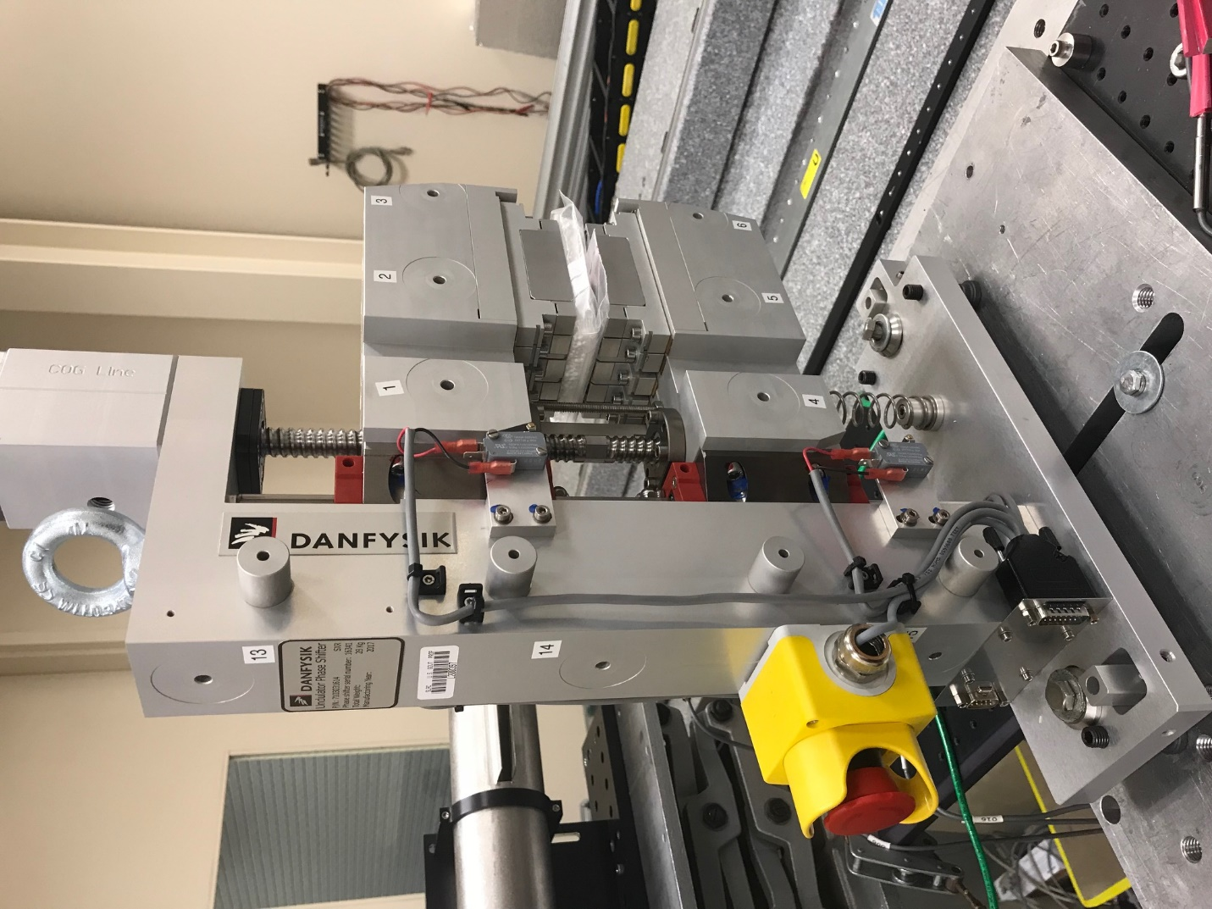
TB1
TB2
TB3
TB6
TB5
TB4
TB13
TB14
TB15
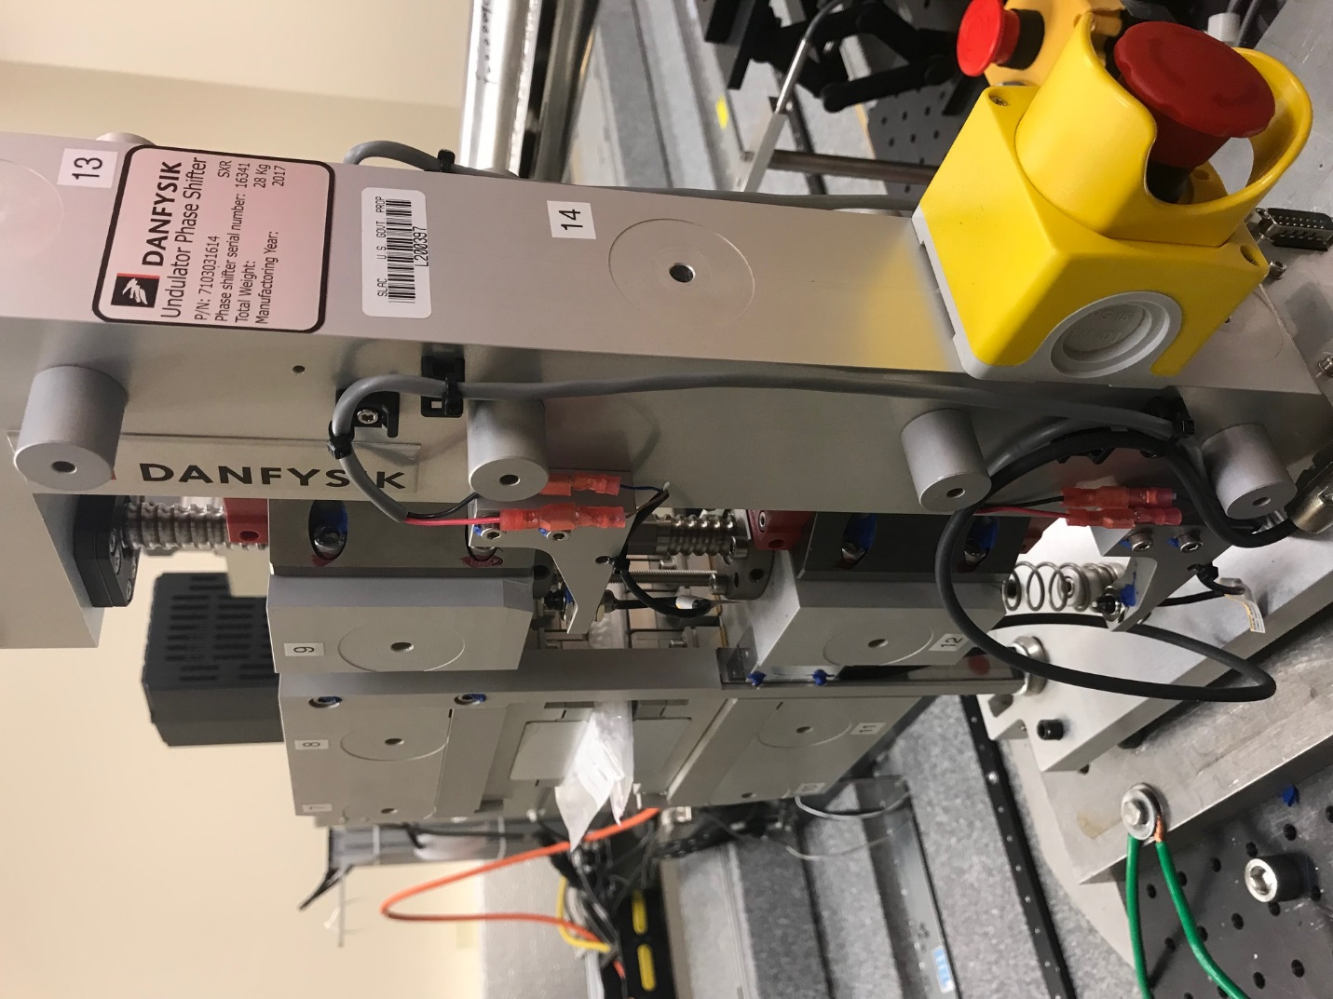
TB6
TB7
TB8
TB12

TB11
TB10
TB13
TB14
TB15

Tooling ball values to center of 1.5 inch sphere, all units are meter. Coordinates are to the HX Phase Shifter Magnetic Axis.
Tooling Ball | Z [m] | X [m] | Y [m]
TB1 | 0.069986 | -0.108837 | 0.090842
TB2 | 0.069990 | -0.026303 | 0.090838
TB3 | 0.070003 | 0.056204 | 0.090764
TB4 | 0.070169 | -0.108863 | -0.090760
TB5 | 0.070144 | -0.026427 | -0.090620
TB6 | 0.070161 | 0.056081 | -0.090644
TB7 | -0.070311 | 0.056182 | 0.090589
TB8 | -0.070339 | -0.026309 | 0.090639
TB9 | -0.070359 | -0.108823 | 0.090694
TB10 | -0.070168 | 0.056092 | -0.090740
TB11 | -0.070190 | -0.026390 | -0.090758
TB12 | -0.070205 | -0.108900 | -0.090721
TB13 | -0.000300 | -0.267973 | 0.187161
TB14 | -0.000174 | -0.268004 | 0.017164
TB15 | -0.000134 | -0.268038 | -0.152812

