LCLS2 SX Phase Shifter

Alignment Engineering Group
L200xxx
SN SXPS-15081
May 4th, 2021

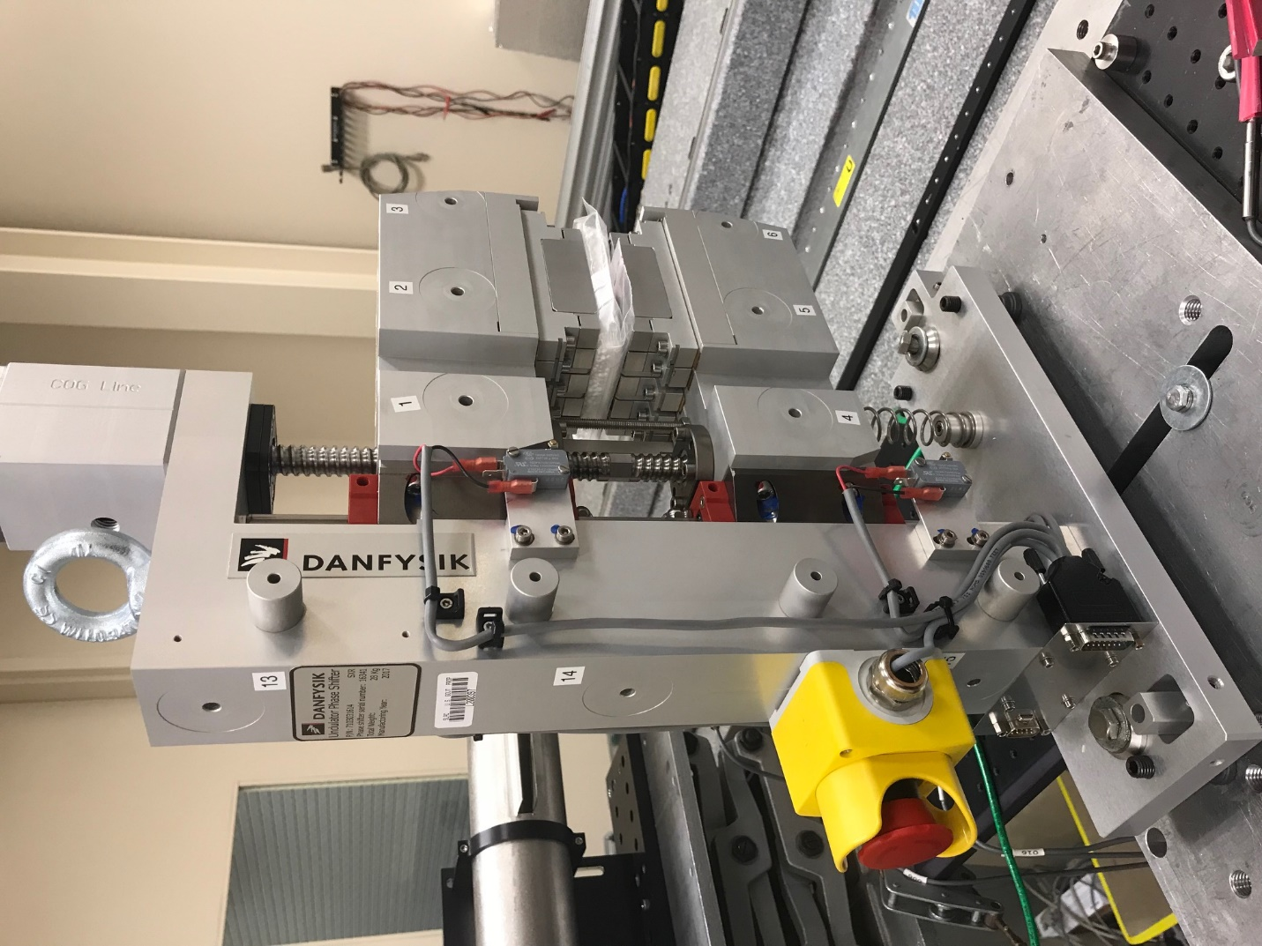
TB1
TB2
TB3
TB6
TB5
TB4
TB13
TB14
TB15
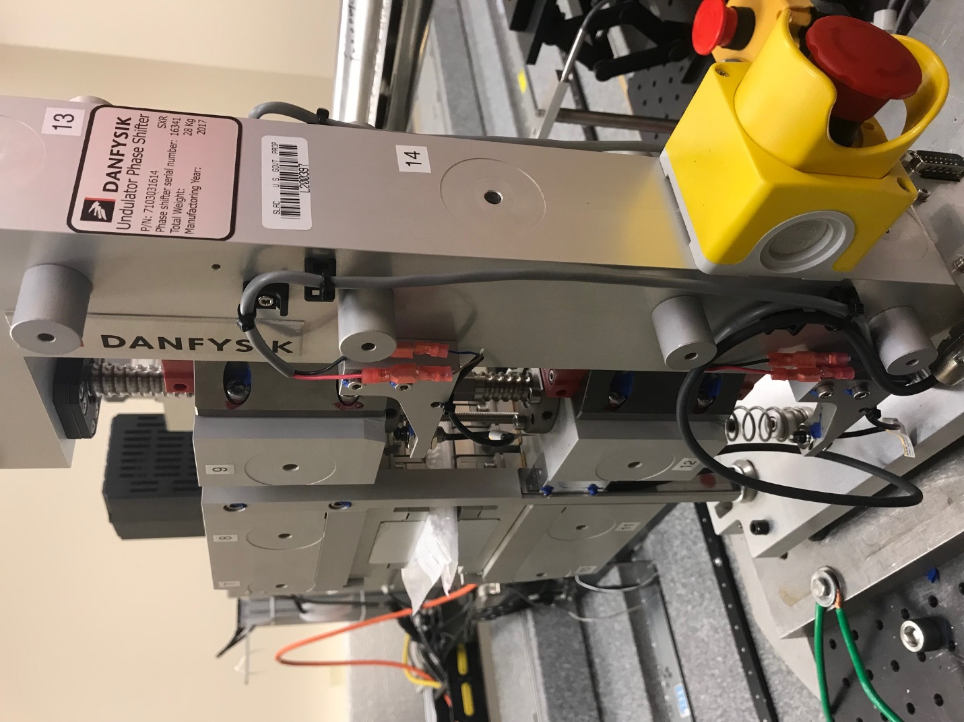
TB6
TB7
TB8
TB12

TB11
TB10
TB13
TB14
TB15

Tooling ball values to center of 1.5 inch sphere, all units are meter. Coordinates are to the HX Phase Shifter Magnetic Axis.
Tooling Ball | Z [m] | X [m] | Y [m]
TB1 | 0.070279 | -0.108593 | 0.100919
TB2 | 0.070395 | -0.026097 | 0.100916
TB3 | 0.070501 | 0.056387 | 0.100866
TB4 | 0.069985 | -0.108618 | -0.100780
TB5 | 0.070057 | -0.026090 | -0.100823
TB6 | 0.070129 | 0.056375 | -0.100813
TB7 | -0.069733 | 0.056564 | 0.100959
TB8 | -0.069855 | -0.025975 | 0.101009
TB9 | -0.069974 | -0.108449 | 0.100999
TB10 | -0.070111 | 0.056487 | -0.100569
TB11 | -0.070187 | -0.025996 | -0.100533
TB12 | -0.070268 | -0.108519 | -0.100493
TB13 | 0.000036 | -0.267708 | 0.185917
TB14 | 0.000016 | -0.267722 | 0.015972
TB15 | -0.000044 | -0.267749 | -0.154087

