LCLS2 HX Phase Shifter

Alignment Engineering Group
L201262
SN HXPS-16323
July 13, 2018

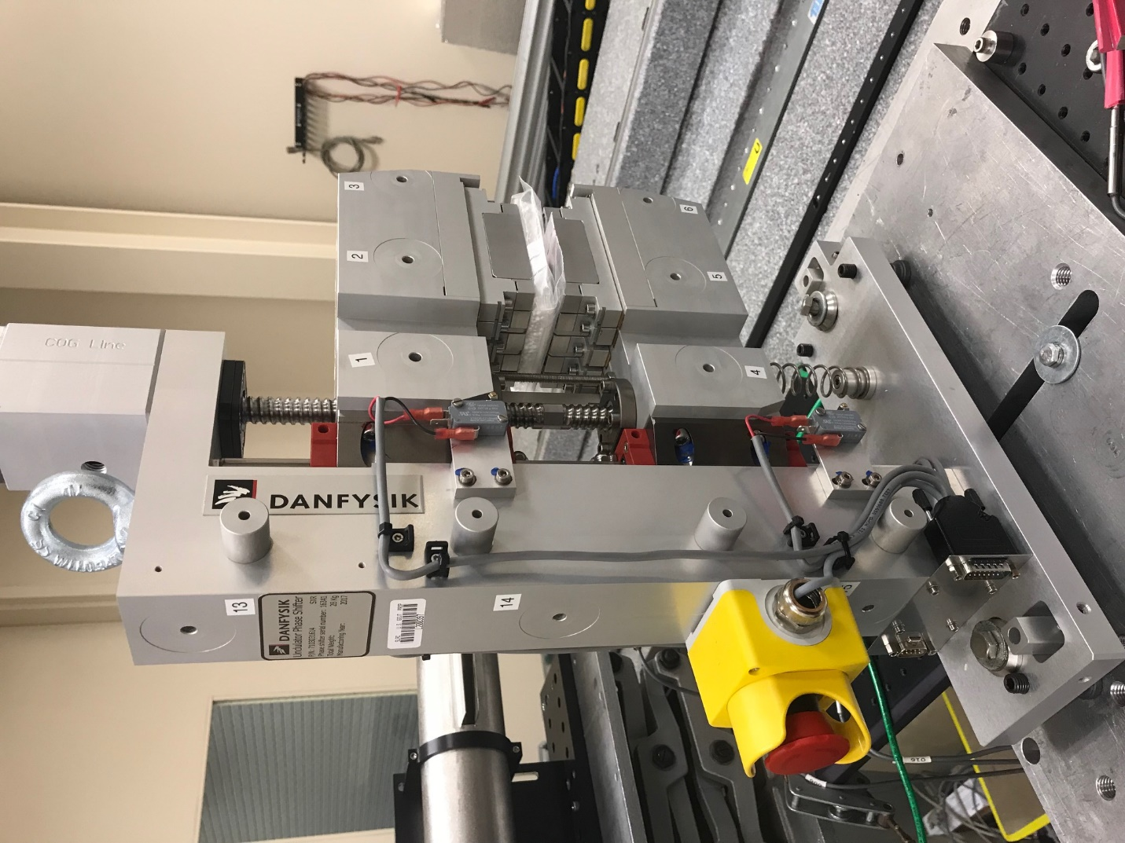
TB1
TB2
TB3
TB6
TB5
TB4
TB13
TB14
TB15
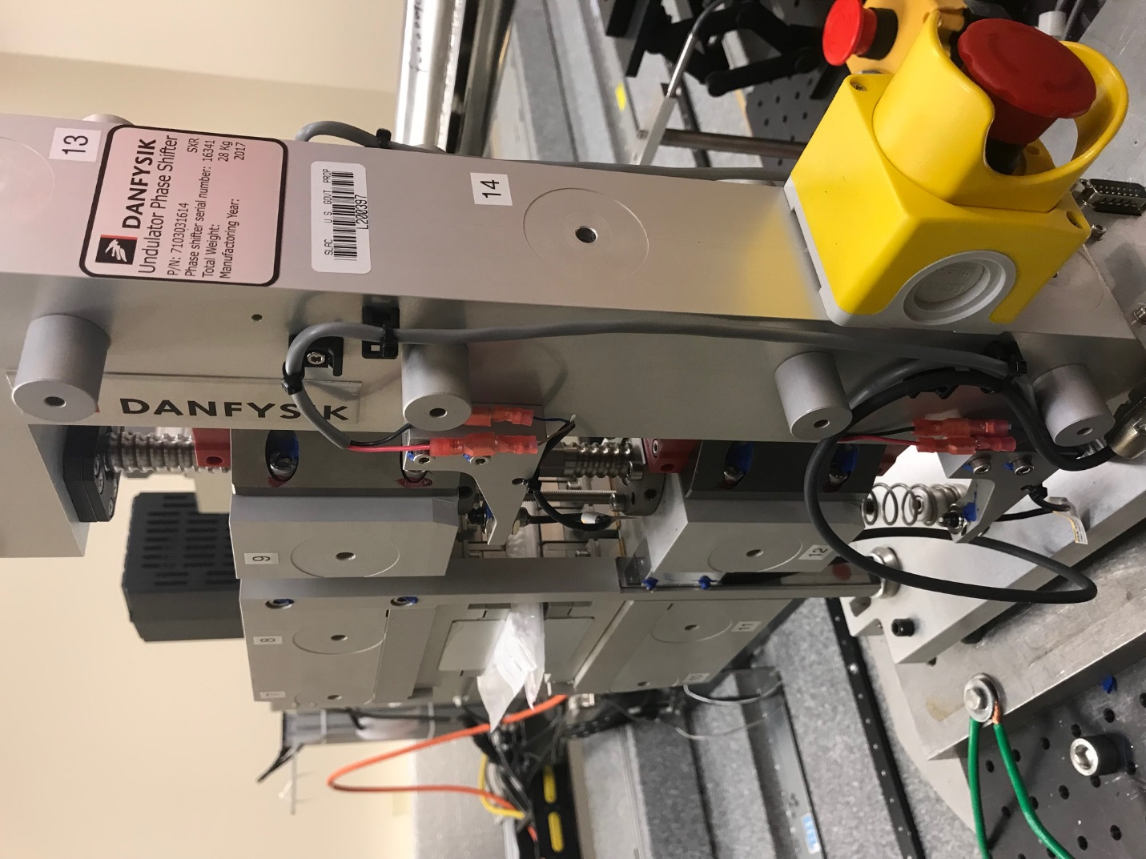
TB6
TB7
TB8
TB12

TB11
TB10
TB13
TB14
TB15

Tooling ball values to center of 1.5 inch sphere, all units are meter. Coordinates are to the HX Phase Shifter Magnetic Axis.
Tooling Ball | Z [m] | X [m] | Y [m]
TB1 | -0.069535 | 0.109787 | 0.083084
TB2 | -0.069839 | 0.027310 | 0.083153
TB3 | -0.070150 | -0.055190 | 0.083174
TB4 | -0.069713 | 0.109735 | -0.083081
TB5 | -0.070035 | 0.027246 | -0.083000
TB6 | -0.070357 | -0.055271 | -0.082916
TB7 | 0.070157 | -0.055718 | 0.083002
TB8 | 0.070487 | 0.026793 | 0.082991
TB9 | 0.070815 | 0.109303 | 0.082948
TB10 | 0.069930 | -0.055820 | -0.083160
TB11 | 0.070266 | 0.026689 | -0.083238
TB12 | 0.070596 | 0.109198 | -0.083269
TB13 | 0.001471 | 0.268762 | 0.186276
TB14 | 0.001220 | 0.268672 | 0.016273
TB15 | 0.001017 | 0.268585 | -0.153711

