LCLS2 SX Phase Shifter

Alignment Engineering Group
L200xxx
SN HXPS-16321
May 4th, 2021

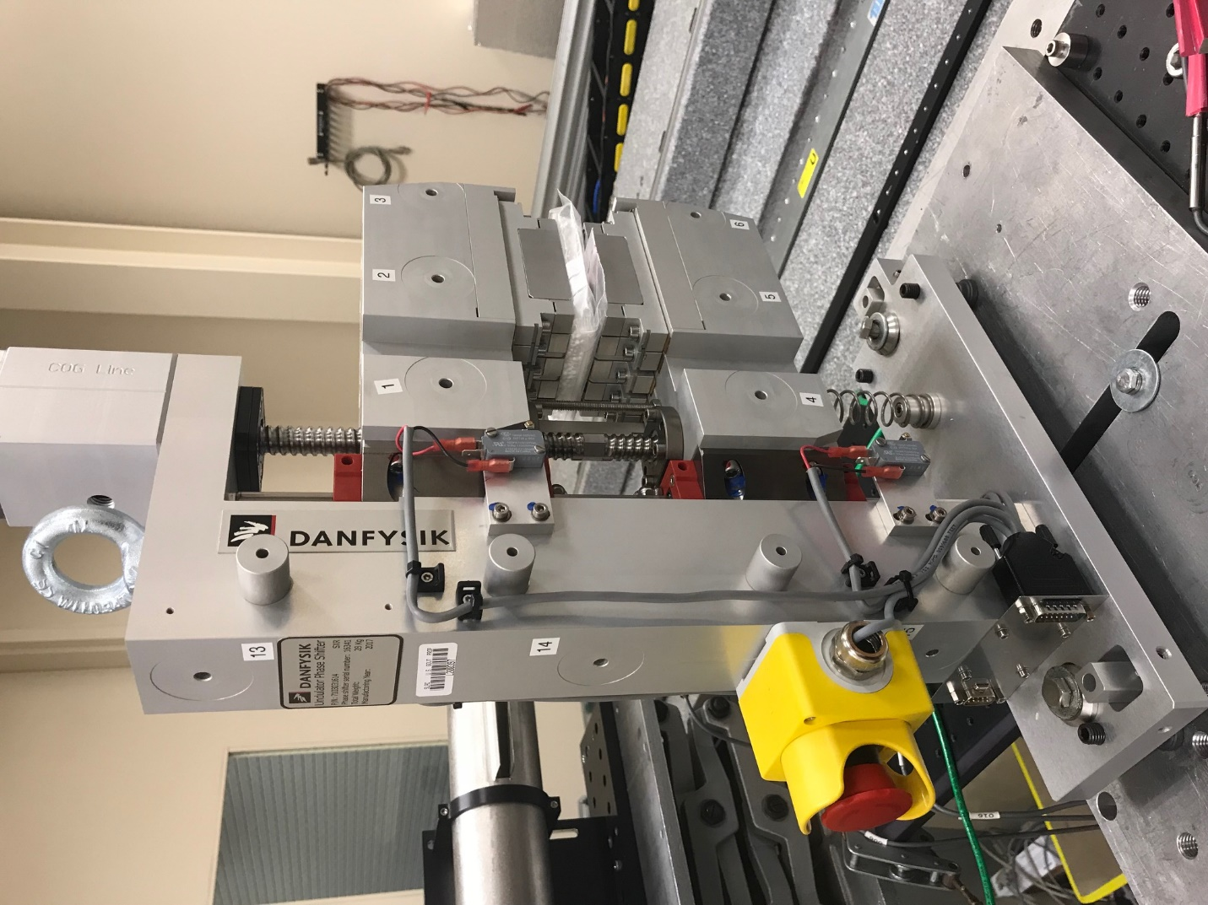
TB1
TB2
TB3
TB6
TB5
TB4
TB13
TB14
TB15
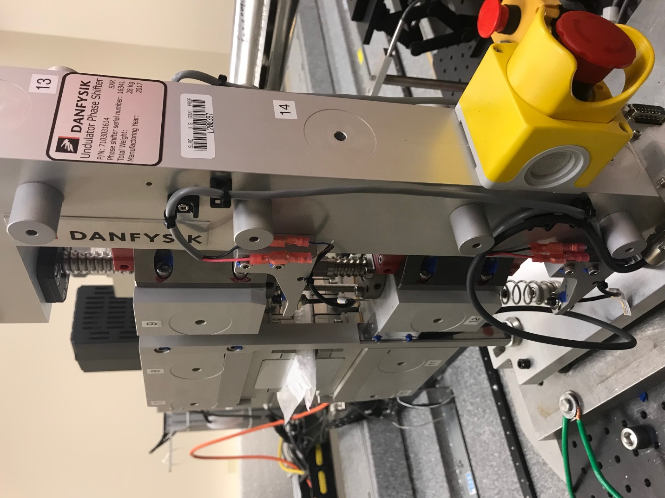
TB6
TB7
TB8
TB12

TB11
TB10
TB13
TB14
TB15

Tooling ball values to center of 1.5 inch sphere, all units are meter. Coordinates are to the HX Phase Shifter Magnetic Axis.
Tooling Ball | Z [m] | X [m] | Y [m]
TB1 | -0.070143 | 0.108720 | 0.083303
TB2 | -0.070244 | 0.026198 | 0.083342
TB3 | -0.070336 | -0.056296 | 0.083336
TB4 | -0.070385 | 0.108770 | -0.08294
TB5 | -0.070481 | 0.026275 | -0.08289
TB6 | -0.070584 | -0.056205 | -0.08286
TB7 | 0.069962 | -0.056412 | 0.083069
TB8 | 0.070062 | 0.026085 | 0.083088
TB9 | 0.070190 | 0.108588 | 0.083063
TB10 | 0.069715 | -0.056448 | -0.08296
TB11 | 0.069848 | 0.026064 | -0.08301
TB12 | 0.070004 | 0.108560 | -0.08308
TB13 | 0.000525 | 0.267794 | 0.186258
TB14 | 0.000236 | 0.267794 | 0.016253
TB15 | 0.000014 | 0.267801 | -0.153743

