LCLS2 HX Phase Shifter

Alignment Engineering Group
L201258
SN HXPS-16318
July 6, 2018

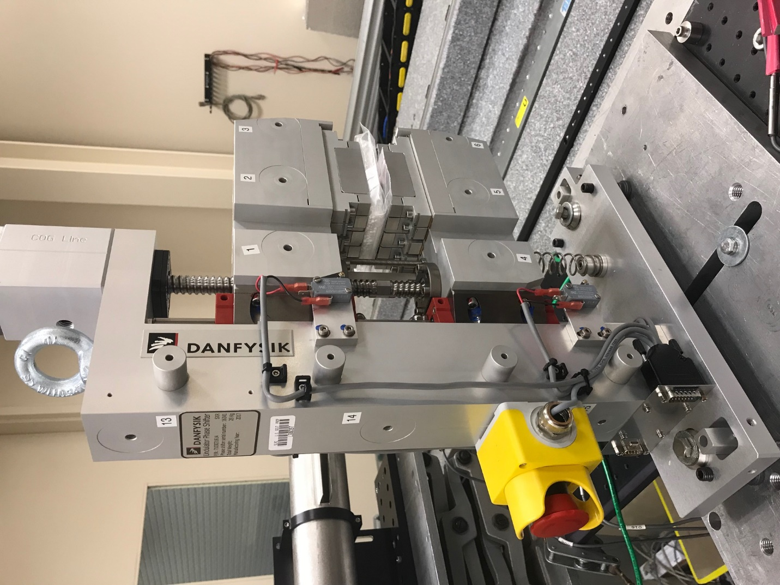
TB1
TB2
TB3
TB6
TB5
TB4
TB13
TB14
TB15
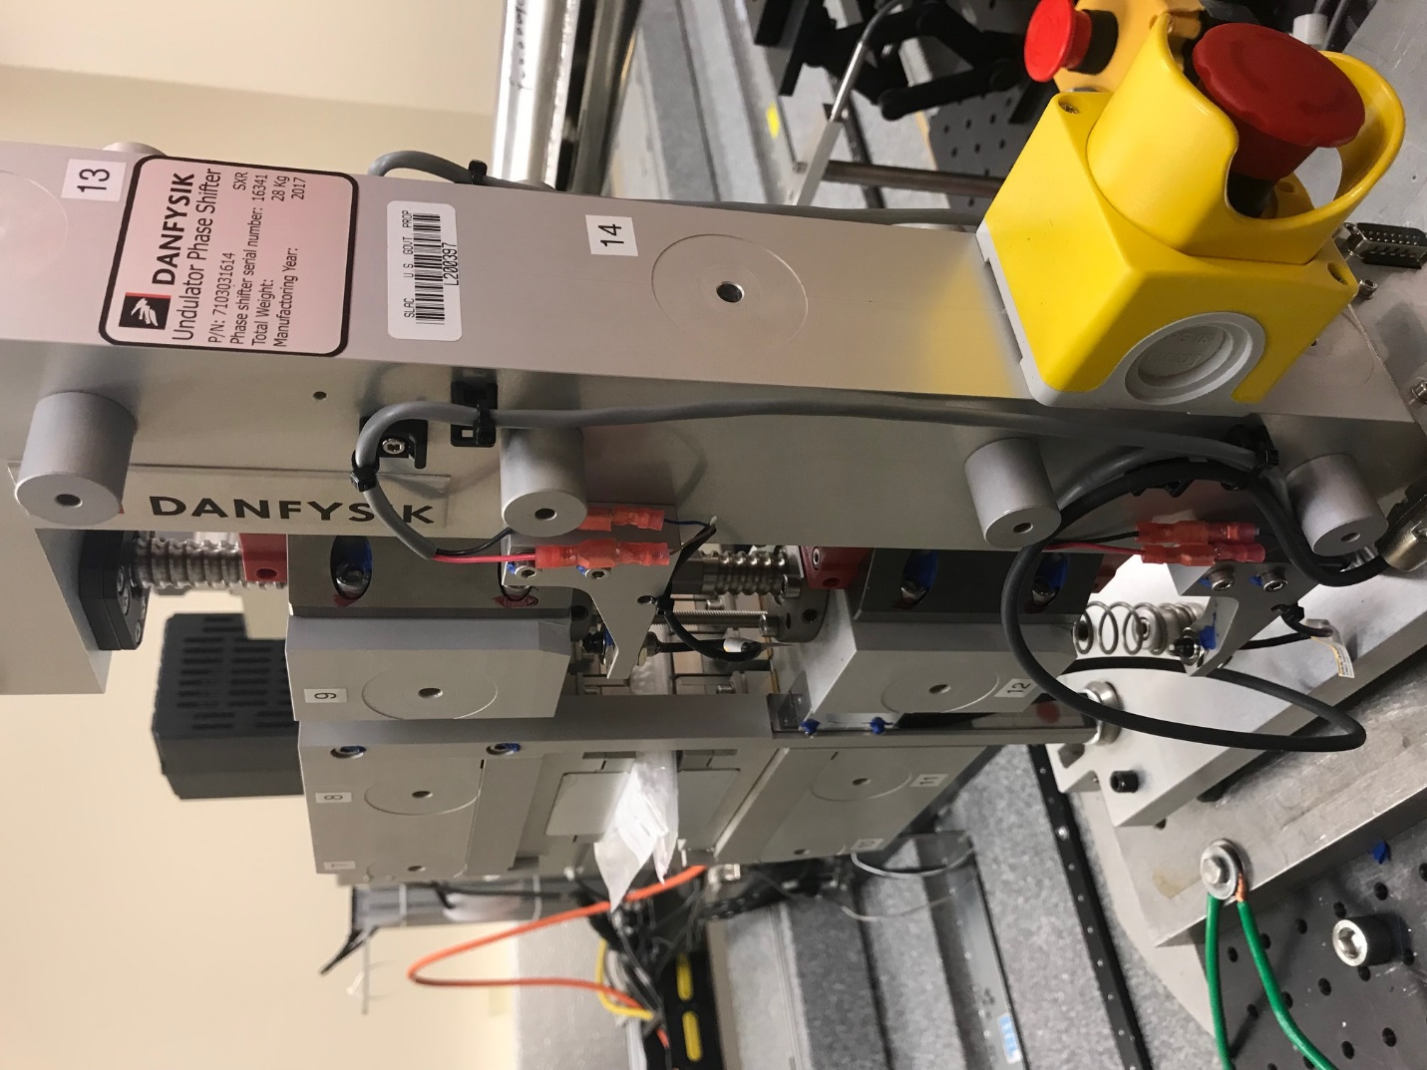
TB6
TB7
TB8
TB12

TB11
TB10
TB13
TB14
TB15

Tooling ball values to center of 1.5 inch sphere, all units are meter. Coordinates are to the HX Phase Shifter Magnetic Axis.
Tooling Ball | Z [m] | X [m] | Y [m]
TB1 | -0.069956 | 0.109127 | 0.083048
TB2 | -0.069962 | 0.026638 | 0.083119
TB3 | -0.069972 | -0.055874 | 0.083147
TB4 | -0.070333 | 0.108964 | -0.083067
TB5 | -0.070327 | 0.026478 | -0.082953
TB6 | -0.070325 | -0.056020 | -0.082835
TB7 | 0.070345 | -0.055829 | 0.082911
TB8 | 0.070359 | 0.026646 | 0.082871
TB9 | 0.070377 | 0.109137 | 0.082810
TB10 | 0.070015 | -0.056027 | -0.083149
TB11 | 0.070027 | 0.026436 | -0.083280
TB12 | 0.070015 | 0.108981 | -0.083286
TB13 | 0.000582 | 0.268392 | 0.186736
TB14 | 0.000175 | 0.268217 | 0.016753
TB15 | -0.000190 | 0.268062 | -0.153231

