LCLS2 HX Phase Shifter

Alignment Engineering Group
L201257
SN HXPS-16317
June 29, 2018

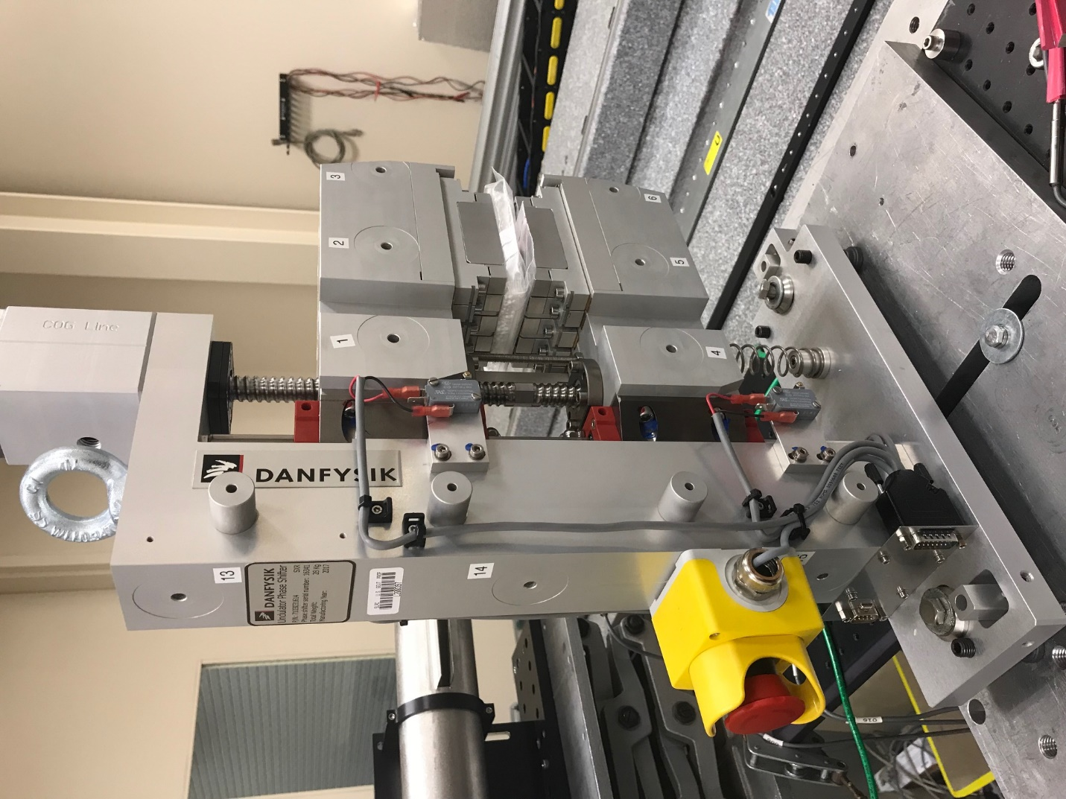
TB1
TB2
TB3
TB6
TB5
TB4
TB13
TB14
TB15
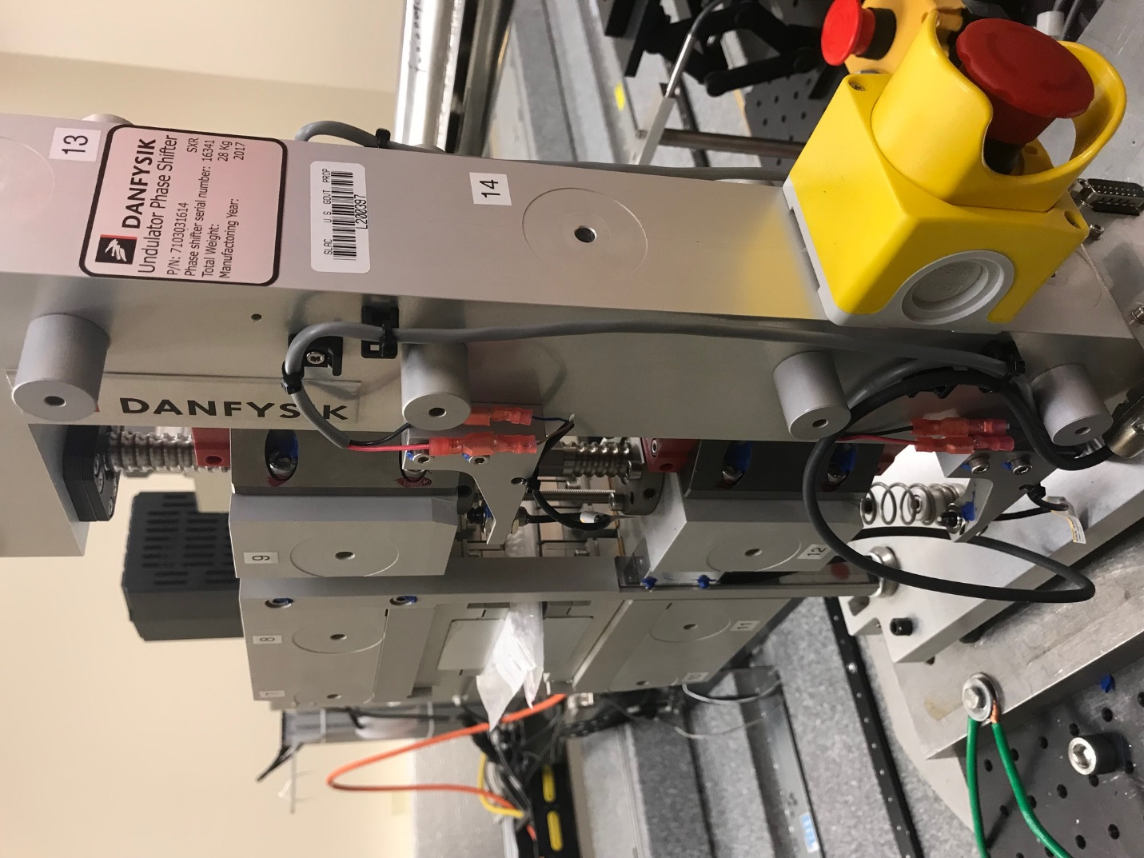
TB6
TB7
TB8
TB12

TB11
TB10
TB13
TB14
TB15

Tooling ball values to center of 1.5 inch sphere, all units are meter. Coordinates are to the HX Phase Shifter Magnetic Axis.
Tooling Ball | Z [m] | X [m] | Y [m]
TB1 | -0.069883 | 0.109330 | 0.084007
TB2 | -0.069948 | 0.026824 | 0.084118
TB3 | -0.070011 | -0.055690 | 0.084201
TB4 | -0.070075 | 0.109118 | -0.084245
TB5 | -0.070132 | 0.026621 | -0.084097
TB6 | -0.070191 | -0.055896 | -0.083920
TB7 | 0.070292 | -0.055778 | 0.083972
TB8 | 0.070368 | 0.026720 | 0.083917
TB9 | 0.070448 | 0.109240 | 0.083794
TB10 | 0.070129 | -0.056009 | -0.083983
TB11 | 0.070201 | 0.026472 | -0.084154
TB12 | 0.070273 | 0.108995 | -0.084259
TB13 | 0.000471 | 0.268618 | 0.186279
TB14 | 0.000360 | 0.268365 | 0.016274
TB15 | 0.000311 | 0.268110 | -0.153686

