LCLS2 HX Phase Shifter

Alignment Engineering Group
L201256
SN HXPS-16316
June 27, 2018

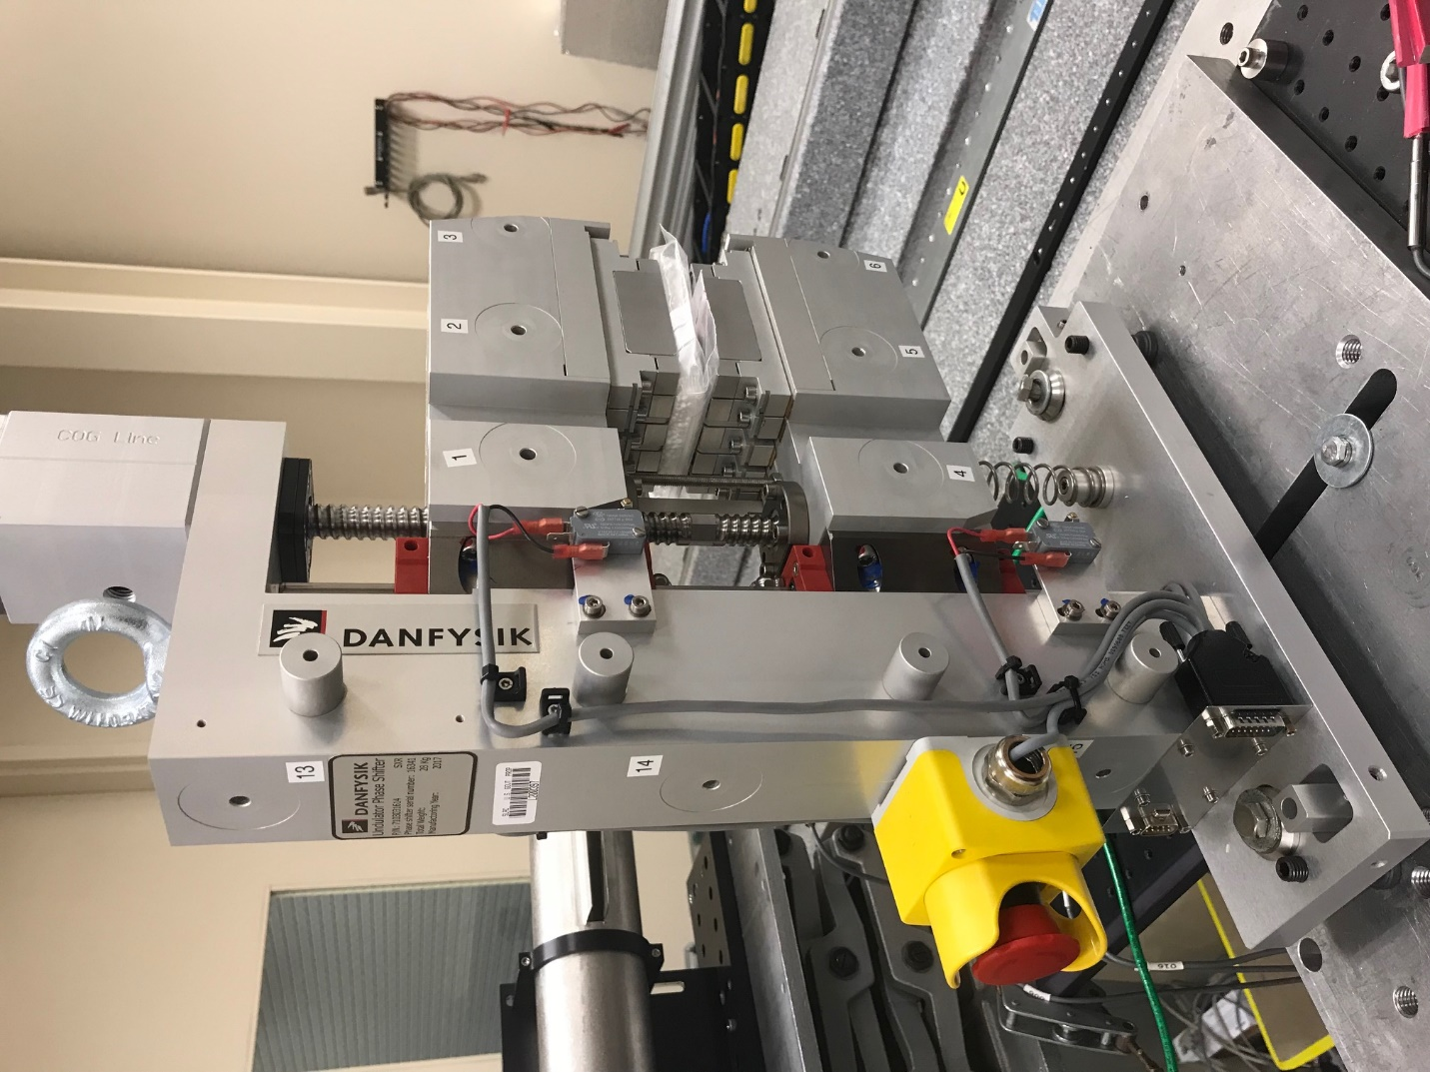
TB1
TB2
TB3
TB6
TB5
TB4
TB13
TB14
TB15
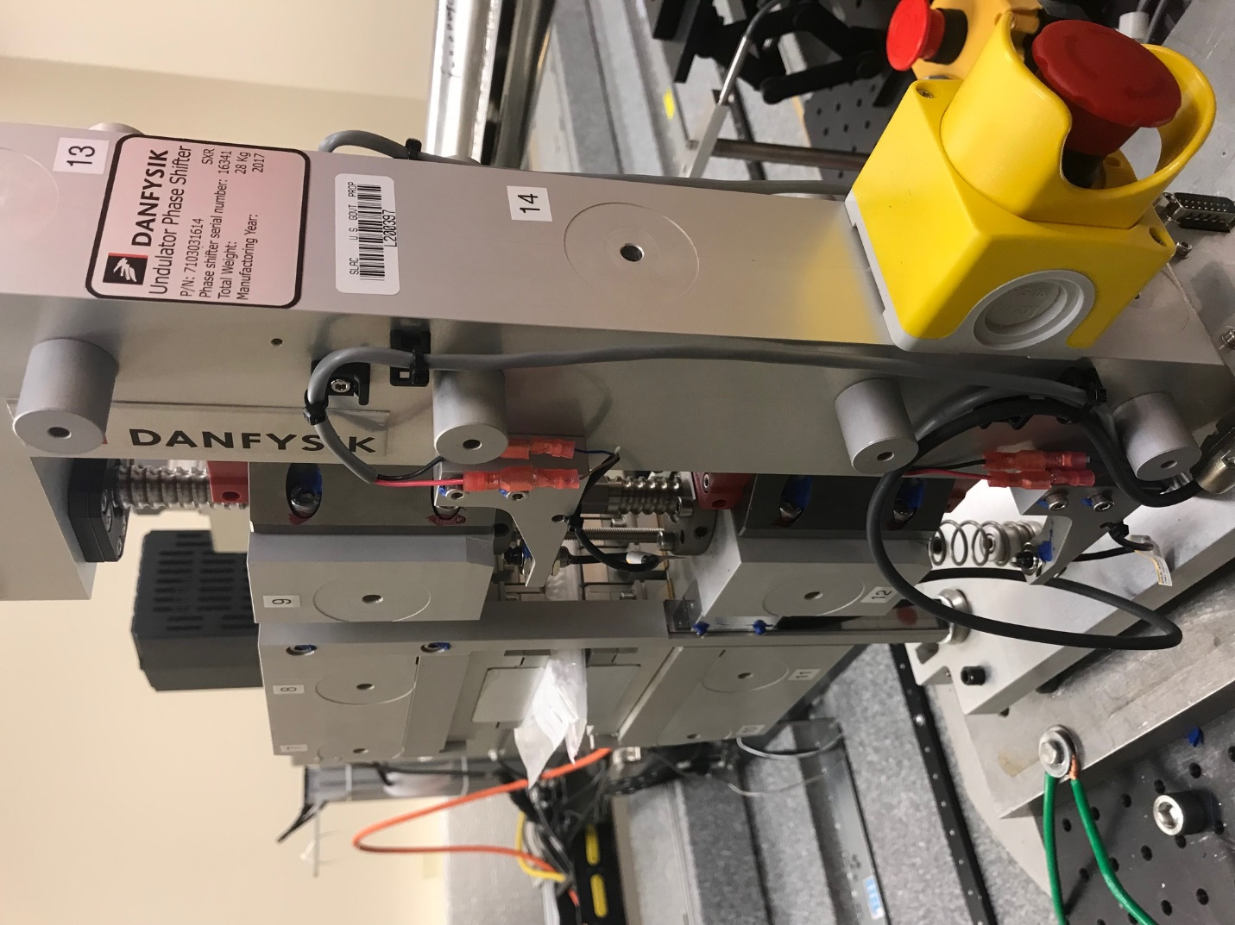
TB6
TB7
TB8
TB12

TB11
TB10
TB13
TB14
TB15

Tooling ball values to center of 1.5 inch sphere, all units are meter. Coordinates are to the HX Phase Shifter Magnetic Axis.
Tooling Ball | Z [m] | X [m] | Y [m]
TB1 | -0.069974 | 0.109334 | 0.083212
TB2 | -0.070022 | 0.026849 | 0.083195
TB3 | -0.070066 | -0.055648 | 0.083158
TB4 | -0.070121 | 0.109261 | -0.083269
TB5 | -0.070172 | 0.026759 | -0.083200
TB6 | -0.070222 | -0.055731 | -0.083117
TB7 | 0.070246 | -0.055725 | 0.083149
TB8 | 0.070306 | 0.026779 | 0.083154
TB9 | 0.070355 | 0.109286 | 0.083151
TB10 | 0.070120 | -0.055838 | -0.083343
TB11 | 0.070190 | 0.026658 | -0.083442
TB12 | 0.070244 | 0.109146 | -0.083425
TB13 | 0.000450 | 0.268562 | 0.185832
TB14 | 0.000335 | 0.268471 | 0.015850
TB15 | 0.000195 | 0.268393 | -0.154135

