LCLS2 HX Phase Shifter

Alignment Engineering Group
L201255
SN HXPS-16315
June 26, 2018

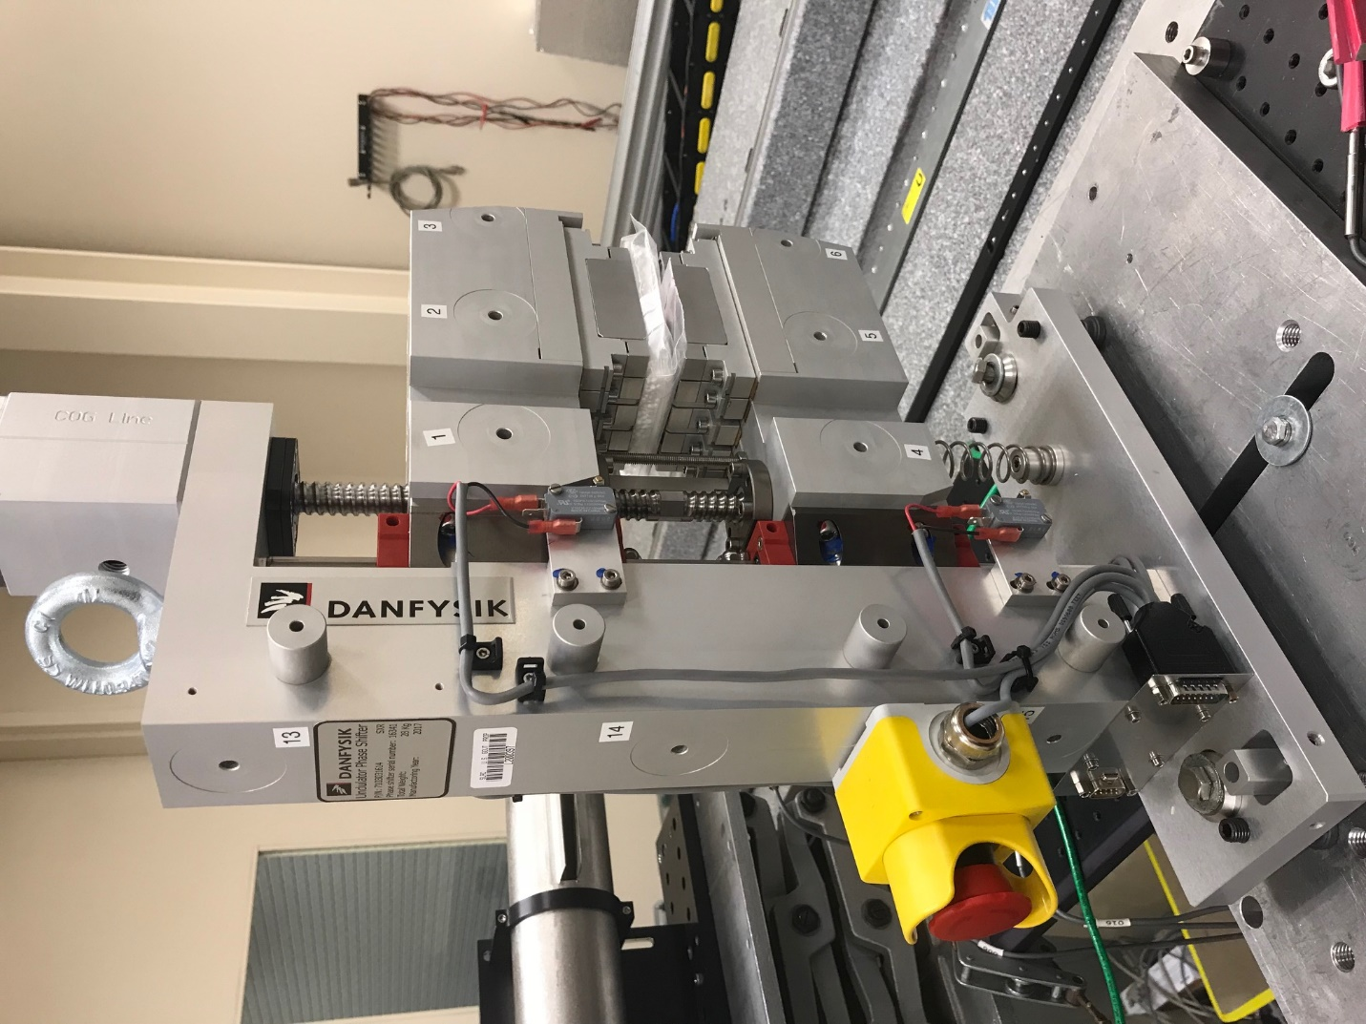
TB1
TB2
TB3
TB6
TB5
TB4
TB13
TB14
TB15
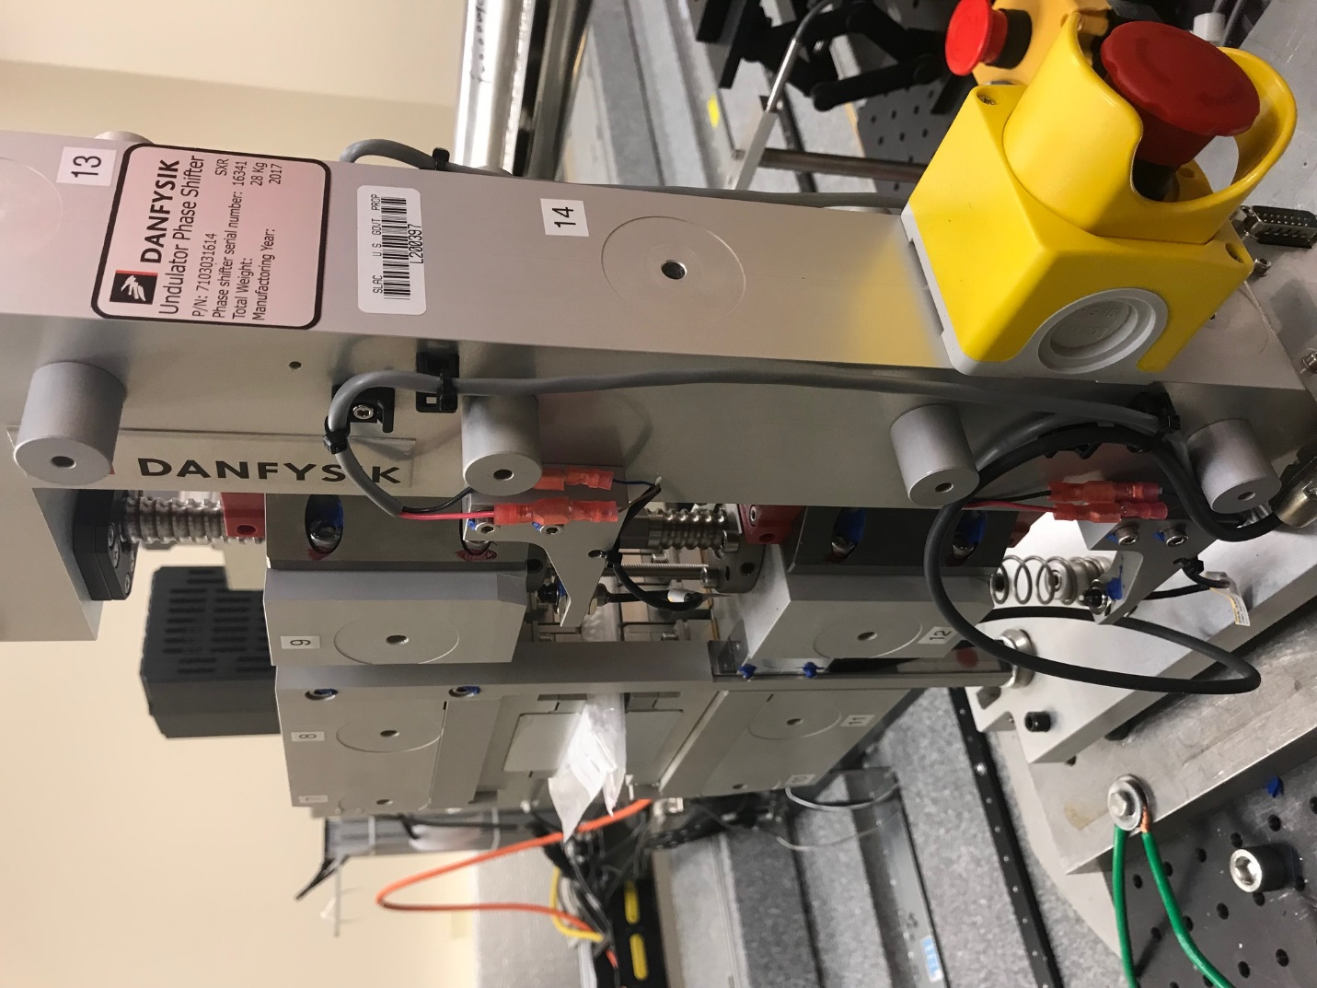
TB6
TB7
TB8
TB12

TB11
TB10
TB13
TB14
TB15

Tooling ball values to center of 1.5 inch sphere, all units are meter. Coordinates are to the HX Phase Shifter Magnetic Axis.
Tooling Ball | Z [m] | X [m] | Y [m]
TB1 | -0.070194 | 0.109251 | 0.083158
TB2 | -0.070164 | 0.026744 | 0.083176
TB3 | -0.070128 | -0.055728 | 0.083205
TB4 | -0.069996 | 0.109182 | -0.083324
TB5 | -0.069962 | 0.026700 | -0.083258
TB6 | -0.069927 | -0.055818 | -0.083164
TB7 | 0.070183 | -0.055674 | 0.083195
TB8 | 0.070168 | 0.026819 | 0.083198
TB9 | 0.070143 | 0.109333 | 0.083184
TB10 | 0.070372 | -0.055745 | -0.083277
TB11 | 0.070344 | 0.026735 | -0.083320
TB12 | 0.070316 | 0.109230 | -0.083334
TB13 | 0.000017 | 0.268487 | 0.185881
TB14 | 0.000090 | 0.268421 | 0.015888
TB15 | 0.000248 | 0.268359 | -0.154126

