LCLS2 HX Phase Shifter

Alignment Engineering Group
L201253
SN HXPS-16313
May 30, 2018

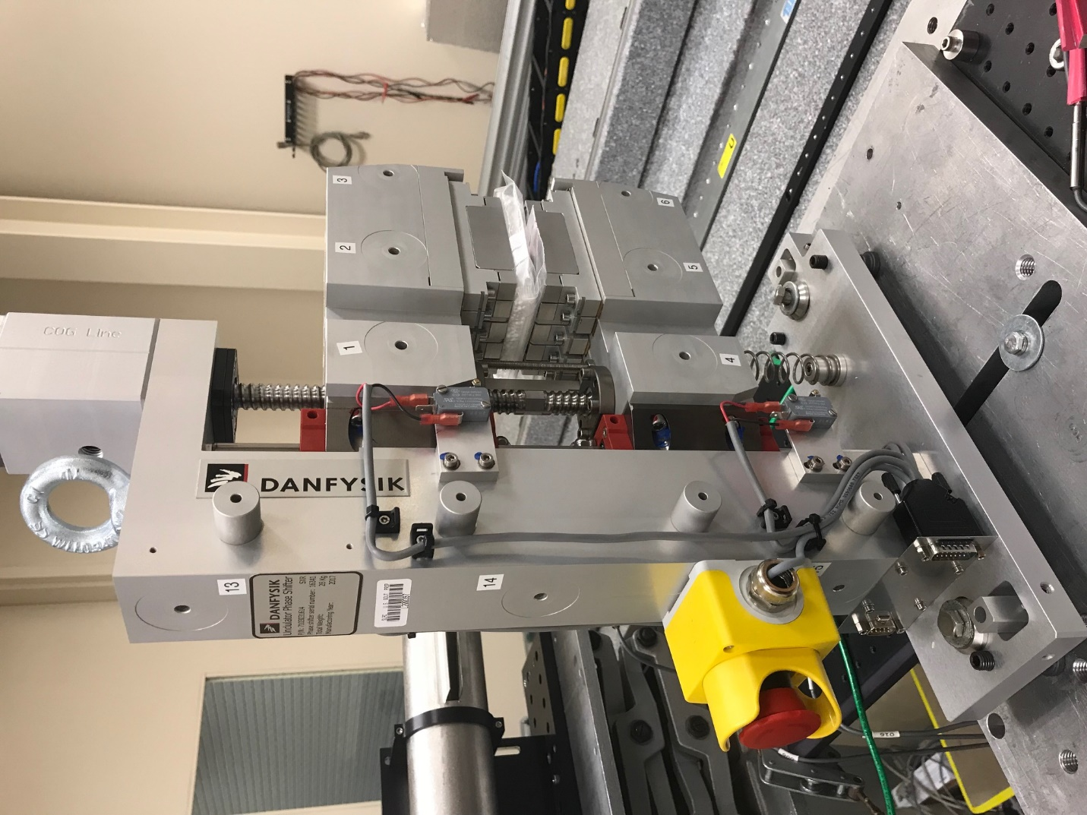
TB1
TB2
TB3
TB6
TB5
TB4
TB13
TB14
TB15
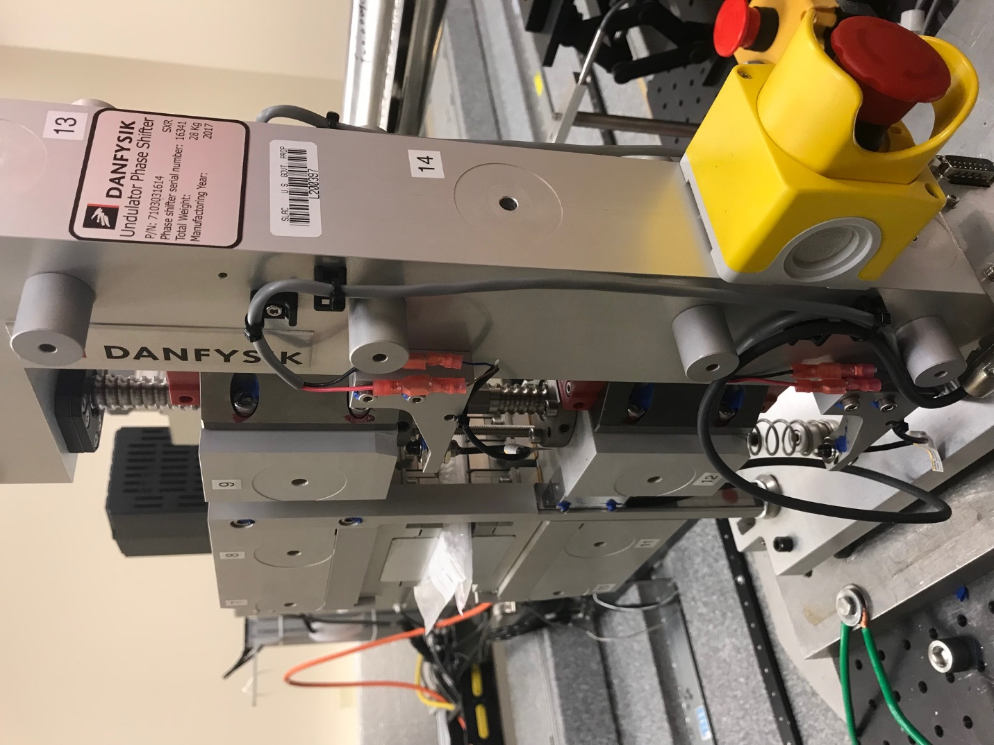
TB6
TB7
TB8
TB12

TB11
TB10
TB13
TB14
TB15

Tooling ball values to center of 1.5 inch sphere, all units are meter. Coordinates are to the HX Phase Shifter Magnetic Axis.
Tooling Ball | Z [m] | X [m] | Y [m]
TB1 | -0.070119 | 0.109642 | 0.083241
TB2 | -0.070051 | 0.027139 | 0.083246
TB3 | -0.069991 | -0.055381 | 0.083217
TB4 | -0.070220 | 0.109603 | -0.083287
TB5 | -0.070153 | 0.027106 | -0.083225
TB6 | -0.070091 | -0.055402 | -0.083163
TB7 | 0.070297 | -0.055234 | 0.083082
TB8 | 0.070236 | 0.027240 | 0.083154
TB9 | 0.070188 | 0.109773 | 0.083146
TB10 | 0.070200 | -0.055324 | -0.083285
TB11 | 0.070153 | 0.027178 | -0.083371
TB12 | 0.070096 | 0.109705 | -0.083368
TB13 | 0.000073 | 0.268890 | 0.185953
TB14 | -0.000020 | 0.268850 | 0.015943
TB15 | -0.000043 | 0.268812 | -0.154054

