LCLS2 HX Phase Shifter

Alignment Engineering Group
L201252
SN HXPS-16312
May 29, 2018

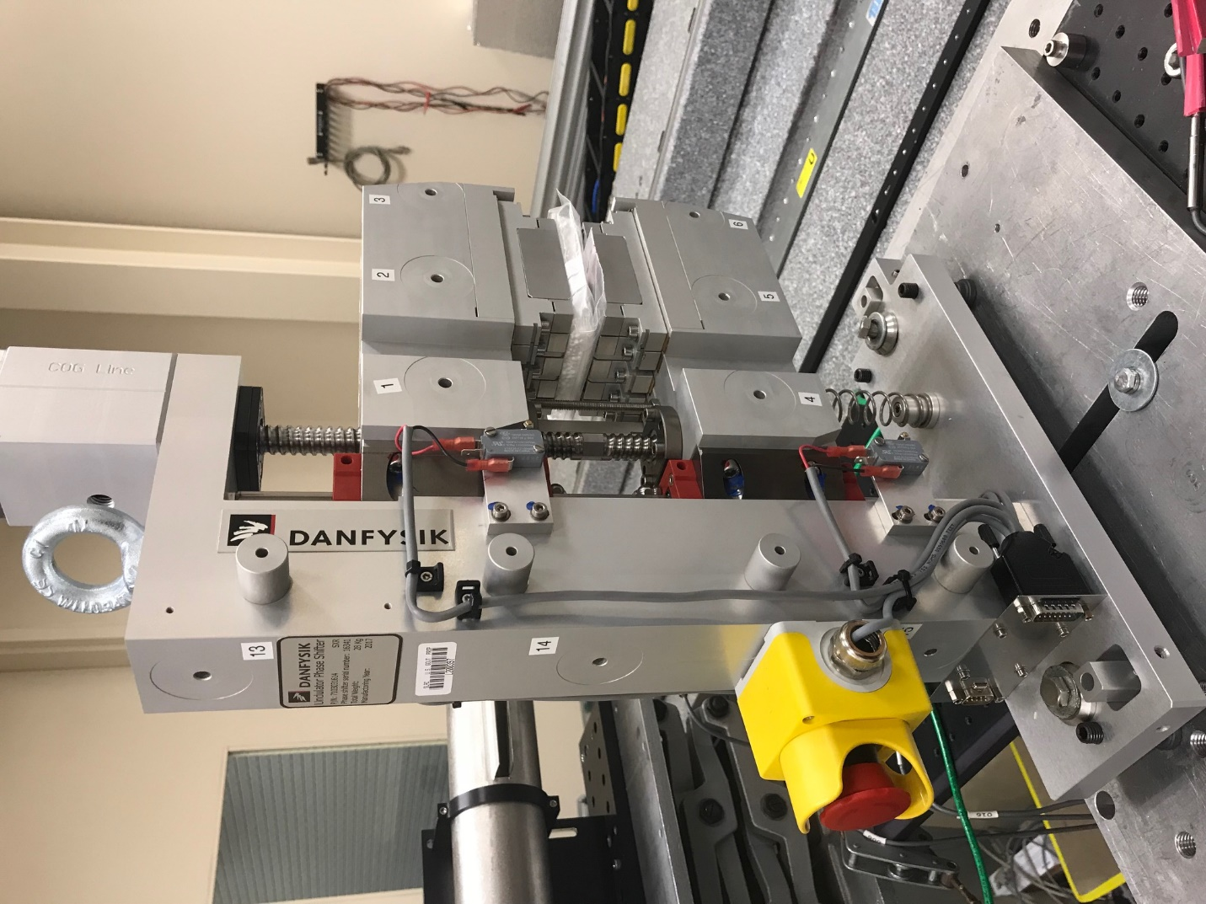
TB1
TB2
TB3
TB6
TB5
TB4
TB13
TB14
TB15
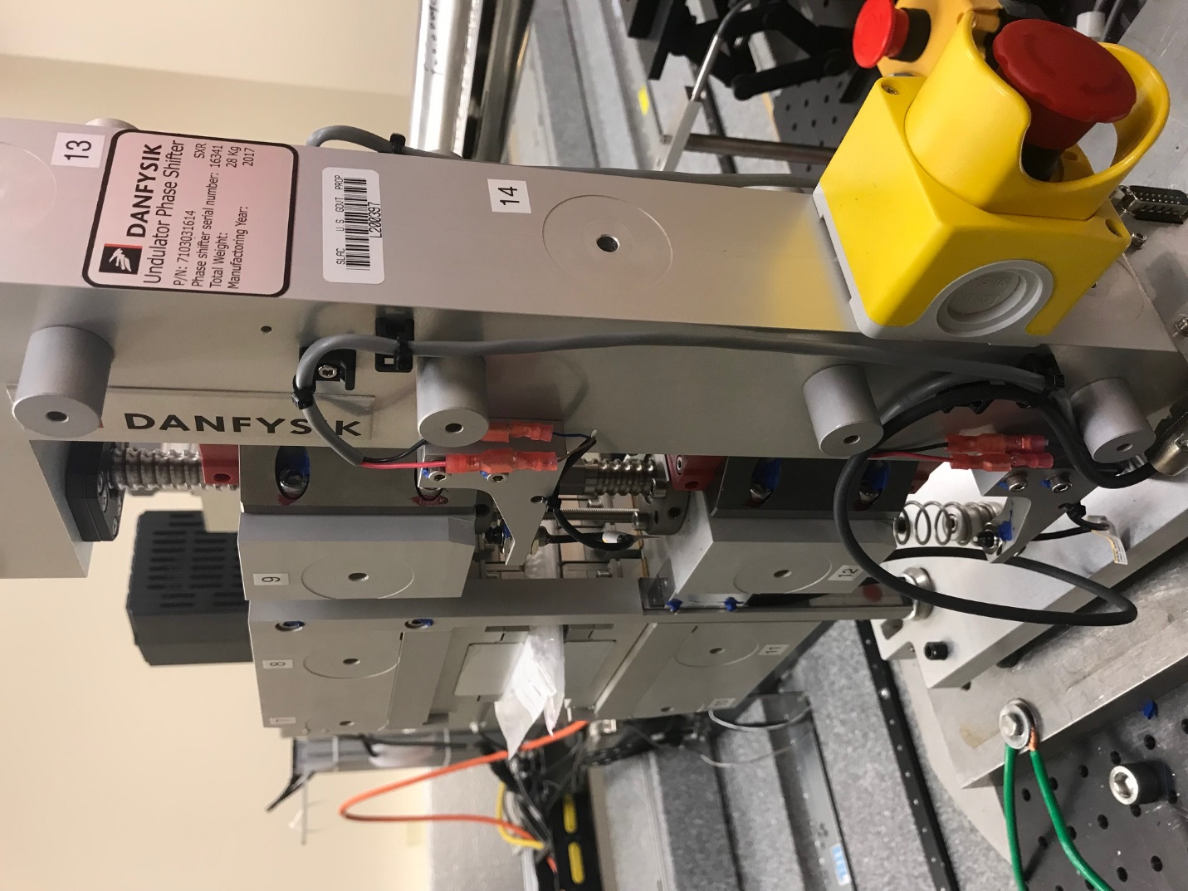
TB6
TB7
TB8
TB12

TB11
TB10
TB13
TB14
TB15

Tooling ball values to center of 1.5 inch sphere, all units are meter. Coordinates are to the HX Phase Shifter Magnetic Axis.
Tooling Ball | Z [m] | X [m] | Y [m]
TB1 | -0.069786 | 0.109334 | 0.083393
TB2 | -0.069920 | 0.026849 | 0.083394
TB3 | -0.070055 | -0.055679 | 0.083371
TB4 | -0.070006 | 0.109328 | -0.083187
TB5 | -0.070159 | 0.026828 | -0.083128
TB6 | -0.070312 | -0.055657 | -0.083040
TB7 | 0.070263 | -0.055891 | 0.083069
TB8 | 0.070416 | 0.026623 | 0.083092
TB9 | 0.070564 | 0.109116 | 0.083105
TB10 | 0.069977 | -0.055960 | -0.083378
TB11 | 0.070152 | 0.026565 | -0.083463
TB12 | 0.070314 | 0.109052 | -0.083464
TB13 | 0.001013 | 0.268404 | 0.186817
TB14 | 0.000666 | 0.268362 | 0.016825
TB15 | 0.000387 | 0.268330 | -0.153221

