LCLS2 HX Phase Shifter

Alignment Engineering Group
L201251
SN HXPS-16311
May 24, 2018

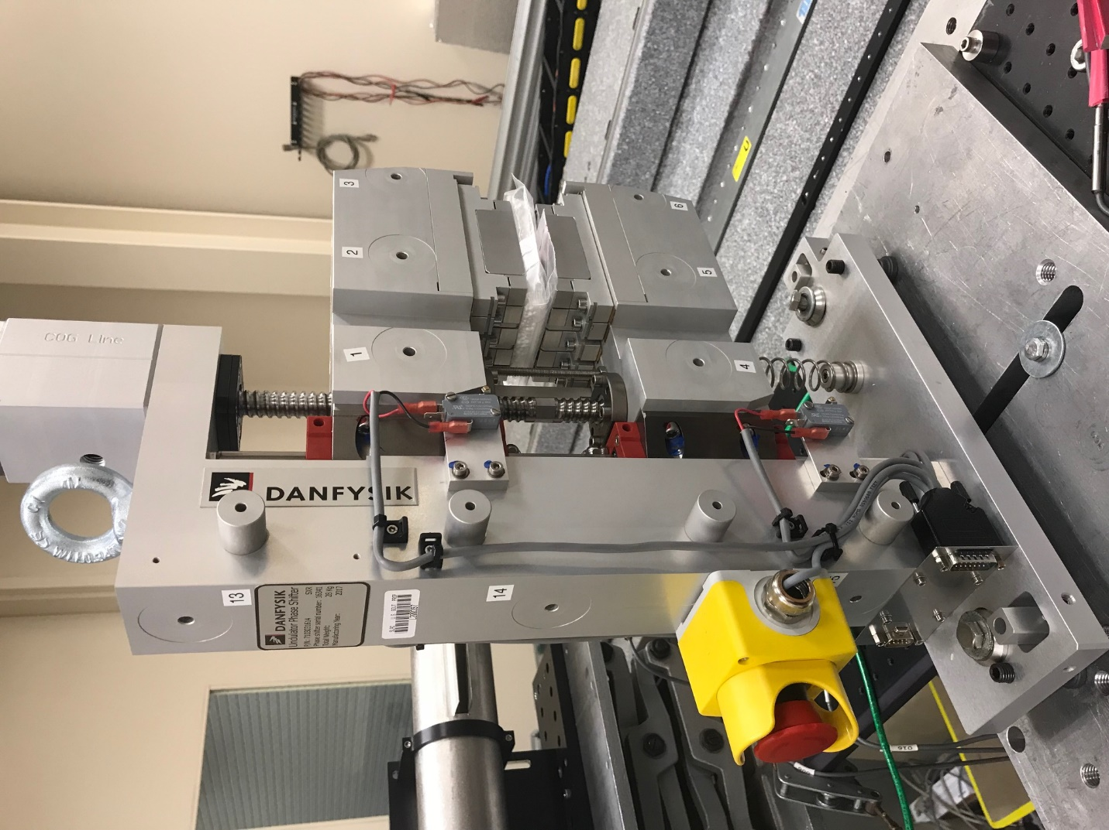
TB1
TB2
TB3
TB6
TB5
TB4
TB13
TB14
TB15
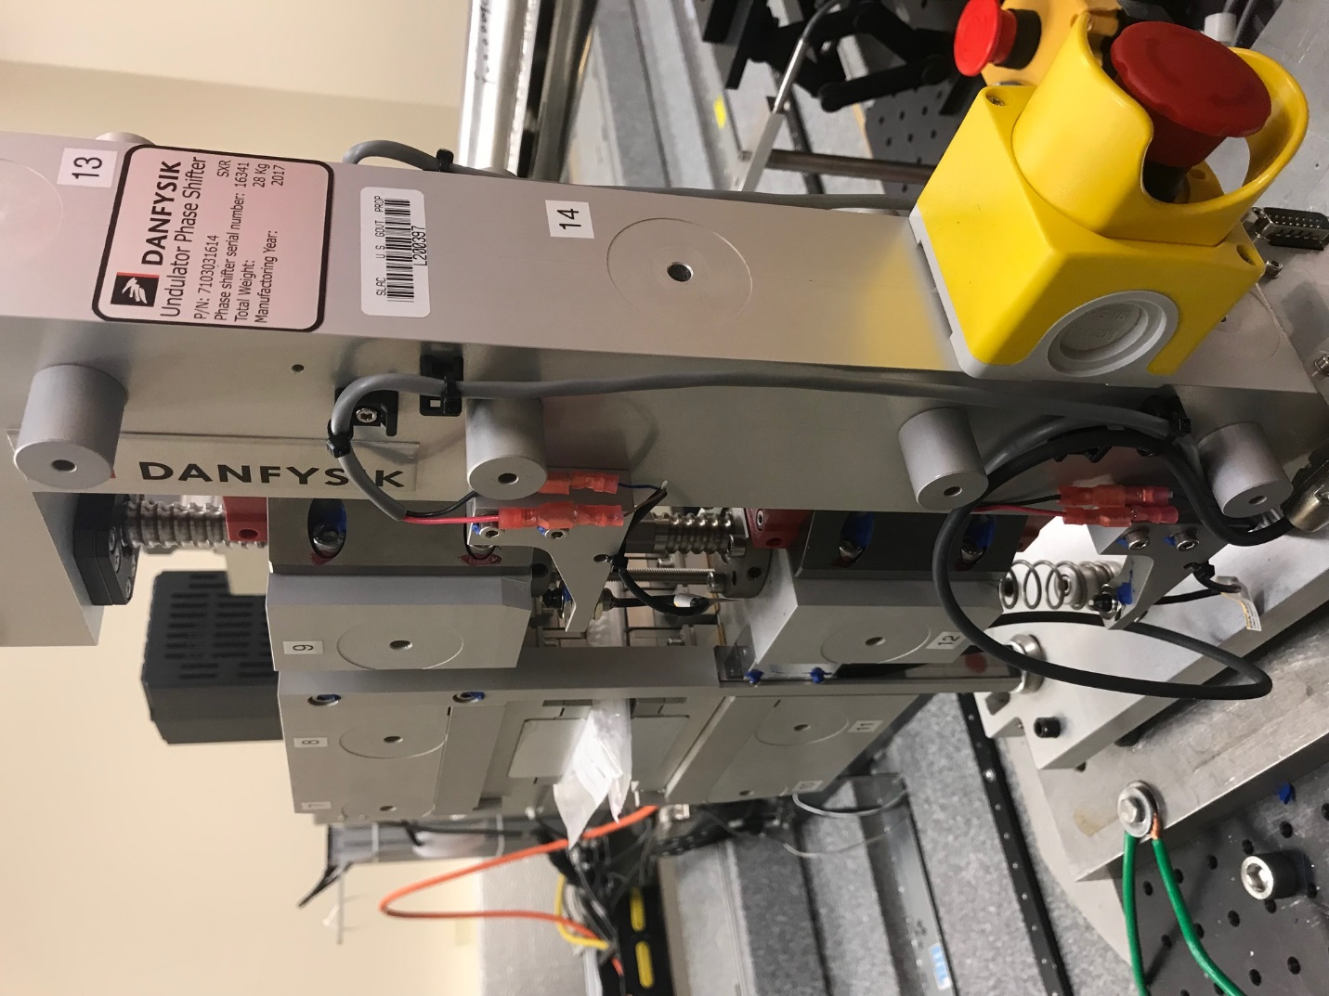
TB6
TB7
TB8
TB12

TB11
TB10
TB13
TB14
TB15

Tooling ball values to center of 1.5 inch sphere, all units are meter. Coordinates are to the HX Phase Shifter Magnetic Axis.
Tooling Ball | Z [m] | X [m] | Y [m]
TB1 | -0.069928 | 0.109336 | 0.084142
TB2 | -0.069960 | 0.026828 | 0.084138
TB3 | -0.069998 | -0.055661 | 0.084120
TB4 | -0.070068 | 0.109356 | -0.084080
TB5 | -0.070111 | 0.026857 | -0.084073
TB6 | -0.070156 | -0.055631 | -0.084030
TB7 | 0.070336 | -0.055712 | 0.083956
TB8 | 0.070380 | 0.026799 | 0.083995
TB9 | 0.070421 | 0.109315 | 0.084012
TB10 | 0.070125 | -0.055716 | -0.084147
TB11 | 0.070184 | 0.026805 | -0.084192
TB12 | 0.070235 | 0.109300 | -0.084158
TB13 | 0.000370 | 0.268533 | 0.185920
TB14 | 0.000301 | 0.268524 | 0.015933
TB15 | 0.000193 | 0.268547 | -0.154106

