LCLS2 HX Phase Shifter

Alignment Engineering Group
L201250
SN HXPS-16310
May 22, 2018

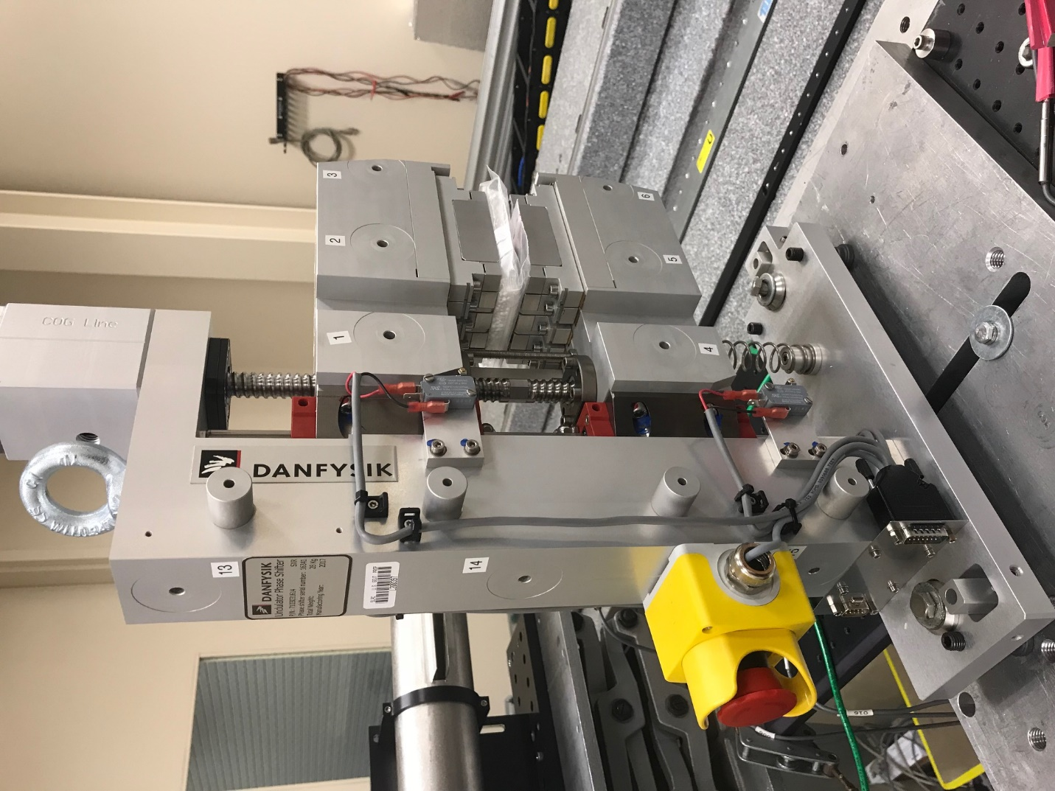
TB1
TB2
TB3
TB6
TB5
TB4
TB13
TB14
TB15
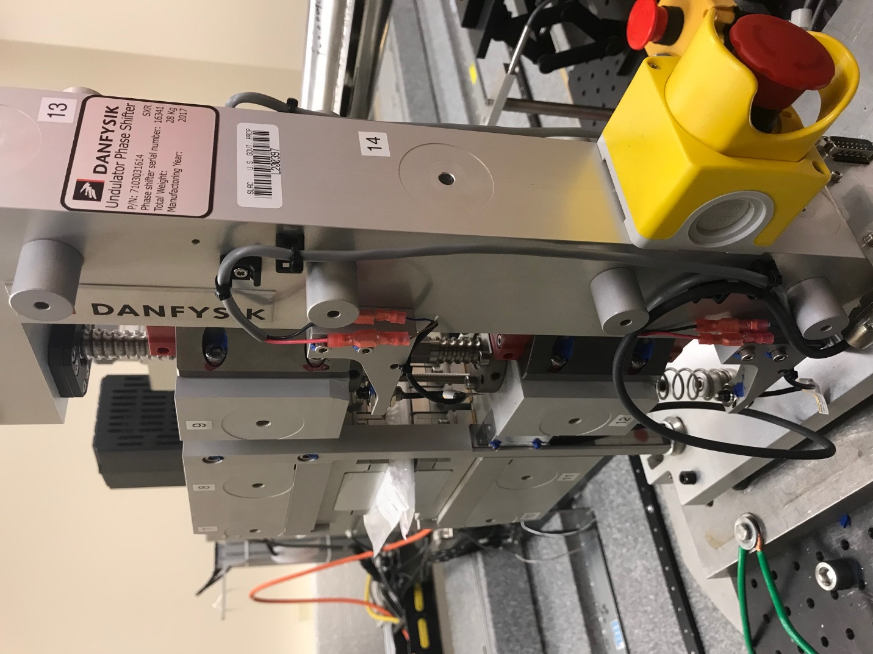
TB6
TB7
TB8
TB12

TB11
TB10
TB13
TB14
TB15

Tooling ball values to center of 1.5 inch sphere, all units are meter. Coordinates are to the HX Phase Shifter Magnetic Axis.
Tooling Ball | Z [m] | X [m] | Y [m]
TB1 | -0.069949 | 0.108975 | 0.083323
TB2 | -0.070036 | 0.026494 | 0.083376
TB3 | -0.070119 | -0.056035 | 0.083375
TB4 | -0.069956 | 0.108912 | -0.083365
TB5 | -0.070055 | 0.026414 | -0.083305
TB6 | -0.070153 | -0.056100 | -0.083196
TB7 | 0.070200 | -0.056144 | 0.083125
TB8 | 0.070297 | 0.026353 | 0.083120
TB9 | 0.070395 | 0.108869 | 0.083070
TB10 | 0.070168 | -0.056281 | -0.083365
TB11 | 0.070277 | 0.026232 | -0.083453
TB12 | 0.070381 | 0.108744 | -0.083481
TB13 | 0.000596 | 0.268199 | 0.186427
TB14 | 0.000510 | 0.268101 | 0.016451
TB15 | 0.000437 | 0.268011 | -0.153527

