LCLS2 HX Phase Shifter

Alignment Engineering Group
L200389
SN HXPS-16304
June 6, 2018

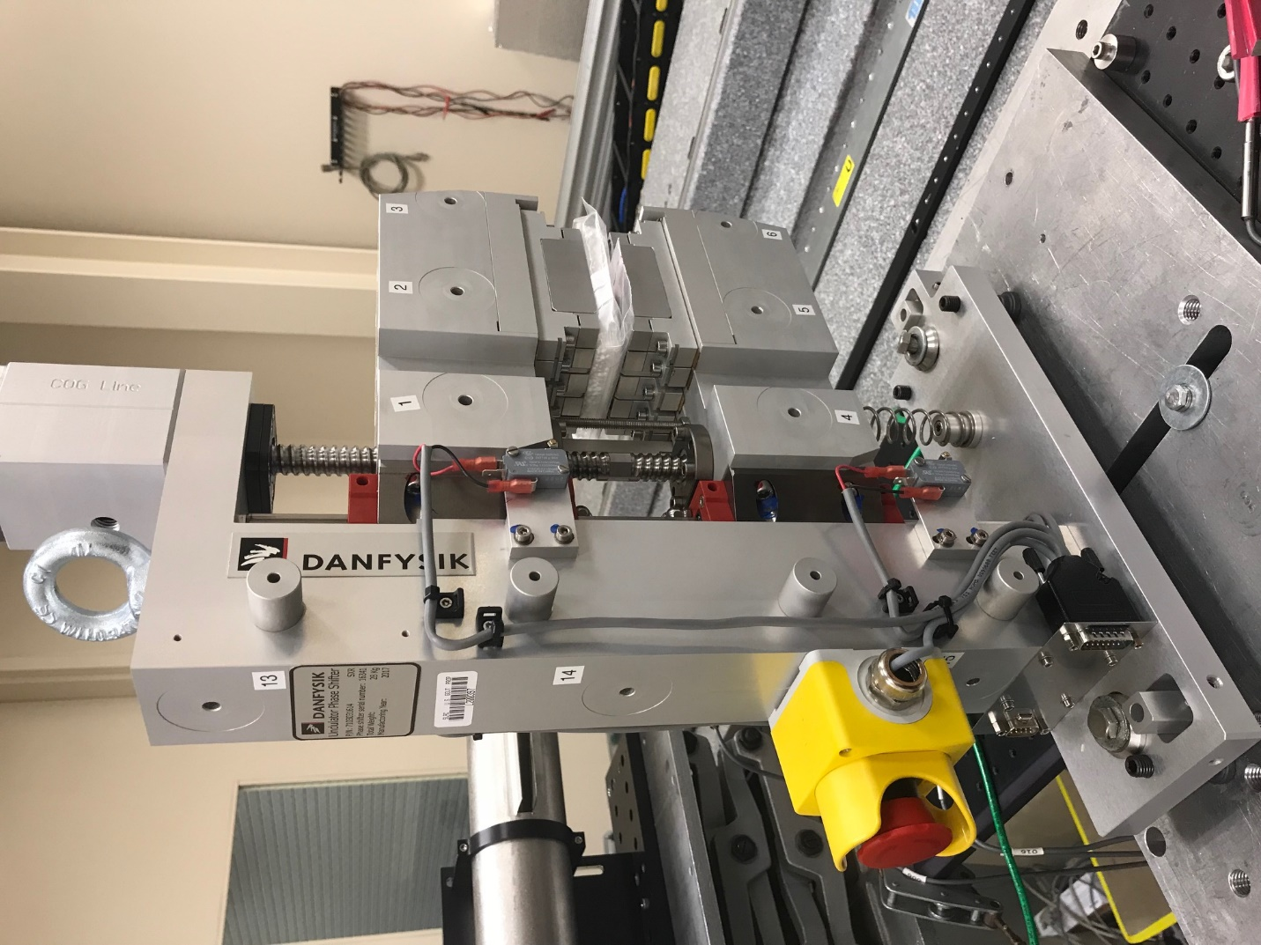
TB1
TB2
TB3
TB6
TB5
TB4
TB13
TB14
TB15
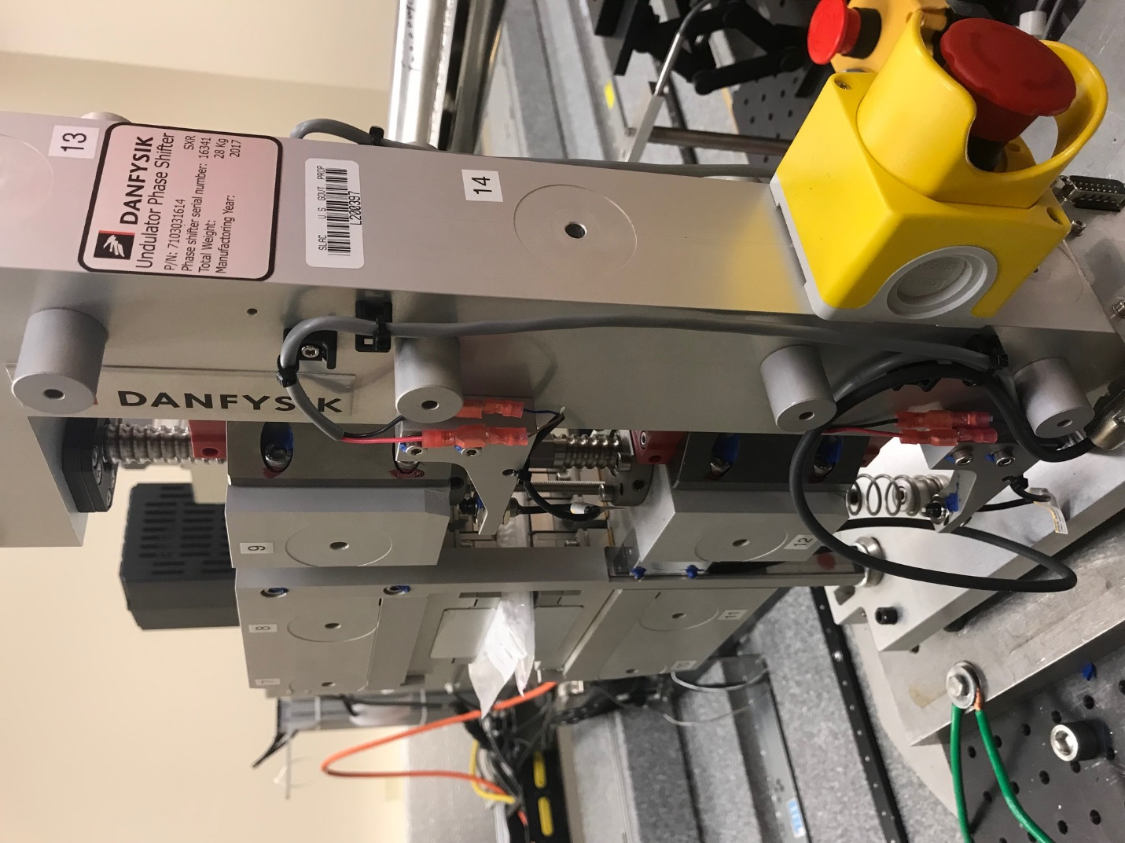
TB6
TB7
TB8
TB12

TB11
TB10
TB13
TB14
TB15

Tooling ball values to center of 1.5 inch sphere, all units are meter. Coordinates are to the HX Phase Shifter Magnetic Axis.
Tooling Ball | Z [m] | X [m] | Y [m]
TB1 | -0.070150 | 0.108569 | 0.099043
TB2 | -0.070163 | 0.026064 | 0.099021
TB3 | -0.070170 | -0.056431 | 0.099017
TB4 | -0.069956 | 0.108582 | -0.099189
TB5 | -0.070005 | 0.026097 | -0.099189
TB6 | -0.070054 | -0.056388 | -0.099119
TB7 | 0.070128 | -0.056418 | 0.099161
TB8 | 0.070158 | 0.026075 | 0.099170
TB9 | 0.070176 | 0.108581 | 0.099175
TB10 | 0.070266 | -0.056508 | -0.099049
TB11 | 0.070331 | 0.025992 | -0.099097
TB12 | 0.070390 | 0.108513 | -0.099085
TB13 | 0.000193 | 0.267746 | 0.185999
TB14 | 0.000268 | 0.267702 | 0.015985
TB15 | 0.000418 | 0.267679 | -0.154019

