LCLS2 HX Phase Shifter

Alignment Engineering Group
L200401
SN HXPS-16303
July 19, 2018

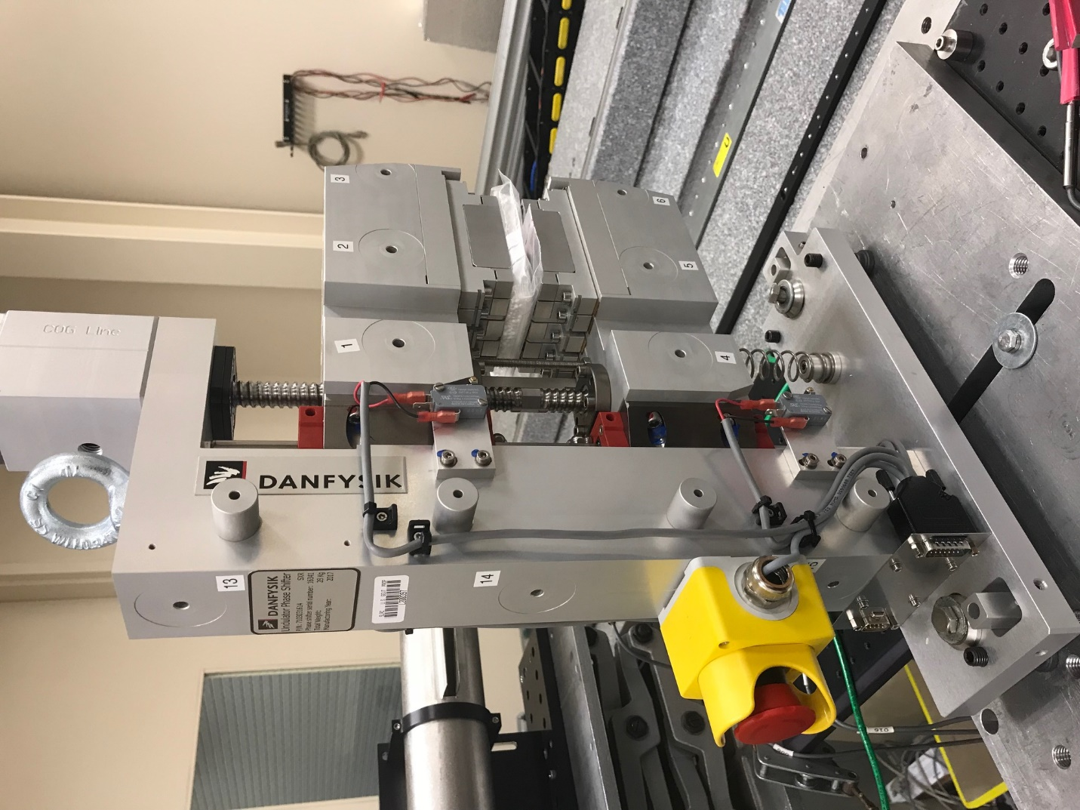
TB1
TB2
TB3
TB6
TB5
TB4
TB13
TB14
TB15
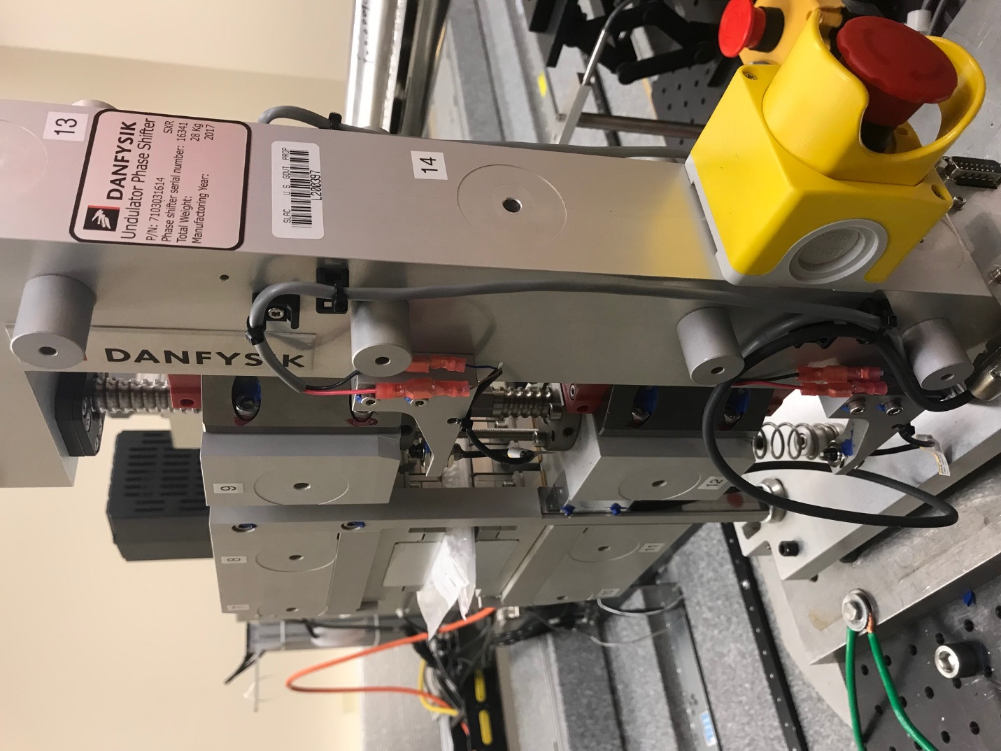
TB6
TB7
TB8
TB12

TB11
TB10
TB13
TB14
TB15

Tooling ball values to center of 1.5 inch sphere, all units are meter. Coordinates are to the HX Phase Shifter Magnetic Axis.
Tooling Ball | Z [m] | X [m] | Y [m]
TB1 | -0.070530 | 0.108920 | 0.084476
TB2 | -0.070620 | 0.026429 | 0.084467
TB3 | -0.070711 | -0.056080 | 0.084455
TB4 | -0.070533 | 0.108958 | -0.084564
TB5 | -0.070655 | 0.026472 | -0.084544
TB6 | -0.070776 | -0.056015 | -0.084526
TB7 | 0.069696 | -0.056248 | 0.084413
TB8 | 0.069790 | 0.026248 | 0.084440
TB9 | 0.069890 | 0.108754 | 0.084445
TB10 | 0.069608 | -0.056281 | -0.084578
TB11 | 0.069743 | 0.026214 | -0.084586
TB12 | 0.069870 | 0.108745 | -0.084535
TB13 | 0.000074 | 0.267986 | 0.186333
TB14 | -0.000009 | 0.267991 | 0.016332
TB15 | -0.000101 | 0.267998 | -0.153676

