SLAC Traveler for LCLS-II 3D8.8, SA-236-406-30 Dipole Corrector Magnet
(Oct. 3, 2018)

This traveler is intended to cover reception, preparation, mechanical fiducialization, and magnetic measurements of one of the 3D8.8 vertical dipole magnets that have been proposed to be used for BYCUS1, BYCUS2 in the Cu to SXR beamline. This measurement plan is to evaluate the suitability of the 3D8.8 for use in the Cu to SXR beamline.

Receiving:
The following information is to be noted upon receipt of the magnets by the SLAC MM group:
Received by (initials): | SDA
Date placed on test stand (dd-mmm-yyyy): | 10/4/2018
SLAC barcode number: | FFTB 3D8.8 # 17
Vendor serial number from magnet label: | 17
SLAC approved electrical safety covers? (Y or N): | N
SLAC approved lifting eyes? (Y or N): | N
Shipping Damage? (Y or N): | N
Vendor tests passed on magnet label? (Y or N): | N
SLAC drawing number (enter number): | SA-236-406-30

Preparation:
A beam direction arrow, with text “beam direction”, is to be applied to the top and/or connector side of the magnet with a sticker supplied by LCLS-II. The terminals shall be oriented down beam.
Beam-direction arrow in place (initials): | SDA

Fiducialization:
Fiducialization may be done before or after magnetic measurements. The magnet is to be fiducialized by the CMM group. This will require the installation of removable tooling balls, location of the geometric axis of the poles of the magnet, and location of tooling balls with respect to the center of this geometric axis when the poles are aligned precisely horizontal.

CMM technician (initials): | BR

URL of on-line CMM fiducialization data (please modify or correct if necessary):

Magnetic Measurements:
- Verify that the magnets are complete and undamaged, including wiring connections.
Incoming inspection OK (initials): | SDA
Date of arrival to mag. meas.(mmm-dd-yyyy): | 10/4/2018

Enter URL of on-line magnetic measurements data (please modify or correct if necessary):
http://www-group.slac.stanford.edu/met/MagMeas/MAGDATA/LCLS-II/Dipole/3D8.8

- Determine the main-coil connection polarity (with main supply outputting positive current) which produces a “positive” field polarity as shown below:

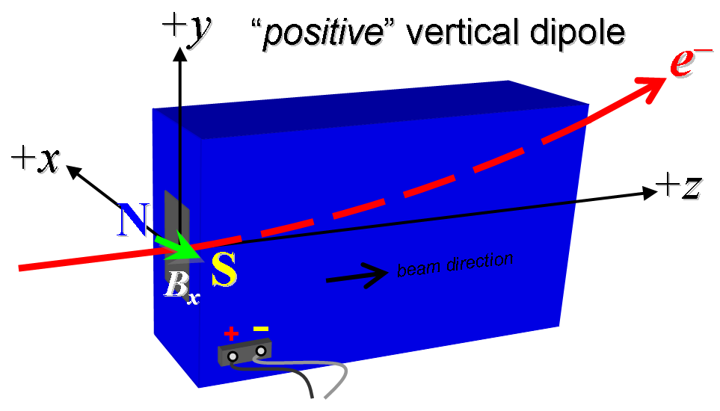

Figure 1. “Positive” polarity (bending electrons up).
- Mark the polarity near the magnet leads with clear “+” and “−” labels as shown above.
Polarity is marked according to Fig. 1 (initials): | SDA

- Connect the magnet terminals, in the correct polarity as established above, to a bipolar power supply with maximum current I ≥ 6 A.

- Standardize the magnet, starting from zero to 6 A then to back to zero, through three full cycles, finally ending at zero, with a flat-top pause time (at 6 A) of 10 seconds. Use a three linear ramp rate of 1 A/sec, if possible, and record the ramp rate used.
Standardization complete (initials): | SDA
Ramp rate used (A/sec): | 1 A/sec

- Maintaining this cycle history, measure the length-integrated horizontal dipole field, ∫B_{y}dl, from 0 to 6 A in 0.5-A steps, including zero (13 ‘up’ measurements). Then, still maintaining the cycle history, measure ∫B_{y}dl back down from 6 A to 0 in 0.5-A steps, including zero (13 ‘down’ measurements).
Filename & run number of ∫B_{y}dl up & down data: | Wiredat.ru3, wireplt.ru3

- Standardize the magnet, starting from zero to 6 A then to back to zero, through three full cycles, finally ending at zero, with a flat-top pause time (at 6 A) of 10 seconds. Use a three linear ramp rate of 1 A/sec, if possible, and record the ramp rate used.
Standardization complete (initials): | SDA
Ramp rate used (A/sec): | 1 A/sec

- With main coil at 4A, use a stretched wire to measure the length-integrated vertical field at multiple positions in x. With the wire located at the vertical mid-plane (y = 0), measure the vertical length-integrated field at each 3-mm step of horizontal wire position, from x = −30 mm to +30 mm, with x = 0 centered at the magnet’s horizontal center. Record data file name:
Filename: | Wirevsx.ru5, wirepltvsx.ru5

- With main coil at 6A, use a stretched wire to measure the length-integrated horizontal field at multiple positions in x. With the wire located at the vertical mid-plane (y = 0), measure the vertical length-integrated field at each 3-mm step of horizontal wire position, from x = −30 mm to +30 mm, with x = 0 centered at the magnet’s horizontal center. Record data file name:
Filename: | Wirevsx.ru4, wirepltvsx.ru4

- Standardize the magnet, starting from zero to 6 A then to back to zero, through three full cycles, finally ending at zero, with a flat-top pause time (at 6 A) of 10 seconds. Use a three linear ramp rate of 1 A/sec, if possible, and record the ramp rate used.
Standardization complete (initials): | SDA
Ramp rate used (A/sec): | 1 A/sec

- Use a rotating coil to measure the harmonics with main coil at 0A, 2A, 4A, 6A with at least a 0.5-inch diameter (use smaller probe only if 0.5-inch is not available, staying with largest diameter possible). Record probe designation, radius, and data file names:
Coil designation (text): | 48BC1.6
Coil radius (m): | 0.01954603 m
Filename: | Hardat.r11, harplt.r11

- Standardize the magnet, starting from zero to 6 A then to back to zero, through three full cycles, finally ending at zero, with a flat-top pause time (at 6 A) of 10 seconds. Use a three linear ramp rate of 1 A/sec, if possible, and record the ramp rate used.
Standardization complete (initials): | SDA
Ramp rate used (A/sec): | 1 A/sec

- At a current of 6A, measure the vertical magnetic field component, By, at x = y = 0, as a function of the longitudinal beam-direction coordinate, z (from -5 cm to +20 cm in 1-cm steps, where z = 0 is defined at the iron edge), at both the downstream and upstream ends of the magnet. Please also measure the background field at z = -20 cm with magnet switched off (separate file).
Filenames of B_{y} vs. z data: | bhvszdat.ru2, bhvszplt.ru2
Background filenames of B_{y}(z = +/-20 cm), magnet OFF: | bhvszdat.ru1, bhvszplt.ru1

- Run the best degauss procedure known using cycling of the main coil current (trim current at zero) and record the smallest final measured |∫B_{y}dl| achievable and reproducible with I_{main} = 0. Please also finish the degauss procedure with a positive step, by setting the current in the positive direction to zero (i.e., from I_{main} < 0 to I_{main} = 0). Record the degauss procedure applied (ramp rate, hold times, current sequence, etc). See file SRXSS Dipole Degauss Procedure.docx for more details.
De-Gauss procedure’s achieved mean |∫B_{y}dl|: | 3.77e-5 +/- 0.46e-5 Tm
Measurements used for mean and stdev. | Wiredat.ru6, wireplt.ru6
Ramp rate and Type: | 6 A/sec, 3-Linear
Hold times: | 2 sec
Current sequence: | 0.0, 6.0000, -5.2800, 4.6464, -4.0888, 3.5982, -3.1664, 2.7864, -2.4521, 2.1578, -1.8989, 1.6710, -1.4705, 1.2940, -1.1387, 1.0021, -0.8818, 0.7760, -0.6829, 0.6010, -0.5288, 0.4654, -0.4095, 0.3604, -0.3171, 0.2791, -0.2456, 0.2161, -0.1902, 0.1674, -0.1473, 0.1296, -0.1141, 0.1004, -0.0883, 0.0777, -0.0684, 0.0602, -0.0530, 0.0466, -0.0410, 0.0361, -0.0318, 0.0280, -0.0246, 0.0216, -0.0190, 0.0168, -0.0148, 0.0130, -0.0114, 0.0

- Standardize the magnet, starting from zero to 6 A then to back to zero, through three full cycles, finally ending at zero, with a flat-top pause time (at 6 A) of 10 seconds. Use a three linear ramp rate of 1 A/sec, if possible, and record the ramp rate used.
Standardization complete (initials): | SDA
Ramp rate used (A/sec): | 1 A/sec

- Maintaining this cycle history, measure the length-integrated horizontal dipole field, ∫B_{y}dl, from 0 to 6 A in 0.5-A steps, including zero (13 ‘up’ measurements). Then, still maintaining the cycle history, measure ∫B_{y}dl back down from 6 A to 0 in 0.5-A steps, including zero (13 ‘down’ measurements).
Filename & run number of ∫B_{y}dl up & down data: | Wiredat.ru8. wireplt.ru8

- Run the magnet up to 6 A for 6 hours to warm it up (record temperature).
Ambient temperature (°C): | 21.6 °C
Final magnet core temperature (°C): | 31.1 °C
Final magnet coil temperature (°C): | 37.6 °C

- Measure the inductance and resistance of the main magnet coils:
Inductance of main coil (mH): | 66.1 mH
Resistance of main coil (Ohms): | 1.669 Ohm

- Measure pole tip field of the main at 6 A
Pole Tip Field and Current | 0.09961 T at 6.000 Amps

- Upon completion of tests, send data link to Mark Woodley who will produce a data analysis file. Place data analysis file in magnetic measurements data directory
Magnet data accepted and data analysis file produced

Enter URL of on-line magnetic measurements analysis data :

