LCLS2 HE SXR Undulator

Alignment Engineering Group
L2?????
SN 29A804-029
January 29, 2025

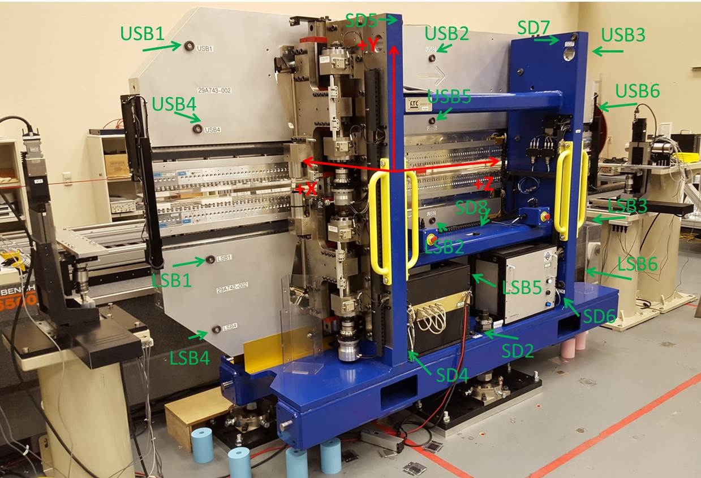

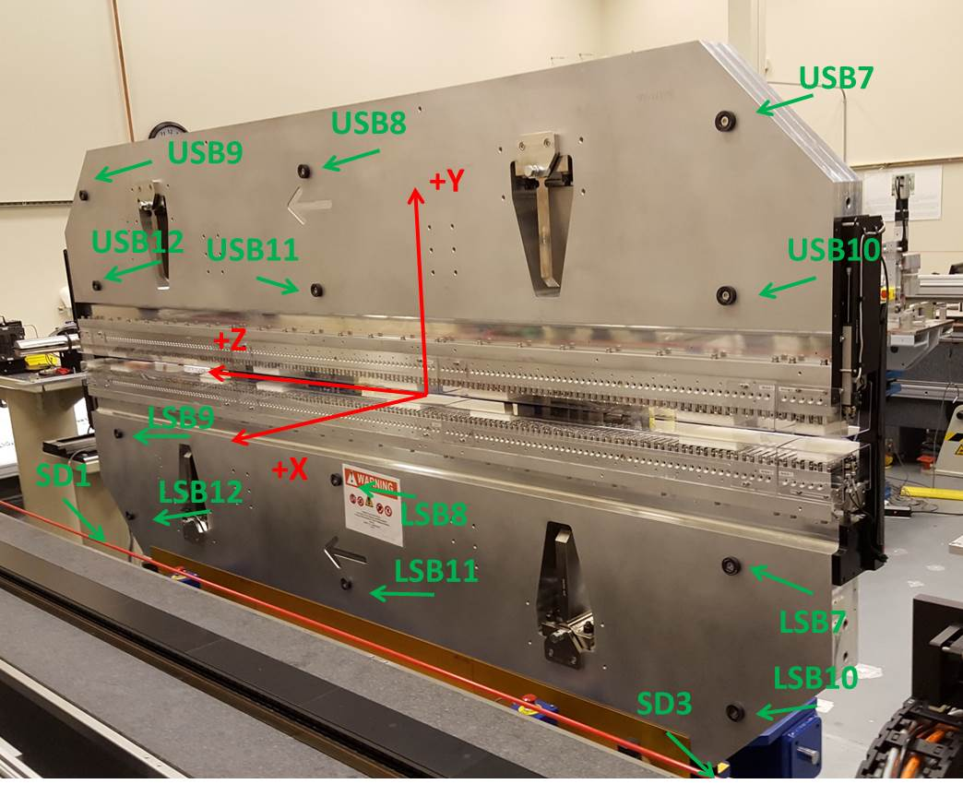

Tooling ball values to center of 1.5 inch sphere, all units are inches. Coordinates are to the SXR Undulator Magnetic Axis.
Tooling Ball | Z (in) | X (in) | Y (in)
LSB1 | -57.4854 | -3.4855 | -10.4846
LSB2 | -0.0157 | -3.4876 | -10.4909
LSB3 | 57.4611 | -3.4854 | -10.4885
LSB4 | -57.4769 | -3.4820 | -24.2780
LSB5 | 0.0039 | -3.4857 | -24.2681
LSB6 | 57.4615 | -3.4821 | -24.2703
LSB7 | -57.4781 | 3.4898 | -10.4854
LSB8 | -0.0004 | 3.4870 | -10.4857
LSB9 | 57.4656 | 3.4893 | -10.4879
LSB10 | -57.4886 | 3.4936 | -24.2604
LSB11 | 0.0015 | 3.4903 | -24.2740
LSB12 | 57.4698 | 3.4947 | -24.2672
SD1 | 50.9791 | 7.2601 | -34.7563
SD2 | -3.9317 | -19.5518 | -34.8094
SD3 | -50.9961 | 7.1929 | -34.7406
SD4
SD5 | -25.4826 | -21.6079 | 29.3852
SD6
SD7 | 25.6857 | -21.6444 | 29.3772
SD8 | 0.0440 | -16.9311 | -12.3649
USB1 | -57.4513 | -3.4903 | 24.2605
USB2 | 0.0267 | -3.4863 | 24.2652
USB3 | 57.5133 | -3.4914 | 24.2765
USB4 | -57.4393 | -3.4891 | 10.4800
USB5 | 0.0402 | -3.4863 | 10.4965
USB6 | 57.5104 | -3.4909 | 10.4984
USB7 | -57.4478 | 3.4862 | 24.2727
USB8 | 0.0430 | 3.4907 | 24.2572
USB9 | 57.5163 | 3.4866 | 24.2727
USB10 | -57.4447 | 3.4881 | 10.4798
USB11 | 0.0257 | 3.4901 | 10.4894
USB12 | 57.5144 | 3.4851 | 10.4789

Center | Z (m) | X (m) | Y (m) | Z (in) | X (in) | Y (in)
PM10M | -2.818824 | -0.026414 | 0.000565 | -110.9773 | -1.0399 | 0.0222
PM11M | 2.722817 | -0.026742 | 0.000594 | 107.1975 | -1.0528 | 0.0234
RFM | -2.674061 | 0.048563 | -0.000118 | -105.2780 | 1.9119 | -0.0046

PM10 and Granite coordinate system with Yurii shifts.
 |  | From Yurii |  |  | Measured
Device | Z (m) | X (m) | Y (m) | Z (m) | X (m) | Y (m) | dX (mm) | dY (mm)
PM10 | -2.818824 | -0.026418 | 0.000583 | -2.818824 | -0.026414 | 0.000565 | 0.004 | -0.018
PM11 | 2.722778 | -0.026738 | 0.000576 | 2.722817 | -0.026742 | 0.000594 | -0.004 | 0.018
Ref Block |  |  |  | -2.674061 | 0.048563 | -0.000118

