LCLS2 HE SXR Undulator

Alignment Engineering Group
L2?????
SN 29A804-028
February 27, 2025

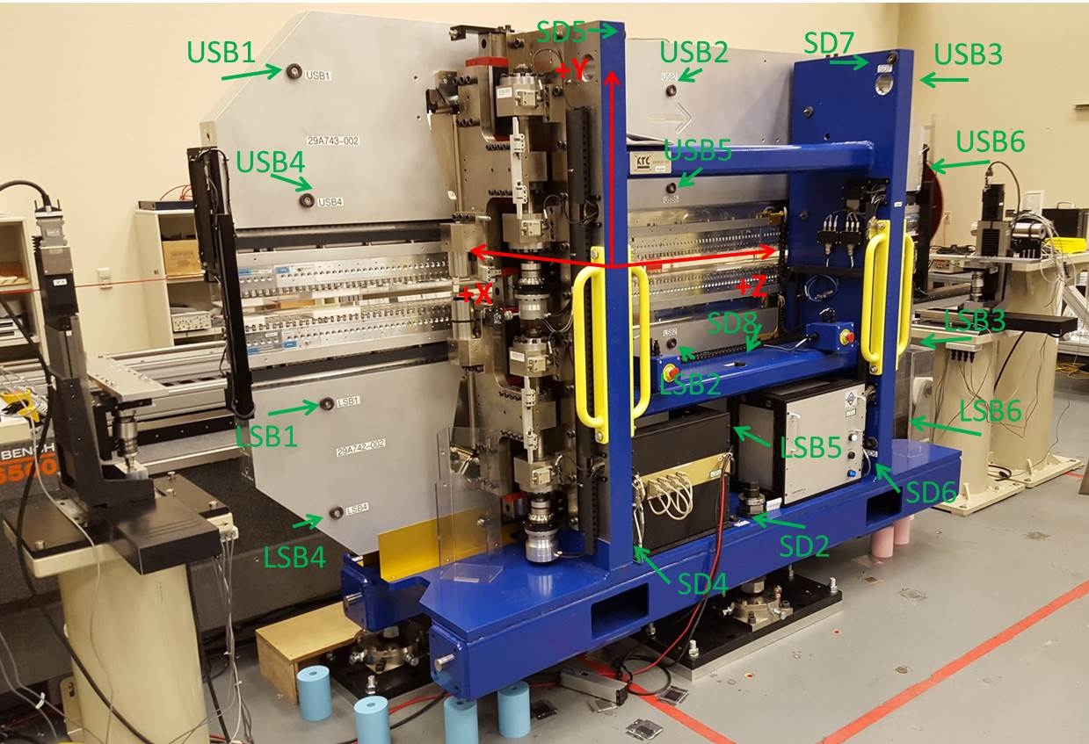

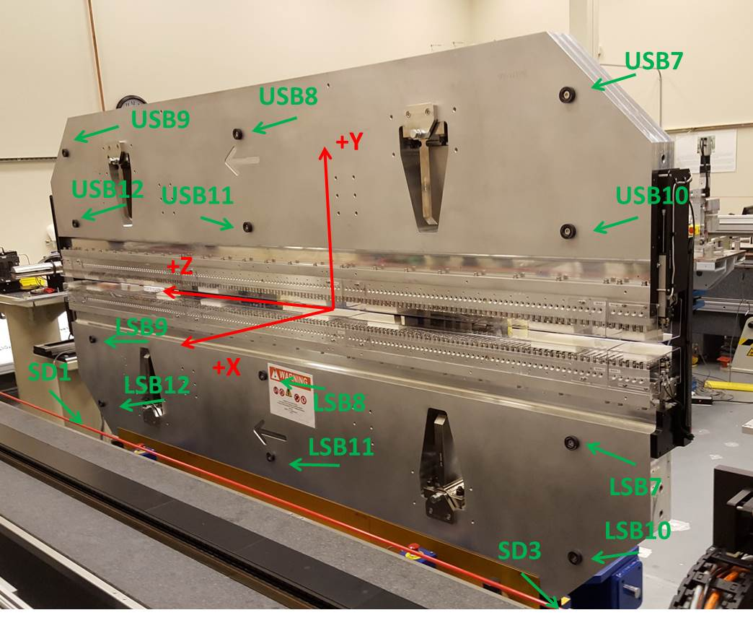

Tooling ball values to center of 1.5 inch sphere, all units are inches. Coordinates are to the SXR Undulator Magnetic Axis.
Tooling Ball | Z (in) | X (in) | Y (in)
LSB1 | -57.4830 | -3.4802 | -10.4981
LSB2 | -0.0180 | -3.4776 | -10.4984
LSB3 | 57.4646 | -3.4884 | -10.4910
LSB4 | -57.4921 | -3.4746 | -24.2766
LSB5 | -0.0178 | -3.4751 | -24.2785
LSB6 | 57.4654 | -3.4846 | -24.2748
LSB7 | -57.4919 | 3.4967 | -10.4970
LSB8 | -0.0046 | 3.4983 | -10.4911
LSB9 | 57.4680 | 3.4882 | -10.4789
LSB10 | -57.4890 | 3.5007 | -24.2792
LSB11 | -0.0098 | 3.5028 | -24.2767
LSB12 | 57.4719 | 3.4923 | -24.2787
SD1 | 51.0026 | 7.2097 | -34.6001
SD2 | -3.9276 | -19.5443 | -34.6539
SD3 | -50.9607 | 7.2246 | -34.5834
SD4 | -25.5973 | -21.4887 | -29.4860
SD5 | -25.6276 | -21.6679 | 29.5472
SD6 | 25.5822 | -21.6076 | -29.5044
SD7 | 25.5833 | -21.5995 | 29.5293
SD8 | -0.0265 | -16.9760 | -12.2228
USB1 | -57.4793 | -3.4814 | 24.2629
USB2 | -0.0133 | -3.4795 | 24.2736
USB3 | 57.4769 | -3.4870 | 24.2754
USB4 | -57.4758 | -3.4863 | 10.4983
USB5 | -0.0114 | -3.4831 | 10.4842
USB6 | 57.4790 | -3.4879 | 10.4815
USB7 | -57.4834 | 3.4965 | 24.2565
USB8 | -0.0064 | 3.4959 | 24.2754
USB9 | 57.4708 | 3.4903 | 24.2720
USB10 | -57.4809 | 3.4893 | 10.4789
USB11 | 0.0071 | 3.4923 | 10.4842
USB12 | 57.4745 | 3.4889 | 10.4850

Center | Z (m) | X (m) | Y (m) | Z (in) | X (in) | Y (in)
PM10M | -2.818831 | -0.026359 | 0.000726 | -110.9776 | -1.0378 | 0.0286
PM11M | 2.722786 | -0.026686 | 0.000755 | 107.1963 | -1.0506 | 0.0297
RFM | -2.674073 | 0.048616 | 0.000047 | -105.2785 | 1.9140 | 0.0019

PM10 and Granite coordinate system with Yurii shifts.
 |  | From Yurii |  |  | Measured
Device | Z (m) | X (m) | Y (m) | Z (m) | X (m) | Y (m) | dX (mm) | dY (mm)
PM10 | -0.369065 | -0.102249 | 0.000771 | -2.818831 | -0.102249 | 0.000771 | 0.000 | 0.000
PM11 | 5.172612 | -0.102558 | 0.000810 | 2.722786 | -0.102576 | 0.000800 | -0.018 | -0.010
Ref Block |  |  |  | -2.674073 | -0.027274 | 0.000092

