LCLS2 HE SXR Undulator

Alignment Engineering Group
L2?????
SN 29A804-027
October 29, 2024

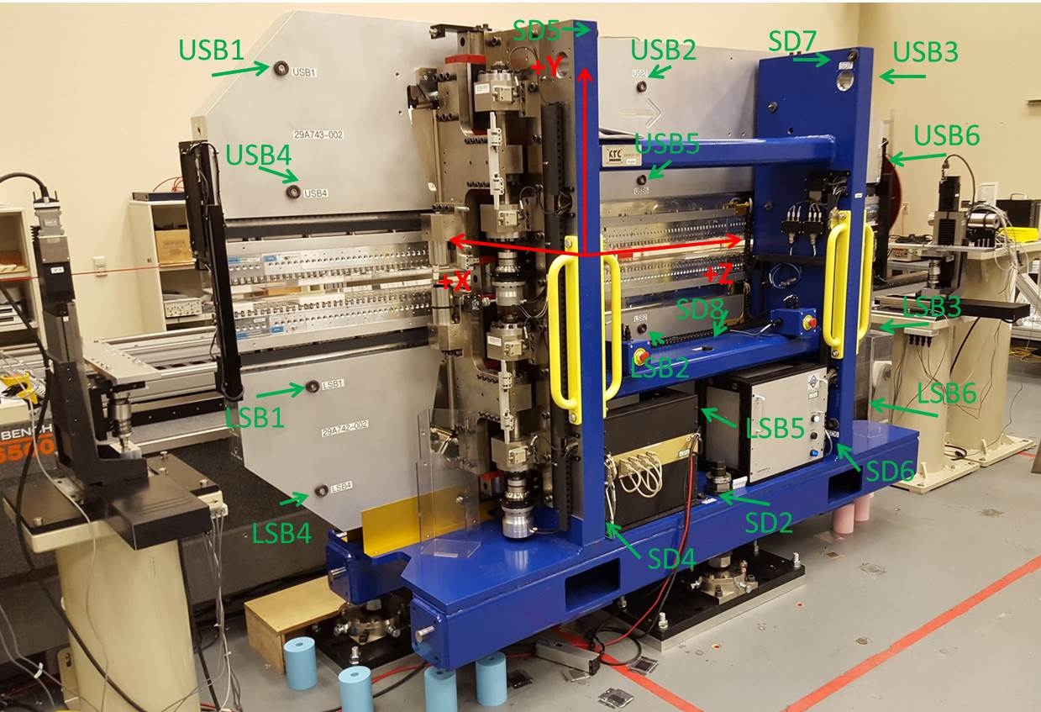

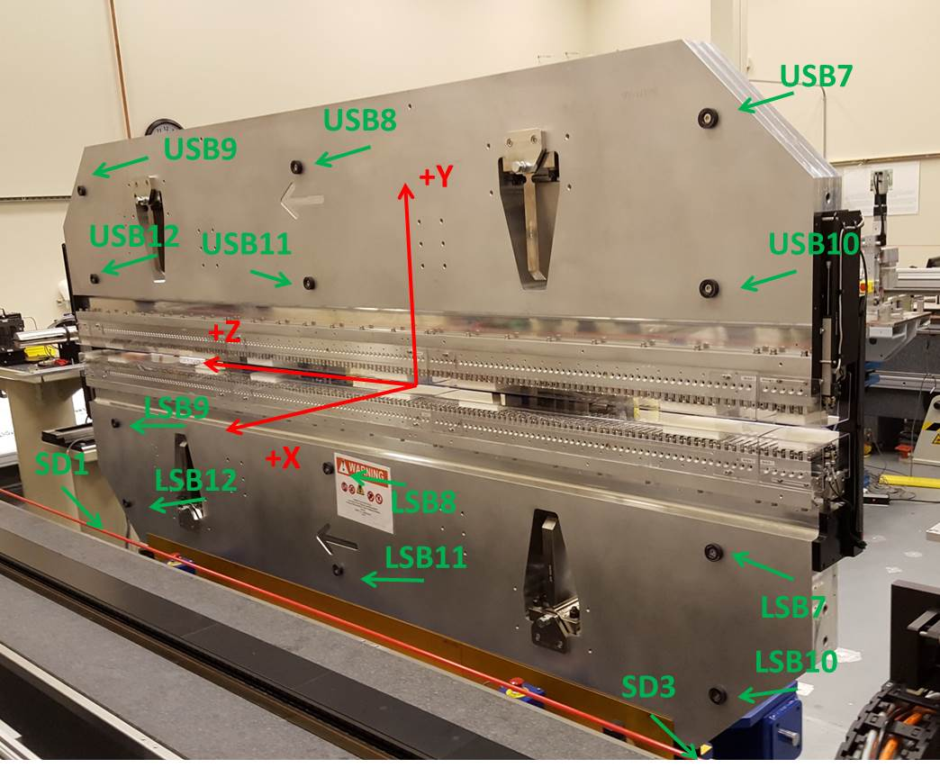

Tooling ball values to center of 1.5 inch sphere, all units are inches. Coordinates are to the SXR Undulator Magnetic Axis.
Tooling Ball | Z (in) | X (in) | Y (in)
LSB1 | -57.4989 | -3.4857 | -10.4805
LSB2 | -0.0068 | -3.4789 | -10.4926
LSB3 | 57.4681 | -3.4857 | -10.4837
LSB4 | -57.4927 | -3.4825 | -24.2709
LSB5 | -0.0207 | -3.4752 | -24.2635
LSB6 | 57.4719 | -3.4840 | -24.2639
LSB7 | -57.4900 | 3.4902 | -10.4848
LSB8 | -0.0103 | 3.4976 | -10.4886
LSB9 | 57.4631 | 3.4908 | -10.4861
LSB10 | -57.4876 | 3.4941 | -24.2634
LSB11 | -0.0151 | 3.5015 | -24.2601
LSB12 | 57.4648 | 3.4940 | -24.2658
SD1 | 50.9992 | 7.2467 | -34.4493
SD2 | -3.9226 | -19.5163 | -34.5098
SD3 | -50.9632 | 7.2482 | -34.4483
SD4 | -25.6182 | -21.6818 | -29.4052
SD5 | -25.6298 | -21.7215 | 29.6636
SD6 | 25.6242 | -21.5637 | -29.3638
SD7 | 25.6265 | -21.5397 | 29.7120
SD8 | 0.0390 | -16.9410 | -12.2571
USB1 | -57.4807 | -3.4937 | 24.2770
USB2 | -0.0131 | -3.4950 | 24.2686
USB3 | 57.4691 | -3.4840 | 24.2606
USB4 | -57.4910 | -3.4906 | 10.4945
USB5 | -0.0128 | -3.4961 | 10.4914
USB6 | 57.4636 | -3.4907 | 10.4904
USB7 | -57.4795 | 3.4836 | 24.2777
USB8 | 0.0048 | 3.4818 | 24.2751
USB9 | 57.4847 | 3.4917 | 24.2698
USB10 | -57.4737 | 3.4860 | 10.4972
USB11 | -0.0019 | 3.4803 | 10.4972
USB12 | 57.4736 | 3.4865 | 10.4902

Center | Z (m) | X (m) | Y (m) | Z (in) | X (in) | Y (in)
PM10M | -2.819066 | -0.026542 | 0.000907 | -110.9869 | -1.0450 | 0.0357
PM11M | 2.722665 | -0.026859 | 0.000955 | 107.1915 | -1.0574 | 0.0376
RFM | -2.674308 | 0.048433 | 0.000220 | -105.2877 | 1.9068 | 0.0087

PM10 and Granite coordinate system with Yurii shifts.
 |  | From Yurii |  |  | Measured
Device | Z (m) | X (m) | Y (m) | Z (m) | X (m) | Y (m) | dX (mm) | dY (mm)
PM10 | -0.369278 | -0.102332 | 0.001094 | -2.819066 | -0.102332 | 0.001094 | 0.000 | 0.000
PM11 | 5.172465 | -0.102636 | 0.001088 | 2.722665 | -0.102649 | 0.001142 | -0.013 | 0.054
Ref Block |  |  |  | 2.722665 | -0.102649 | 0.001142

