LCLS2 HE SXR Undulator

Alignment Engineering Group
L2?????
SN 29A804-026
November 15, 2024

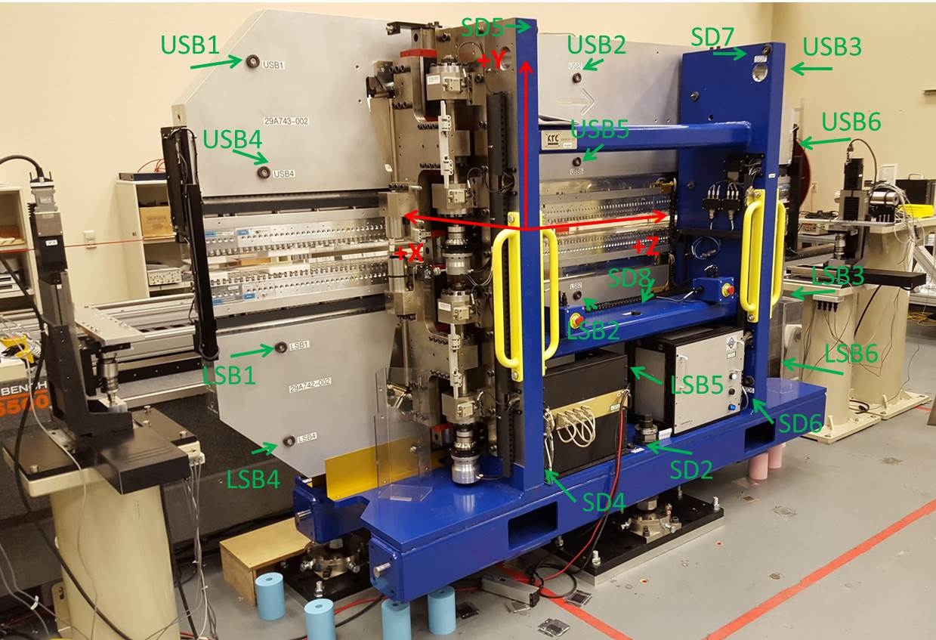

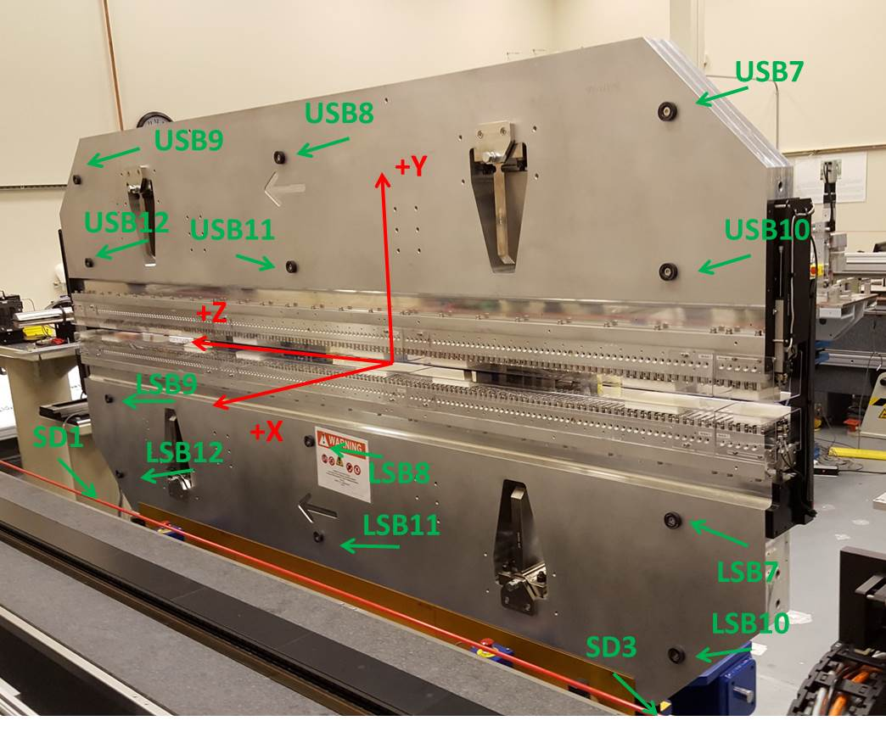

Tooling ball values to center of 1.5 inch sphere, all units are inches. Coordinates are to the SXR Undulator Magnetic Axis.
Tooling Ball | Z (in) | X (in) | Y (in)
LSB1 | -57.4815 | -3.4886 | -10.4976
LSB2 | -0.0096 | -3.4788 | -10.4989
LSB3 | 57.4712 | -3.4814 | -10.4961
LSB4 | -57.4900 | -3.4790 | -24.2777
LSB5 | -0.0110 | -3.4715 | -24.2669
LSB6 | 57.4751 | -3.4752 | -24.2657
LSB7 | -57.4882 | 3.4870 | -10.4943
LSB8 | -0.0124 | 3.4973 | -10.4784
LSB9 | 57.4678 | 3.4949 | -10.4838
LSB10 | -57.4930 | 3.4968 | -24.2769
LSB11 | -0.0049 | 3.5059 | -24.2695
LSB12 | 57.4704 | 3.5017 | -24.2648
SD1 | 50.9983 | 7.2480 | -34.6880
SD2 | -3.9333 | -19.5283 | -34.7356
SD3 | -50.9748 | 7.2413 | -34.6845
SD4 | -25.6329 | -21.6686 | -29.6318
SD5 | -25.6045 | -21.7011 | 29.4354
SD6 | 25.6513 | -21.5573 | -29.5854
SD7 | 25.6400 | -21.6000 | 29.4183
SD8 | 0.0413 | -16.9513 | -12.4232
USB1 | -57.4442 | -3.4865 | 24.2801
USB2 | 0.0261 | -3.4905 | 24.2788
USB3 | 57.5160 | -3.4814 | 24.2794
USB4 | -57.4495 | -3.4835 | 10.4856
USB5 | 0.0374 | -3.4915 | 10.4982
USB6 | 57.5084 | -3.4852 | 10.4855
USB7 | -57.4498 | 3.4814 | 24.2698
USB8 | 0.0462 | 3.4781 | 24.2730
USB9 | 57.5091 | 3.4857 | 24.2581
USB10 | -57.4509 | 3.4842 | 10.4911
USB11 | 0.0321 | 3.4774 | 10.4867
USB12 | 57.5085 | 3.4823 | 10.4958

Center | Z (m) | X (m) | Y (m) | Z (in) | X (in) | Y (in)
PM10M | -2.818808 | -0.026413 | 0.000960 | -110.9767 | -1.0399 | 0.0378
PM11M | 2.722899 | -0.026723 | 0.000999 | 107.2007 | -1.0521 | 0.0393
RFM | -2.674042 | 0.048565 | 0.000292 | -105.2772 | 1.9120 | 0.0115

PM10 and Granite coordinate system with Yurii shifts.
 |  | From Yurii |  |  | Measured
Device | Z (m) | X (m) | Y (m) | Z (m) | X (m) | Y (m) | dX (mm) | dY (mm)
PM10 | -0.369318 | -0.102331 | 0.001148 | -2.818808 | -0.102331 | 0.001148 | 0.000 | 0.000
PM11 | 5.172413 | -0.102646 | 0.001140 | 2.722899 | -0.102641 | 0.001187 | 0.005 | 0.047
Ref Block |  |  |  | -2.674042 | -0.027353 | 0.000480

