LCLS2 HE SXR Undulator

Alignment Engineering Group
L2?????
SN 29A804-025
September 04, 2024

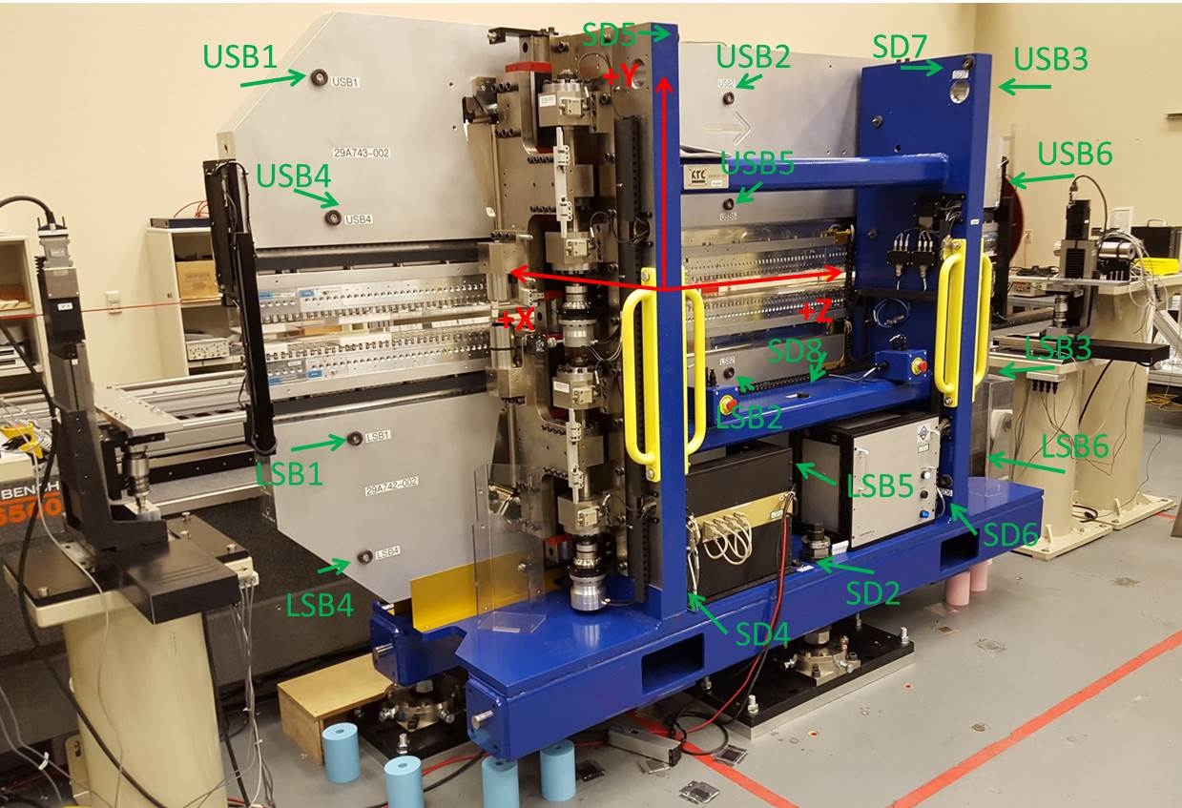

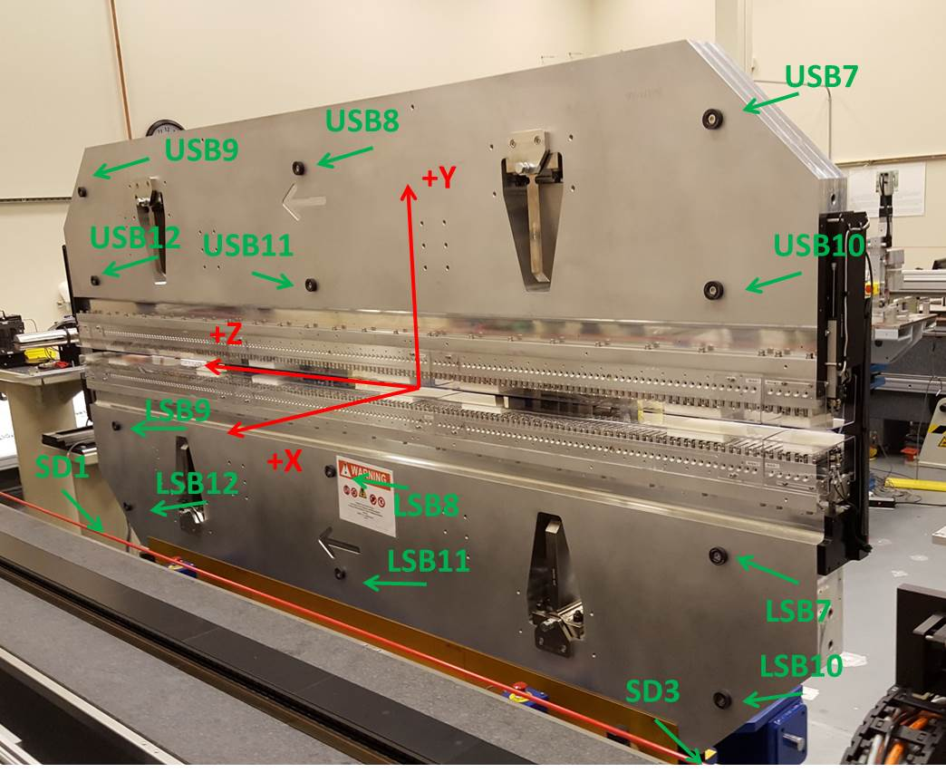

Tooling ball values to center of 1.5 inch sphere, all units are inches. Coordinates are to the SXR Undulator Magnetic Axis.
Tooling Ball | Z (in) | X (in) | Y (in)
LSB1 | -57.4338 | -3.4809 | -10.4996
LSB2 | 0.0430 | -3.4817 | -10.5011
LSB3 | 57.5105 | -3.4862 | -10.4925
LSB4 | -57.4445 | -3.4736 | -24.2668
LSB5 | 0.0479 | -3.4754 | -24.2638
LSB6 | 57.5175 | -3.4801 | -24.2647
LSB7 | -57.4436 | 3.4938 | -10.4848
LSB8 | 0.0321 | 3.4951 | -10.4909
LSB9 | 57.5208 | 3.4900 | -10.4953
LSB10 | -57.4317 | 3.5029 | -24.2693
LSB11 | 0.0398 | 3.5011 | -24.2750
LSB12 | 57.5204 | 3.4960 | -24.2789
SD1 | 51.0033 | 7.2316 | -34.7756
SD2 | -3.9418 | -19.5298 | -34.8312
SD3 | -50.9725 | 7.2509 | -34.7776
SD4 | -25.6628 | -21.6944 | -29.6718
SD5 | -25.6347 | -21.7571 | 29.3658
SD6 | 25.6531 | -21.7023 | -29.7022
SD7 | 25.6157 | -21.7000 | 29.3867
SD8 | -0.0092 | -17.0009 | -12.4742
USB1 | -57.4322 | -3.4935 | 24.2739
USB2 | 0.0416 | -3.4982 | 24.2694
USB3 | 57.5193 | -3.4901 | 24.2792
USB4 | -57.4420 | -3.4923 | 10.5019
USB5 | 0.0417 | -3.4982 | 10.4955
USB6 | 57.5223 | -3.4908 | 10.4911
USB7 | -57.4457 | 3.4842 | 24.2663
USB8 | 0.0264 | 3.4904 | 24.2877
USB9 | 57.5116 | 3.4866 | 24.2643
USB10 | -57.4458 | 3.4848 | 10.4927
USB11 | 0.0346 | 3.4788 | 10.4870
USB12 | 57.5248 | 3.4858 | 10.4844

Center | Z (m) | X (m) | Y (m) | Z (in) | X (in) | Y (in)
PM10M | -2.819552 | -0.026347 | 0.000910 | -111.0060 | -1.0373 | 0.0358
PM11M | 2.722181 | -0.026661 | 0.000930 | 107.1725 | -1.0496 | 0.0366
RFM | -2.674783 | 0.048637 | 0.000219 | -105.3064 | 1.9148 | 0.0086

PM10 and Granite coordinate system with Yurii shifts.
 |  | From Yurii |  |  | Measured
Device | Z (m) | X (m) | Y (m) | Z (m) | X (m) | Y (m) | dX (mm) | dY (mm)
PM10 | -2.819552 | -0.026347 | 0.000910 | -2.819552 | -0.026347 | 0.000910 | 0.000 | 0.000
PM11 | 2.722187 | -0.026652 | 0.000904 | 2.722181 | -0.026661 | 0.000930 | -0.009 | 0.026
Ref Block |  |  |  | -2.674783 | 0.048637 | 0.000219

