LCLS2 HE SXR Undulator

Alignment Engineering Group
L2?????
SN 29A804-023
August 06, 2024

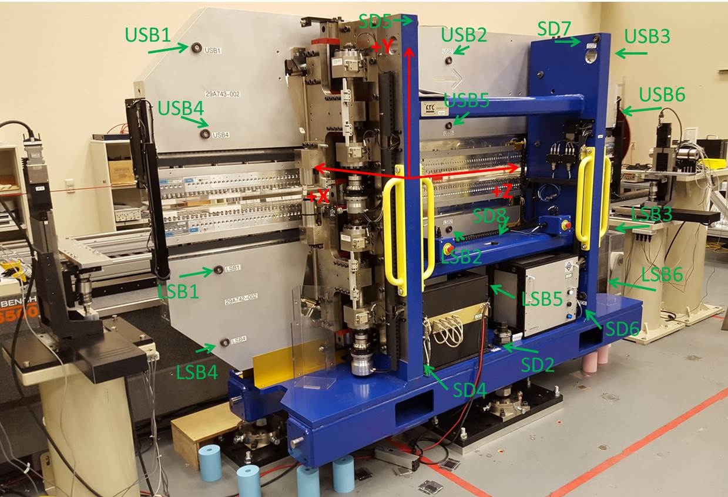

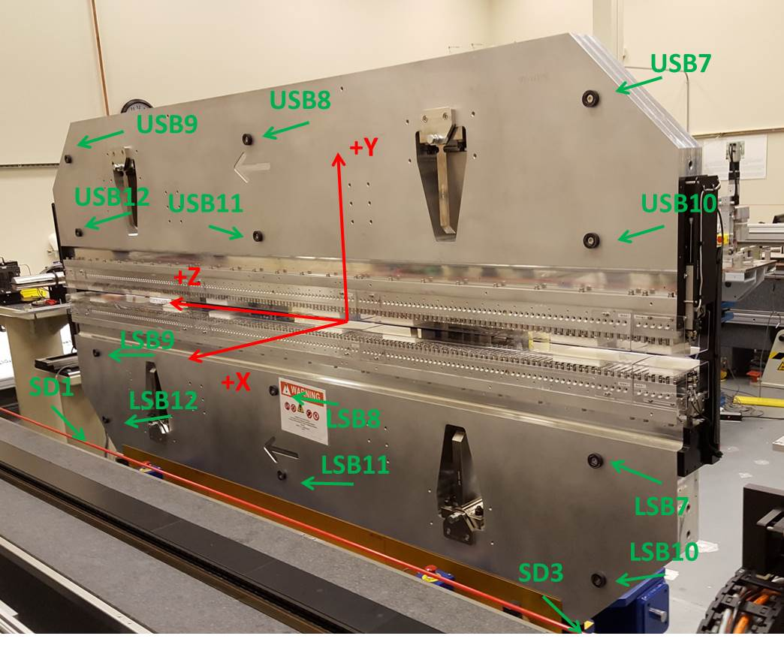

Tooling ball values to center of 1.5 inch sphere, all units are inches. Coordinates are to the SXR Undulator Magnetic Axis.
Tooling Ball | Z (in) | X (in) | Y (in)
LSB1 | -57.4861 | -3.4881 | -10.4958
LSB2 | -0.0099 | -3.4850 | -10.4956
LSB3 | 57.4637 | -3.4867 | -10.4928
LSB4 | -57.4848 | -3.4800 | -24.2719
LSB5 | -0.0119 | -3.4784 | -24.2716
LSB6 | 57.4731 | -3.4797 | -24.2698
LSB7 | -57.4840 | 3.4893 | -10.4937
LSB8 | -0.0052 | 3.4913 | -10.4903
LSB9 | 57.4709 | 3.4910 | -10.4798
LSB10 | -57.4831 | 3.4959 | -24.2644
LSB11 | -0.0093 | 3.4981 | -24.2710
LSB12 | 57.4769 | 3.4979 | -24.2560
SD1 | 51.0133 | 7.2065 | -34.7128
SD2 | -3.9069 | -19.5564 | -34.7709
SD3 | -50.9485 | 7.2122 | -34.7102
SD4 | -25.5861 | -21.7354 | -29.6267
SD5 | -25.6155 | -21.7092 | 29.4353
SD6 | 25.6298 | -21.6236 | -29.6288
SD7 | 25.6141 | -21.6321 | 29.4324
SD8 | -0.0006 | -16.9909 | -12.4167
USB1 | -57.4739 | -3.4942 | 24.2722
USB2 | -0.0096 | -3.4945 | 24.2812
USB3 | 57.4735 | -3.4921 | 24.2815
USB4 | -57.4822 | -3.4906 | 10.5022
USB5 | -0.0033 | -3.4918 | 10.5007
USB6 | 57.4812 | -3.4898 | 10.4990
USB7 | -57.4863 | 3.4803 | 24.2725
USB8 | -0.0056 | 3.4819 | 24.2769
USB9 | 57.4740 | 3.4843 | 24.2681
USB10 | -57.4751 | 3.4842 | 10.5004
USB11 | 0.0070 | 3.4845 | 10.4978
USB12 | 57.4869 | 3.4864 | 10.4953

Center | Z (m) | X (m) | Y (m) | Z (in) | X (in) | Y (in)
PM10M | -2.819587 | -0.026398 | 0.000817 | -111.0074 | -1.0393 | 0.0322
PM11M | 2.722169 | -0.026716 | 0.000846 | 107.1720 | -1.0518 | 0.0333
RFM | -2.674826 | 0.048580 | 0.000141 | -105.3081 | 1.9126 | 0.0056

PM10 and Granite coordinate system with Yurii shifts.
 |  | From Yurii |  |  | Measured
Device | Z (m) | X (m) | Y (m) | Z (m) | X (m) | Y (m) | dX (mm) | dY (mm)
PM10 | -0.369353 | -0.102341 | 0.001070 | -2.819587 | -0.102341 | 0.001070 | 0.000 | 0.000
PM11 | 5.172377 | -0.102654 | 0.001066 | 2.722169 | -0.102659 | 0.001099 | -0.005 | 0.033
Ref Block |  |  |  | -2.674826 | -0.027363 | 0.000394

