LCLS2 HE SXR Undulator

Alignment Engineering Group
L2?????
SN 29A804-003
February 19, 2026

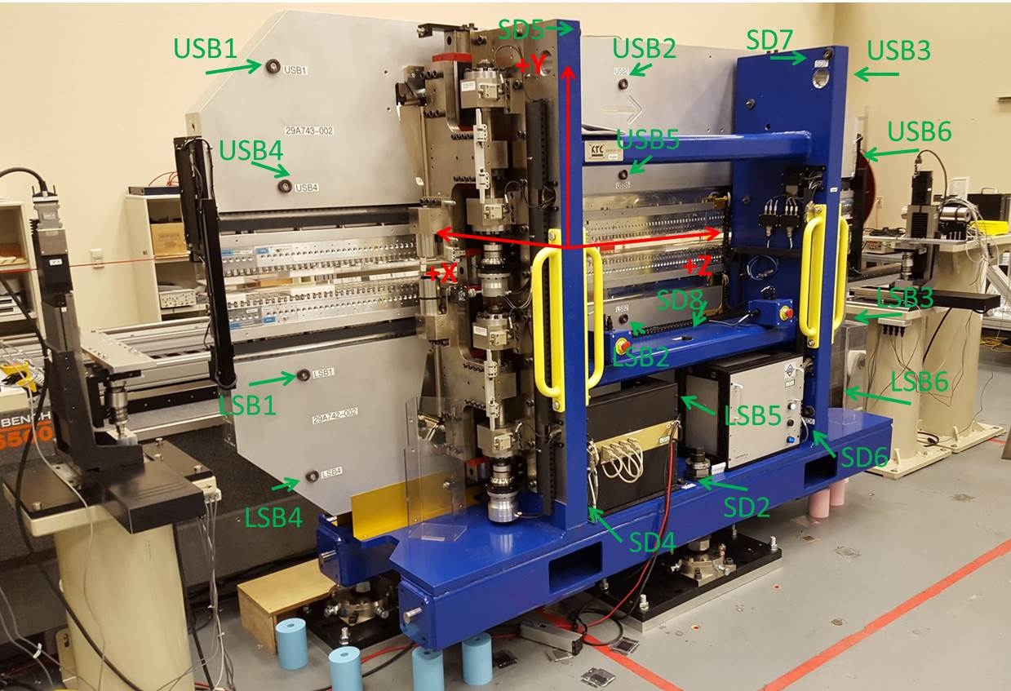

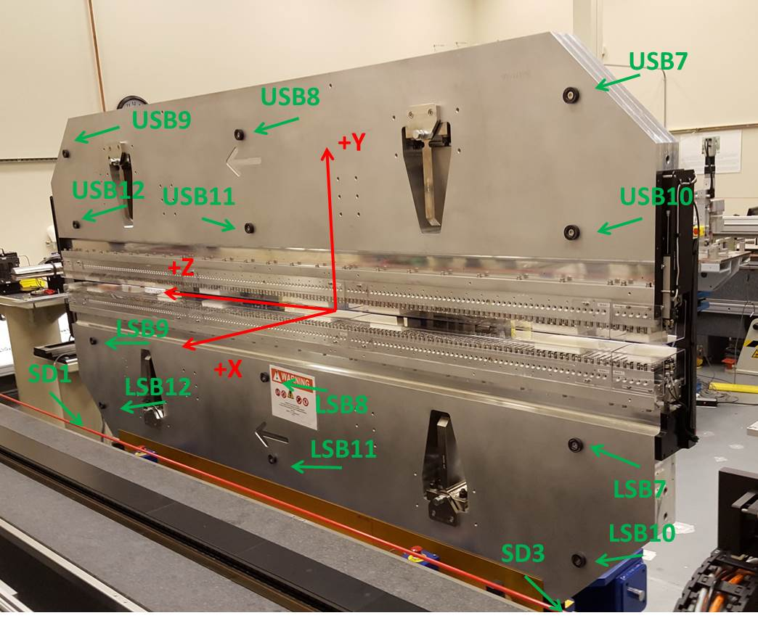

Tooling ball values to center of 1.5 inch sphere, all units are inches. Coordinates are to the SXR Undulator Magnetic Axis.
Tooling Ball | Z (in) | X (in) | Y (in)
LSB1 | -57.4821 | -3.4967 | -10.4912
LSB2 | 0.0034 | -3.4898 | -10.5005
LSB3 | 57.4805 | -3.4955 | -10.4958
LSB4 | -57.4742 | -3.4913 | -24.2665
LSB5 | 0.0000 | -3.4856 | -24.2826
LSB6 | 57.4727 | -3.4906 | -24.2662
LSB7 | -57.4914 | 3.4826 | -10.4958
LSB8 | -0.0155 | 3.4911 | -10.4961
LSB9 | 57.4641 | 3.4850 | -10.4957
LSB10 | -57.4955 | 3.4875 | -24.2762
LSB11 | -0.0145 | 3.4965 | -24.2614
LSB12 | 57.4572 | 3.4882 | -24.2655
SD1 | 50.9777 | 7.2678 | -34.6843
SD2 | -3.9276 | -19.5221 | -34.7482
SD3 | -50.9870 | 7.2409 | -34.6893
SD4 | -25.5850 | -21.6621 | -29.7743
SD5 | -25.6323 | -21.6540 | 29.4517
SD6 | 25.6406 | -21.7180 | -29.5768
SD7 | 25.6547 | -21.6755 | 29.4712
SD8 | 0.0119 | -17.0115 | -12.3721
USB1 | -57.4872 | -3.4826 | 24.2768
USB2 | -0.0142 | -3.4873 | 24.2674
USB3 | 57.4625 | -3.4868 | 24.2769
USB4 | -57.4925 | -3.4873 | 10.4933
USB5 | -0.0095 | -3.4908 | 10.4999
USB6 | 57.4635 | -3.4907 | 10.4954
USB7 | -57.4789 | 3.4972 | 24.2720
USB8 | -0.0001 | 3.4937 | 24.2729
USB9 | 57.4785 | 3.4925 | 24.2706
USB10 | -57.4664 | 3.4937 | 10.4983
USB11 | 0.0044 | 3.4898 | 10.4935
USB12 | 57.4885 | 3.4889 | 10.4907

Center | Z (m) | X (m) | Y (m) | Z (in) | X (in) | Y (in)
PM10M | -2.818998 | -0.025903 | 0.000552 | -110.9842 | -1.0198 | 0.0217
PM11M | 2.722473 | -0.026177 | 0.000578 | 107.1840 | -1.0306 | 0.0227
RFM | -2.674238 | 0.049075 | -0.000126 | -105.2849 | 1.9321 | -0.0050

PM10 and Granite coordinate system with Yurii shifts.
 |  | From Yurii |  |  | Measured
Device | Z (m) | X (m) | Y (m) | Z (m) | X (m) | Y (m) | dX (mm) | dY (mm)
PM10 | -2.818998 | -0.025885 | 0.000583 | -2.818998 | -0.025903 | 0.000552 | -0.018 | -0.031
PM11 | 2.722511 | -0.026195 | 0.000547 | 2.722473 | -0.026177 | 0.000578 | 0.018 | 0.031
Ref Block |  |  |  | -2.674238 | 0.049075 | -0.000126

