LCLS2 HE SXR Undulator

Alignment Engineering Group
L2?????
SN 29A804-010
October 15, 2025

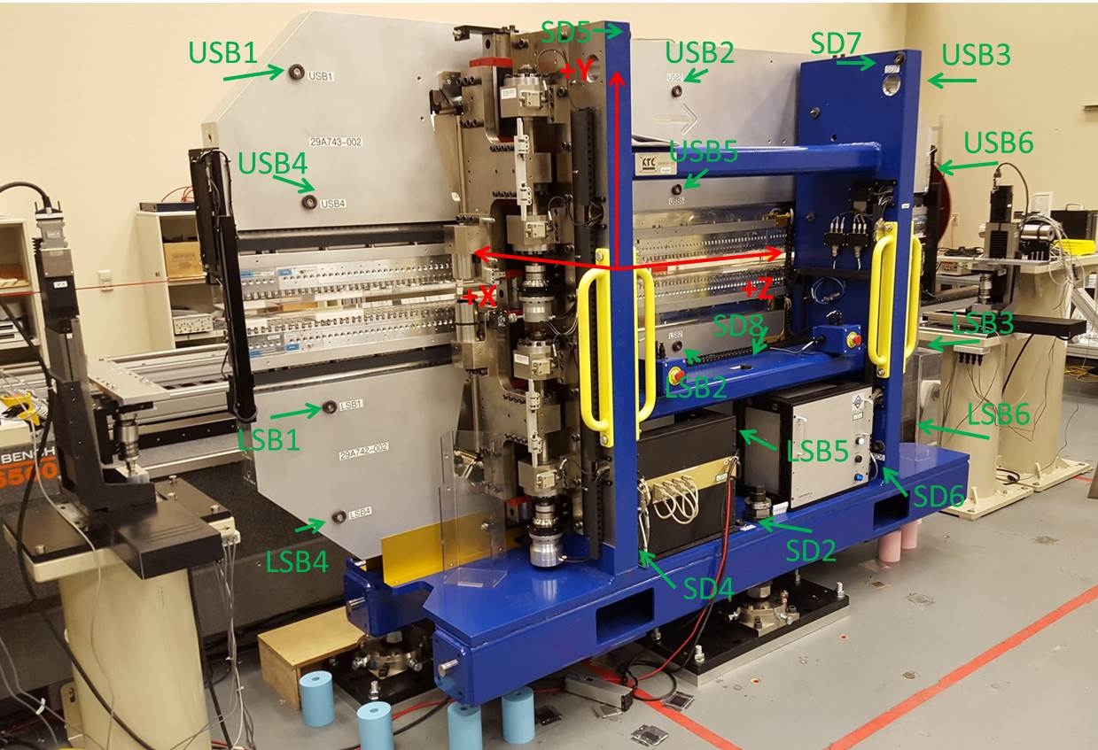

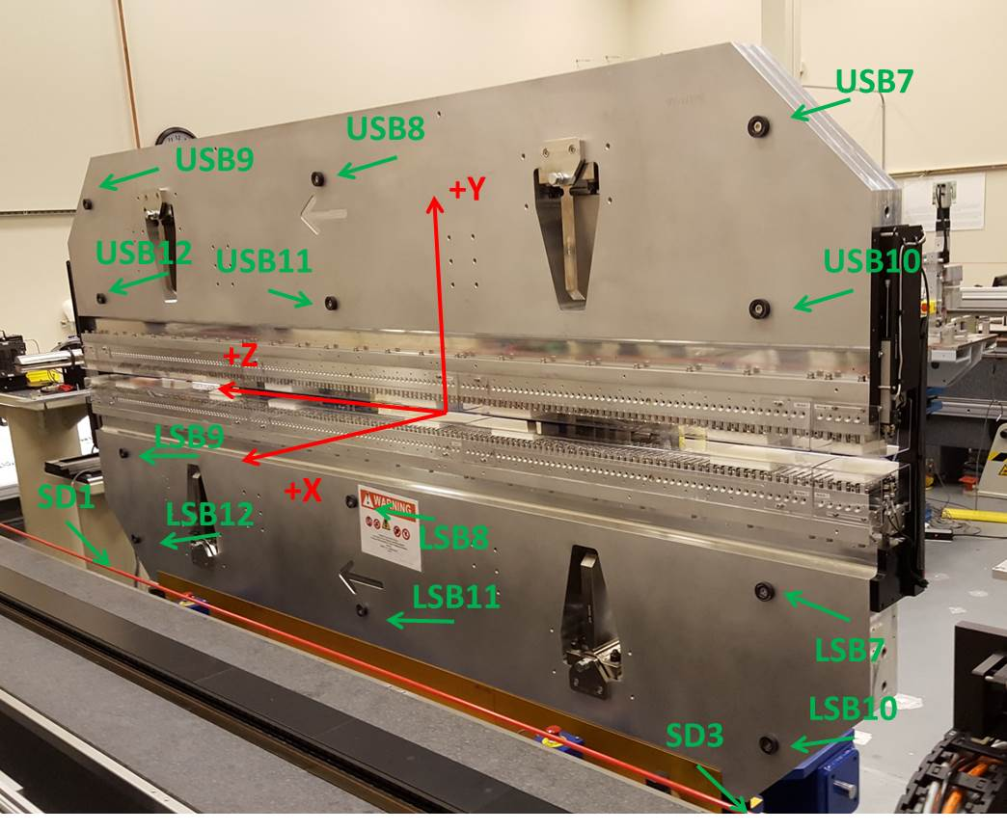

Tooling ball values to center of 1.5 inch sphere, all units are inches. Coordinates are to the SXR Undulator Magnetic Axis.
Tooling Ball | Z (in) | X (in) | Y (in)
LSB1 | -57.4779 | -3.4941 | -10.4887
LSB2 | 0.0033 | -3.4905 | -10.4923
LSB3 | 57.4853 | -3.4913 | -10.4922
LSB4 | -57.4766 | -3.4918 | -24.2644
LSB5 | 0.0040 | -3.4888 | -24.2687
LSB6 | 57.4854 | -3.4906 | -24.2689
LSB7 | -57.4878 | 3.4866 | -10.4909
LSB8 | -0.0047 | 3.4893 | -10.4930
LSB9 | 57.4726 | 3.4886 | -10.4946
LSB10 | -57.4872 | 3.4884 | -24.2709
LSB11 | -0.0072 | 3.4908 | -24.2731
LSB12 | 57.4747 | 3.4891 | -24.2749
SD1 | 50.9753 | 7.2478 | -34.6456
SD2 | -3.9586 | -19.5267 | -34.7024
SD3 | -51.0025 | 7.2355 | -34.6363
SD4 | -25.6988 | -21.7016 | -29.5601
SD5 | -25.7189 | -21.6854 | 29.4991
SD6 | 25.6561 | -21.6557 | -29.5525
SD7 | 25.6499 | -21.6964 | 29.4745
SD8 | 0.0227 | -16.9313 | -12.3413
USB1 | -57.4757 | -3.4870 | 24.2660
USB2 | 0.0044 | -3.4923 | 24.2675
USB3 | 57.4837 | -3.4869 | 24.2670
USB4 | -57.4774 | -3.4878 | 10.4872
USB5 | 0.0041 | -3.4925 | 10.4891
USB6 | 57.4835 | -3.4872 | 10.4887
USB7 | -57.4766 | 3.4928 | 24.2669
USB8 | -0.0007 | 3.4891 | 24.2673
USB9 | 57.4815 | 3.4946 | 24.2669
USB10 | -57.4754 | 3.4941 | 10.4905
USB11 | -0.0002 | 3.4882 | 10.4917
USB12 | 57.4783 | 3.4936 | 10.4910

Center | Z (m) | X (m) | Y (m) | Z (in) | X (in) | Y (in)
PM10M | -2.819316 | -0.026123 | 0.000593 | -110.9967 | -1.0285 | 0.0233
PM11M | 2.722291 | -0.026454 | 0.000618 | 107.1768 | -1.0415 | 0.0243
RFM | -2.674562 | 0.048849 | -0.000099 | -105.2977 | 1.9232 | -0.0039

PM10 and Granite coordinate system with Yurii shifts.
 |  | From Yurii |  |  | Measured
Device | Z (m) | X (m) | Y (m) | Z (m) | X (m) | Y (m) | dX (mm) | dY (mm)
PM10 | -2.819316 | -0.026133 | 0.000612 | -2.819316 | -0.026123 | 0.000593 | 0.010 | -0.019
PM11 | 2.722311 | -0.026441 | 0.000598 | 2.722291 | -0.026454 | 0.000618 | -0.013 | 0.020
Ref Block |  |  |  | -2.674562 | 0.048849 | -0.000099

