LCLS2 HE SXR Undulator

Alignment Engineering Group
L2?????
SN 29A804-008
April 13, 2026

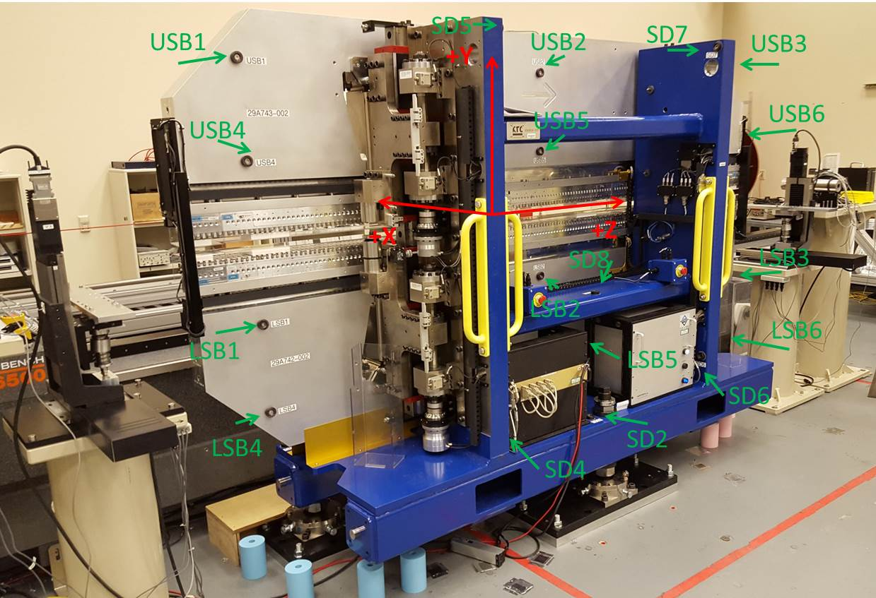

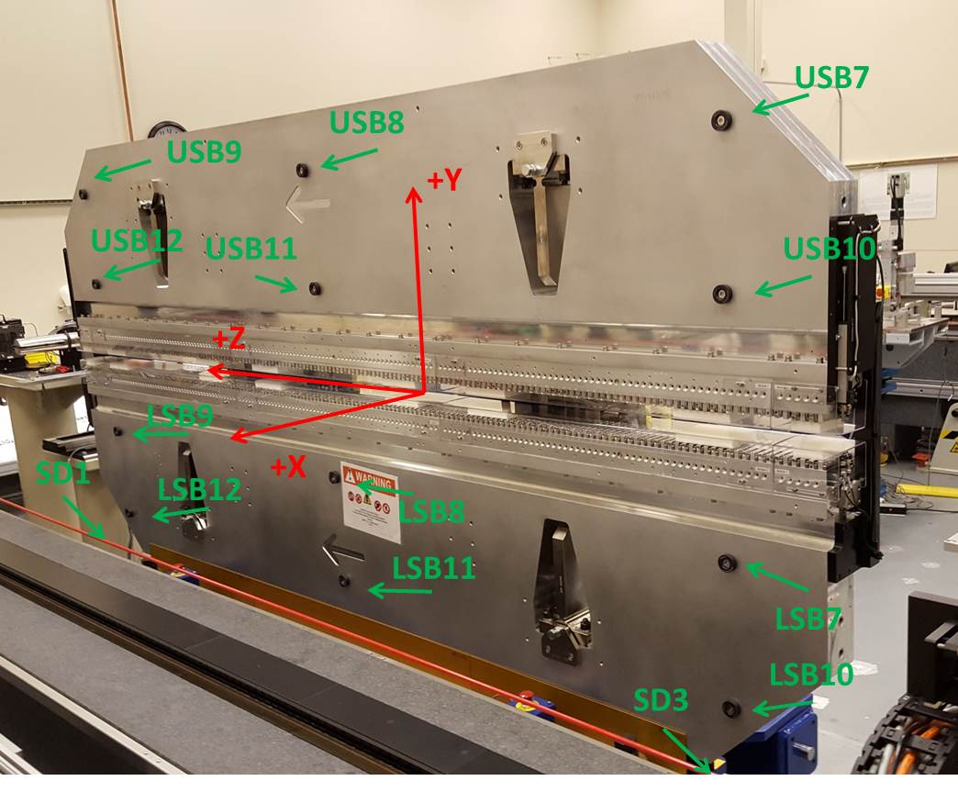

Tooling ball values to center of 1.5 inch sphere, all units are inches. Coordinates are to the SXR Undulator Magnetic Axis.
Tooling Ball | Z (in) | X (in) | Y (in)
LSB1 | -57.4863 | -3.4875 | -10.4881
LSB2 | -0.0087 | -3.4986 | -10.4856
LSB3 | 57.4743 | -3.4871 | -10.4884
LSB4 | -57.4842 | -3.4804 | -24.2680
LSB5 | -0.0078 | -3.4917 | -24.2671
LSB6 | 57.4715 | -3.4813 | -24.2677
LSB7 | -57.4857 | 3.4882 | -10.4812
LSB8 | -0.0061 | 3.4794 | -10.4834
LSB9 | 57.4699 | 3.4867 | -10.4887
LSB10 | -57.4833 | 3.4959 | -24.2617
LSB11 | -0.0057 | 3.4866 | -24.2650
LSB12 | 57.4667 | 3.4920 | -24.2682
SD1 | 50.9893 | 7.2641 | -34.6507
SD2 | -3.9459 | -19.5076 | -34.7152
SD3 | -50.9819 | 7.2539 | -34.6431
SD4 | -25.6436 | -21.6944 | -29.5654
SD5 | -25.6796 | -21.6850 | 29.4768
SD6 | 25.6305 | -21.6558 | -29.5544
SD7 | 25.5837 | -21.7079 | 29.4791
SD8 | 0.0223 | -16.9585 | -12.2993
USB1 | -57.4758 | -3.4827 | 24.2674
USB2 | -0.0030 | -3.4605 | 24.2699
USB3 | 57.4720 | -3.4895 | 24.2661
USB4 | -57.4750 | -3.4843 | 10.4906
USB5 | 0.0017 | -3.4623 | 10.4893
USB6 | 57.4735 | -3.4917 | 10.4867
USB7 | -57.4835 | 3.4955 | 24.2647
USB8 | -0.0068 | 3.5079 | 24.2624
USB9 | 57.4726 | 3.4907 | 24.2700
USB10 | -57.4830 | 3.4937 | 10.4916
USB11 | -0.0031 | 3.5068 | 10.4863
USB12 | 57.4744 | 3.4879 | 10.4847

Center | Z (m) | X (m) | Y (m) | Z (in) | X (in) | Y (in)
PM10M | -2.81915 | -0.02559 | 0.00058 | -110.9903 | -1.0075 | 0.0228
PM11M | 2.722297 | -0.02588 | 0.000577 | 107.1770 | -1.0189 | 0.0227
RFM | -2.6744 | 0.049378 | -0.00011 | -105.2912 | 1.9440 | -0.0044

PM10 and Granite coordinate system with Yurii shifts.
 |  | From Yurii |  |  | Measured
Device | Z (m) | X (m) | Y (m) | Z (m) | X (m) | Y (m) | dX (mm) | dY (mm)
PM10 | -0.368888 | -0.102355 | 0.000879 | -2.819154 | -0.102355 | 0.000879 | 0.000 | 0.000
PM11 | 5.172625 | -0.102637 | 0.000842 | 2.722297 | -0.102643 | 0.000876 | -0.006 | 0.034
Ref Block |  |  |  | -2.674396 | -0.027386 | 0.000188

