LCLS2 HE SXR Undulator

Alignment Engineering Group
L2?????
SN 29A804-007
December 04, 2025

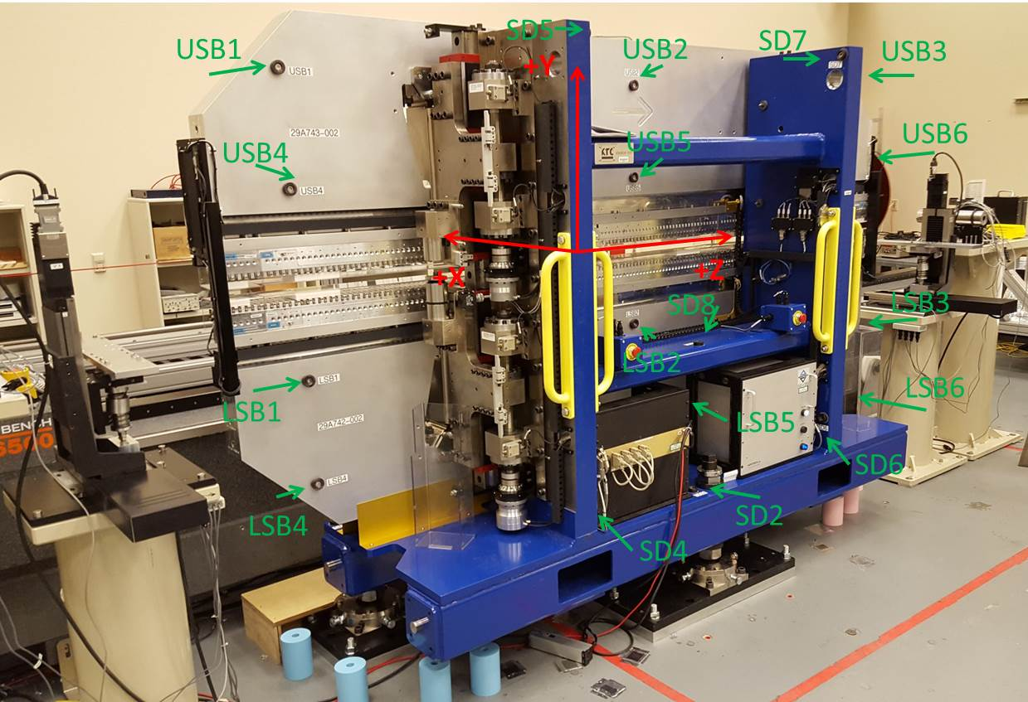

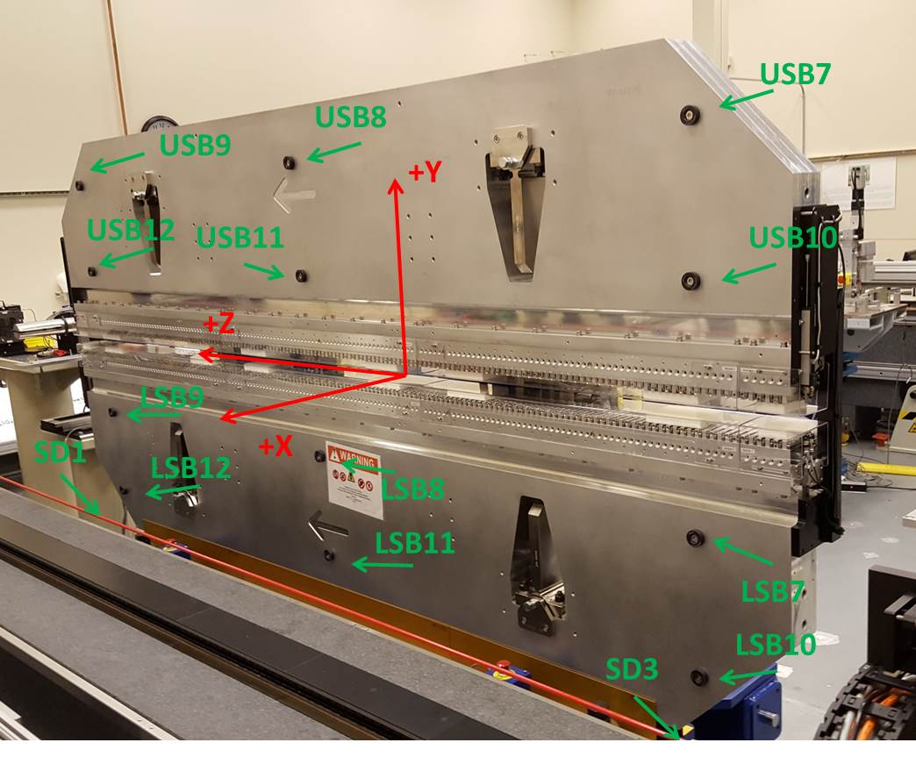

Tooling ball values to center of 1.5 inch sphere, all units are inches. Coordinates are to the SXR Undulator Magnetic Axis.
Tooling Ball | Z (in) | X (in) | Y (in)
LSB1 | -57.4812 | -3.4915 | -10.4881
LSB2 | -0.0009 | -3.5021 | -10.4884
LSB3 | 57.4758 | -3.4862 | -10.4974
LSB4 | -57.4776 | -3.4875 | -24.2617
LSB5 | -0.0017 | -3.4987 | -24.2656
LSB6 | 57.4757 | -3.4853 | -24.2680
LSB7 | -57.4777 | 3.4881 | -10.4883
LSB8 | -0.0046 | 3.4818 | -10.4947
LSB9 | 57.4692 | 3.4908 | -10.4883
LSB10 | -57.4819 | 3.4918 | -24.2630
LSB11 | -0.0121 | 3.4851 | -24.2682
LSB12 | 57.4681 | 3.4921 | -24.2672
SD1 | 50.9668 | 7.2147 | -34.6519
SD2 | -3.9761 | -19.5430 | -34.7101
SD3 | -51.0089 | 7.2287 | -34.6396
SD4 | -25.6524 | -21.7172 | -29.5625
SD5 | -25.6908 | -21.6925 | 29.4750
SD6 | 25.6234 | -21.6931 | -29.5617
SD7 | 25.6024 | -21.7017 | 29.4706
SD8 | -0.0323 | -16.9766 | -12.3155
USB1 | -57.4819 | -3.4792 | 24.2631
USB2 | 0.0061 | -3.4839 | 24.2698
USB3 | 57.4870 | -3.4826 | 24.2695
USB4 | -57.4816 | -3.4850 | 10.4872
USB5 | 0.0001 | -3.4898 | 10.4886
USB6 | 57.4805 | -3.4891 | 10.4869
USB7 | -57.4786 | 3.4981 | 24.2657
USB8 | 0.0058 | 3.5002 | 24.2648
USB9 | 57.4856 | 3.4959 | 24.2686
USB10 | -57.4766 | 3.4933 | 10.4879
USB11 | 0.0074 | 3.4933 | 10.4905
USB12 | 57.4846 | 3.4892 | 10.4879

Center | Z (m) | X (m) | Y (m) | Z (in) | X (in) | Y (in)
PM10M | -2.819363 | -0.025993 | 0.000477 | -110.9985 | -1.0233 | 0.0188
PM11M | 2.722206 | -0.026325 | 0.000491 | 107.1735 | -1.0364 | 0.0193
RFM | -2.674604 | 0.048983 | -0.000212 | -105.2994 | 1.9285 | -0.0083

PM10 and Granite coordinate system with Yurii shifts.
 |  | From Yurii |  |  | Measured
Device | Z (m) | X (m) | Y (m) | Z (m) | X (m) | Y (m) | dX (mm) | dY (mm)
PM10 | -0.368716 | -0.102176 | 0.000621 | -2.819363 | -0.102176 | 0.000621 | 0.000 | 0.000
PM11 | 5.172889 | -0.102485 | 0.000606 | 2.722206 | -0.102508 | 0.000635 | -0.023 | 0.029
Ref Block |  |  |  | -2.674604 | -0.027200 | -0.000068

