LCLS2 HE SXR Undulator

Alignment Engineering Group
L2?????
SN 29A804-003
January 29, 2026

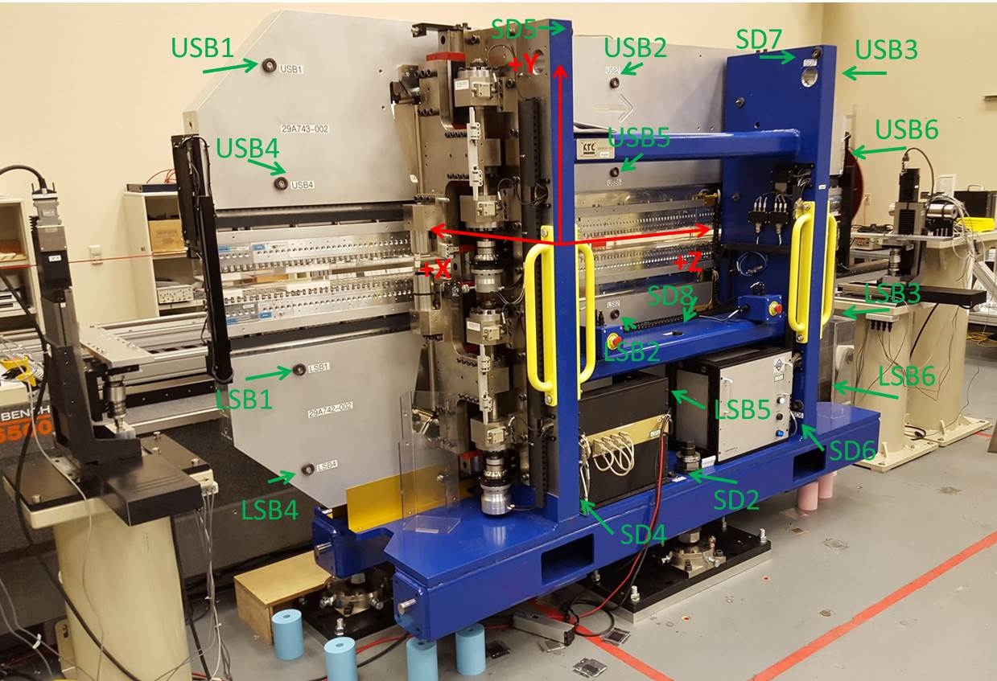

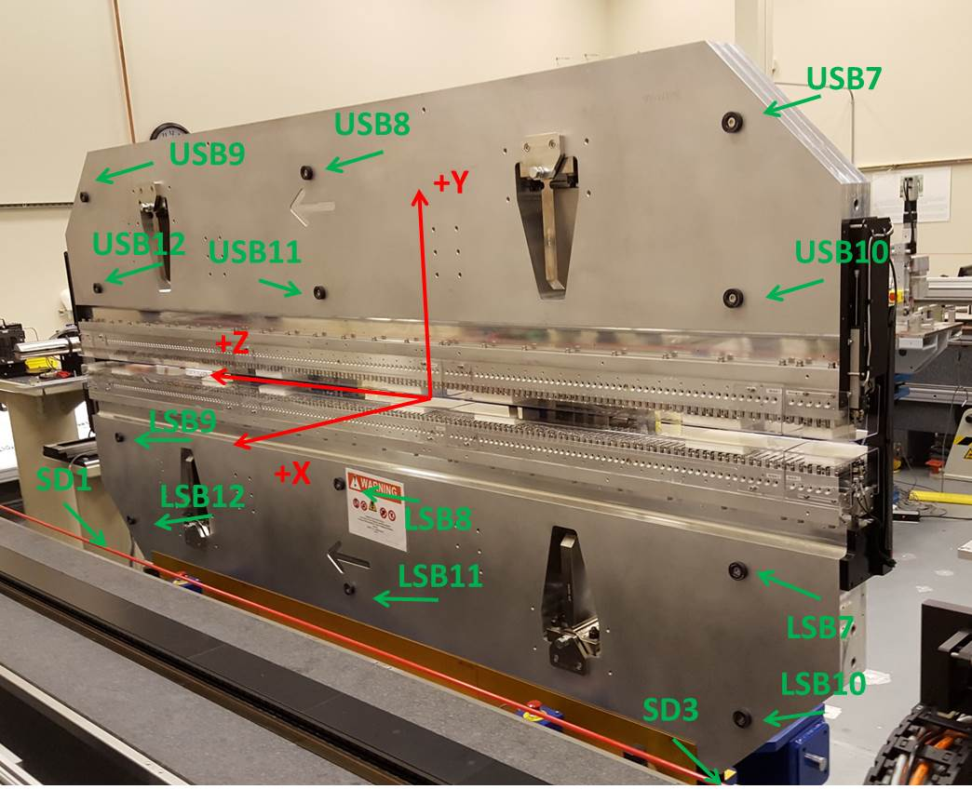

Tooling ball values to center of 1.5 inch sphere, all units are inches. Coordinates are to the SXR Undulator Magnetic Axis.
Tooling Ball | Z (in) | X (in) | Y (in)
LSB1 | -57.4963 | -3.4882 | -10.4980
LSB2 | -0.0180 | -3.4794 | -10.5014
LSB3 | 57.4724 | -3.4830 | -10.4976
LSB4 | -57.4902 | -3.4837 | -24.2757
LSB5 | -0.0214 | -3.4784 | -24.2668
LSB6 | 57.4591 | -3.4828 | -24.2616
LSB7 | -57.4885 | 3.4857 | -10.4876
LSB8 | -0.0150 | 3.4933 | -10.4816
LSB9 | 57.4686 | 3.4886 | -10.4844
LSB10 | -57.4911 | 3.4877 | -24.2645
LSB11 | -0.0131 | 3.4967 | -24.2680
LSB12 | 57.4541 | 3.4898 | -24.2691
SD1 | 50.9768 | 7.2231 | -34.6867
SD2 | -3.9509 | -19.5501 | -34.7498
SD3 | -50.9853 | 7.2225 | -34.6811
SD4 | -25.6180 | -21.7066 | -29.5979
SD5 | -25.6654 | -21.6835 | 29.4538
SD6 | 25.6410 | -21.6730 | -29.6072
SD7 | 25.6207 | -21.7157 | 29.4431
SD8 | -0.0006 | -16.9586 | -12.4033
USB1 | -57.4899 | -3.4788 | 24.2646
USB2 | -0.0197 | -3.4655 | 24.2726
USB3 | 57.4516 | -3.4850 | 24.2666
USB4 | -57.4841 | -3.4811 | 10.4985
USB5 | -0.0182 | -3.4671 | 10.4935
USB6 | 57.4543 | -3.4860 | 10.4873
USB7 | -57.4936 | 3.4994 | 24.2709
USB8 | -0.0165 | 3.5128 | 24.2600
USB9 | 57.4570 | 3.4939 | 24.2695
USB10 | -57.4863 | 3.4965 | 10.4920
USB11 | -0.0201 | 3.5122 | 10.4961
USB12 | 57.4674 | 3.4918 | 10.4856

Center | Z (m) | X (m) | Y (m) | Z (in) | X (in) | Y (in)
PM10M | -2.819 | -0.02588 | 0.000564 | -110.9843 | -1.0187 | 0.0222
PM11M | 2.722504 | -0.02618 | 0.000558 | 107.1852 | -1.0305 | 0.0220
RFM | -2.67425 | 0.049103 | -0.00013 | -105.2853 | 1.9332 | -0.0051

PM10 and Granite coordinate system with Yurii shifts.
 |  | From Yurii |  |  | Measured
Device | Z (m) | X (m) | Y (m) | Z (m) | X (m) | Y (m) | dX (mm) | dY (mm)
PM10 | -0.368629 | -0.10229 | 0.000804 | -2.819000 | -0.102290 | 0.000804 | 0.000 | 0.000
PM11 | 5.172902 | -0.102568 | 0.000768 | 2.722504 | -0.102589 | 0.000798 | -0.021 | 0.030
Ref Block |  |  |  | -2.674246 | -0.027311 | 0.000111

