LCLS2 HE SXR Undulator

Alignment Engineering Group
L2?????
SN 29A804-001
September 24, 2025

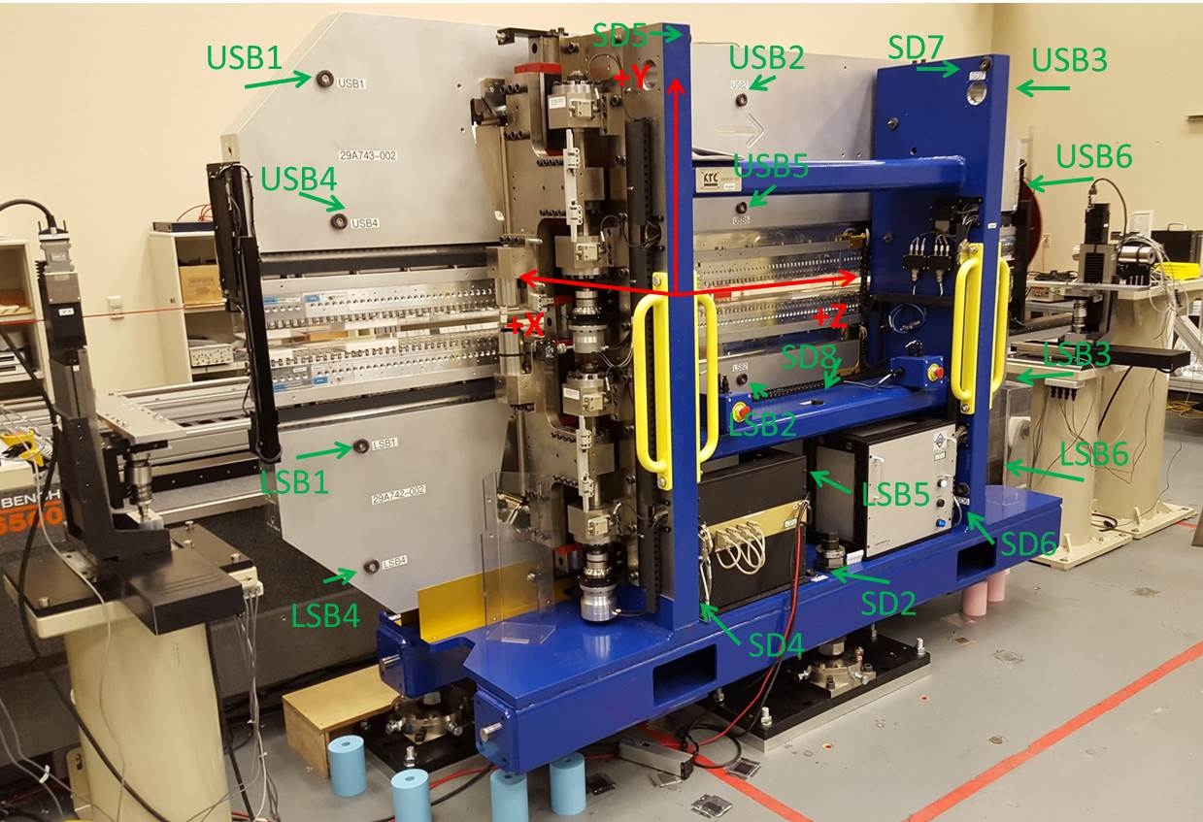

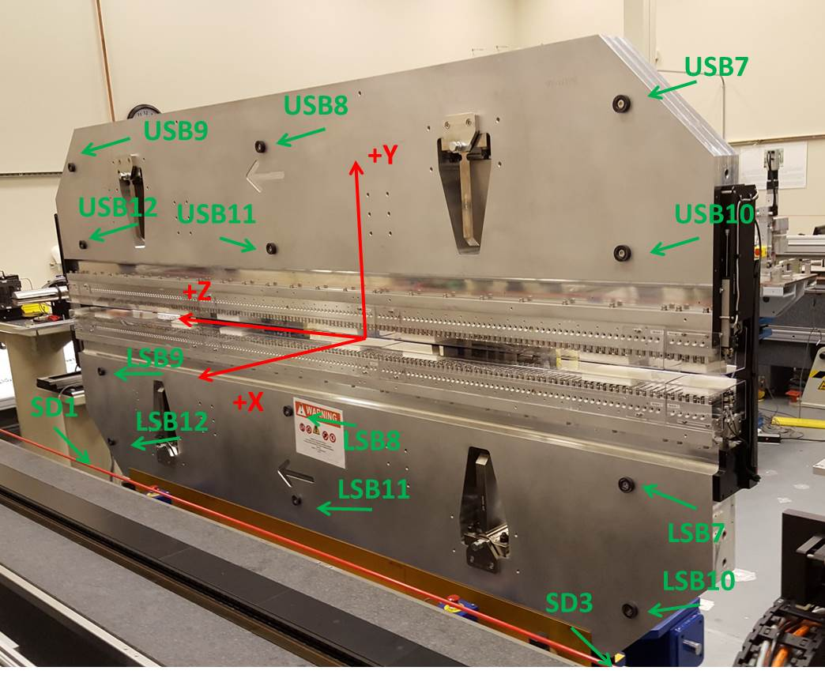

Tooling ball values to center of 1.5 inch sphere, all units are inches. Coordinates are to the SXR Undulator Magnetic Axis.
Tooling Ball | Z (in) | X (in) | Y (in)
LSB1 | -57.4763 | -3.4837 | -10.4869
LSB2 | 0.0021 | -3.4914 | -10.4833
LSB3 | 57.4733 | -3.4828 | -10.4884
LSB4 | -57.4769 | -3.4795 | -24.2663
LSB5 | -0.0020 | -3.4877 | -24.2623
LSB6 | 57.4730 | -3.4797 | -24.2660
LSB7 | -57.4748 | 3.4924 | -10.4869
LSB8 | -0.0041 | 3.4852 | -10.4923
LSB9 | 57.4763 | 3.4934 | -10.4889
LSB10 | -57.4765 | 3.4965 | -24.2642
LSB11 | -0.0010 | 3.4881 | -24.2681
LSB12 | 57.4763 | 3.4970 | -24.2719
SD1 | 50.9665 | 7.2409 | -34.7505
SD2 | -3.9565 | -19.5226 | -34.8176
SD3 | -50.9946 | 7.2400 | -34.7798
SD4 | -25.7345 | -21.7078 | -29.6706
SD5 | -25.7637 | -21.6924 | 29.3938
SD6 | 25.6177 | -21.6863 | -29.6560
SD7 | 25.6167 | -21.6854 | 29.3878
SD8 | 0.0172 | -16.9026 | -12.4356
USB1 | -57.4730 | -3.4823 | 24.2691
USB2 | 0.0013 | -3.4733 | 24.2744
USB3 | 57.4824 | -3.4822 | 24.2746
USB4 | -57.4713 | -3.4875 | 10.4889
USB5 | 0.0062 | -3.4789 | 10.4917
USB6 | 57.4828 | -3.4874 | 10.4965
USB7 | -57.4856 | 3.4940 | 24.2682
USB8 | -0.0063 | 3.5032 | 24.2584
USB9 | 57.4856 | 3.4935 | 24.2654
USB10 | -57.4811 | 3.4885 | 10.4824
USB11 | 0.0005 | 3.4984 | 10.4874
USB12 | 57.4837 | 3.4886 | 10.4898

Center | Z (m) | X (m) | Y (m) | Z (in) | X (in) | Y (in)
PM10M | -2.818974 | -0.026020 | 0.000631 | -110.9832 | -1.0244 | 0.0248
PM11M | 2.722639 | -0.026337 | 0.000632 | 107.1905 | -1.0369 | 0.0249
RFM | -2.674228 | 0.048955 | -0.000057 | -105.2846 | 1.9274 | -0.0022

PM10 and Granite coordinate system with Yurii shifts.
 |  | From Yurii |  |  | Measured
Device | Z (m) | X (m) | Y (m) | Z (m) | X (m) | Y (m) | dX (mm) | dY (mm)
PM10 | -0.369356 | -0.102222 | 0.000833 | -2.818974 | -0.102222 | 0.000833 | 0.000 | 0.000
PM11 | 5.172293 | -0.102546 | 0.000819 | 2.722639 | -0.102539 | 0.000834 | 0.007 | 0.015
Ref Block |  |  |  | -2.674228 | -0.027247 | 0.000145

