LCLS2 HE SXR Undulator

Alignment Engineering Group
L2?????
SN
October 18, 2023

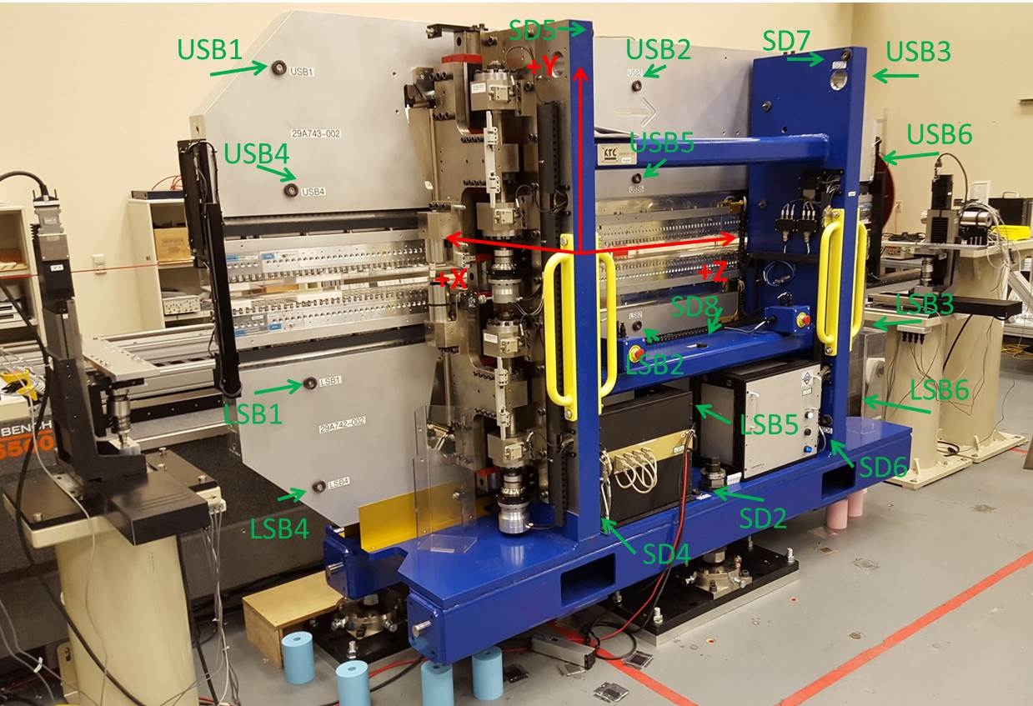

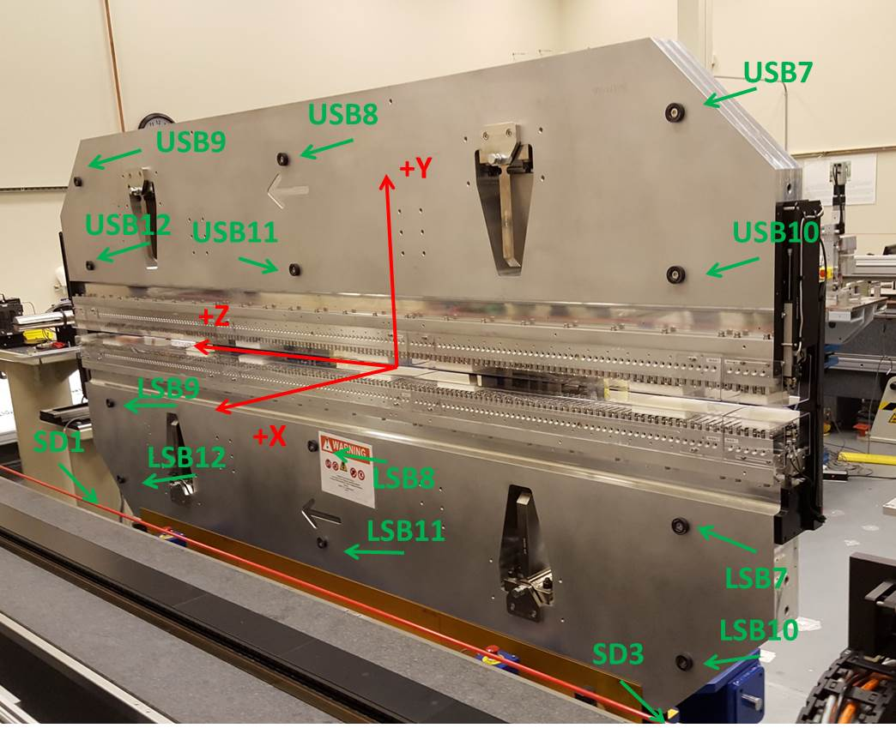

Tooling ball values to center of 1.5 inch sphere, all units are inches. Coordinates are to the SXR Undulator Magnetic Axis.
Tooling Ball | Z (in) | X (in) | Y (in)
LSB1 | -57.384 | -3.486 | -10.485
LSB2 | -2.263 | -3.484 | -10.494
LSB3 | 57.392 | -3.485 | -10.487
LSB4 | -57.366 | -3.480 | -24.274
LSB5 | -2.251 | -3.477 | -24.263
LSB6 | 57.397 | -3.479 | -24.259
LSB7 | -57.372 | 3.488 | -10.485
LSB8 | -2.269 | 3.495 | -10.487
LSB9 | 57.397 | 3.496 | -10.479
LSB10 | -57.382 | 3.493 | -24.262
LSB11 | -2.261 | 3.501 | -24.270
LSB12 | 57.394 | 3.498 | -24.262
SD1 | -50.983 | 7.177 | -34.753
SD2 | -3.896 | -19.476 | -34.827
SD3 | 50.727 | 7.298 | -34.727
SD4 | -25.739 | -21.872 | -33.735
SD5 | -25.750 | -21.927 | 29.634
SD6 | 25.733 | -21.916 | -33.849
SD7 | 25.739 | -21.890 | 29.512
SD8 | -0.053 | -9.054 | -12.426
USB1 | -57.413 | -3.487 | 24.262
USB2 | -2.287 | -3.493 | 24.279
USB3 | 57.379 | -3.492 | 24.274
USB4 | -57.390 | -3.488 | 10.489
USB5 | -2.280 | -3.494 | 10.494
USB6 | 57.367 | -3.492 | 10.487
USB7 | -57.396 | 3.489 | 24.270
USB8 | -2.274 | 3.484 | 24.270
USB9 | 57.383 | 3.482 | 24.273
USB10 | -57.391 | 3.487 | 10.491
USB11 | -2.273 | 3.484 | 10.493
USB12 | 57.383 | 3.484 | 10.493

Center | Z (m) | X (m) | Y (m) | Z (in) | X (in) | Y (in)
PM10M | -2.819347 | -0.026458 | 0.000781 | -110.998 | -1.042 | 0.031
PM11M | 2.722517 | -0.026759 | 0.000831 | 107.186 | -1.054 | 0.033
RFM | -2.674589 | 0.048517 | 0.000114 | -105.299 | 1.910 | 0.004

PM10 and Granite coordinate system with Yurii shifts.
 |  | From Yurii |  |  | Measured
Device | Z (m) | X (m) | Y (m) | Z (m) | X (m) | Y (m) | dX (mm) | dY (mm)
PM10 | -2.819347 | -0.026470 | 0.000802 | -2.819347 | -0.026458 | 0.000781 | 0.012 | -0.021
PM11 | 2.722555 | -0.026747 | 0.000810 | 2.722517 | -0.026759 | 0.000831 | -0.012 | 0.021
RefBlock |  |  |  | -2.674589 | 0.048517 | 0.000114

